OCR ERL Interpreter Project

Computer science NEA – PATRICK WILLIAMS (8123)  
Saint olave’s Grammar School

# Contents

## Analysis of the problem

* Problem identification. *(Establish Problem and Stakeholder)*
* Problem Research. *(Similar Problems and Analysing their Solutions)*
* Proposed Solution. *(Basics and Stakeholder Needs)*
* Solution Research. *(Technologies Used and Computational Methods)*
* Features of the Solution. *(Essential Features, Limitations, Requirements, Success Criteria)*

## Desgin of the solution

* Decompose the problem.
* Describe the solution.
* Describe the approach to testing.

## Developing the solution

* Iterative development process.
* Testing to inform development.

## Evaluation

* Testing to inform evaluation.
* Success of the solution.
* Describe the final product.
* Maintenance and development.

## Final codE

* Source code.
* Version History.

Analysis of the problem

# Problem Identification

## Establishing the Problem

All programming code given in the OCR Computer Science GCSE will be presented using the OCR Exam Reference Language (ERL), so it is important that the students have a solid understanding of the syntax of the language in order to be able to successfully answer many of the questions. Additionally, for questions where the student is required to write their own code, students are given the choice to respond with either the ERL or a high-level programming language.

Despite the code-based questions being written in ERL, a large proportion of GCSE students choose to answer writing questions with a high-level programming language instead of the ERL because of how unfamiliar they are with OCR’s Language. This brings up the question of whether students in school should be primarily taught with the ERL or a high-level programming language of the school’s choosing.

### **Which option is better?**

It is of course important that students are taught the basics of a high-level programming language in school, due to its real-life application in their future. However, in terms of the exam papers themselves, there are advantages in using the ERL instead of an alternate language.

#### syntax differences

The syntax of the ERL differs in some ways from high-level programming languages, which can create confusion during the exam. Although the exam board is lenient, allowing small changes from the formally defined ERL syntax and instead focusing on the logic behind the code, there are some large differences which can cause confusion and for marks to be lost in an exam.

🡺 INCLUSIVITY AND EXCLUSIVITY  
One difference between ERL and many high-level programming languages is very prominent with counter-controlled loops. Take these code snippets below:

|  |  |
| --- | --- |
|  |  |

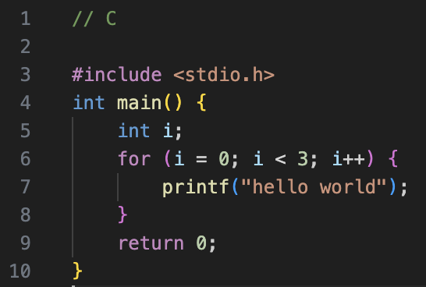Despite both using the same numbers, ERL will print “Hello World” 4 times, whereas Python will only print it 3 times. This is due to ERL being an inclusive language, which therefore can create confusion with students using Python, a very popular choice, and can cause errors throughout the paper.

This issue is not unique to Python, in languages with C-like style of creating for loops, including Java, PHP and JavaScript, the standard is to create for loops with a < operator, rather than <=, therefore also being naturally exclusive. With ERL being a rare case of inclusivity, this can easily cause issues, especially with “fill-in-the-gaps” style questions and for students who attempt to use ERL without a thorough understanding of it in writing questions, where this difference can easily lose a student marks.

🡺 SUBSTRINGS  
There is a drastic change to the formatting of producing substrings in ERL compared to the standard for many other programming languages. This can also be a source of confusion in the exam.

|  |  |
| --- | --- |
|  |  |

The OCR ERL has an unorthodox substring syntax, with the first argument remaining as the initial index, but the second argument being the length of the returned substring in characters, instead of the standard of the final character position +1. Again, an unfamiliar student may get caught out in an exam.

🡺 MISCELLANIOUS CHANGES  
There are also many small, but still potentially dangerous changes between languages.

* The use of “MOD” and “DIV” instead of symbols in typical languages
* The use of ^ as an exponent (** is used in Python, a very commonly chosen language)
* .upper and .lower are properties rather than methods (have no brackets afterwards)
* The use of closing keywords such as endif and endswitch (uncommon in modern languages)

Although many of these minor changes will generally be overlooked by an examiner during the marking process, a student who is fluent in the syntax will feel much more comfortable in the exam when occurring the custom syntax which they might be unfamiliar with.

#### Learning Resources

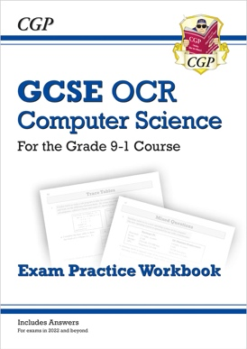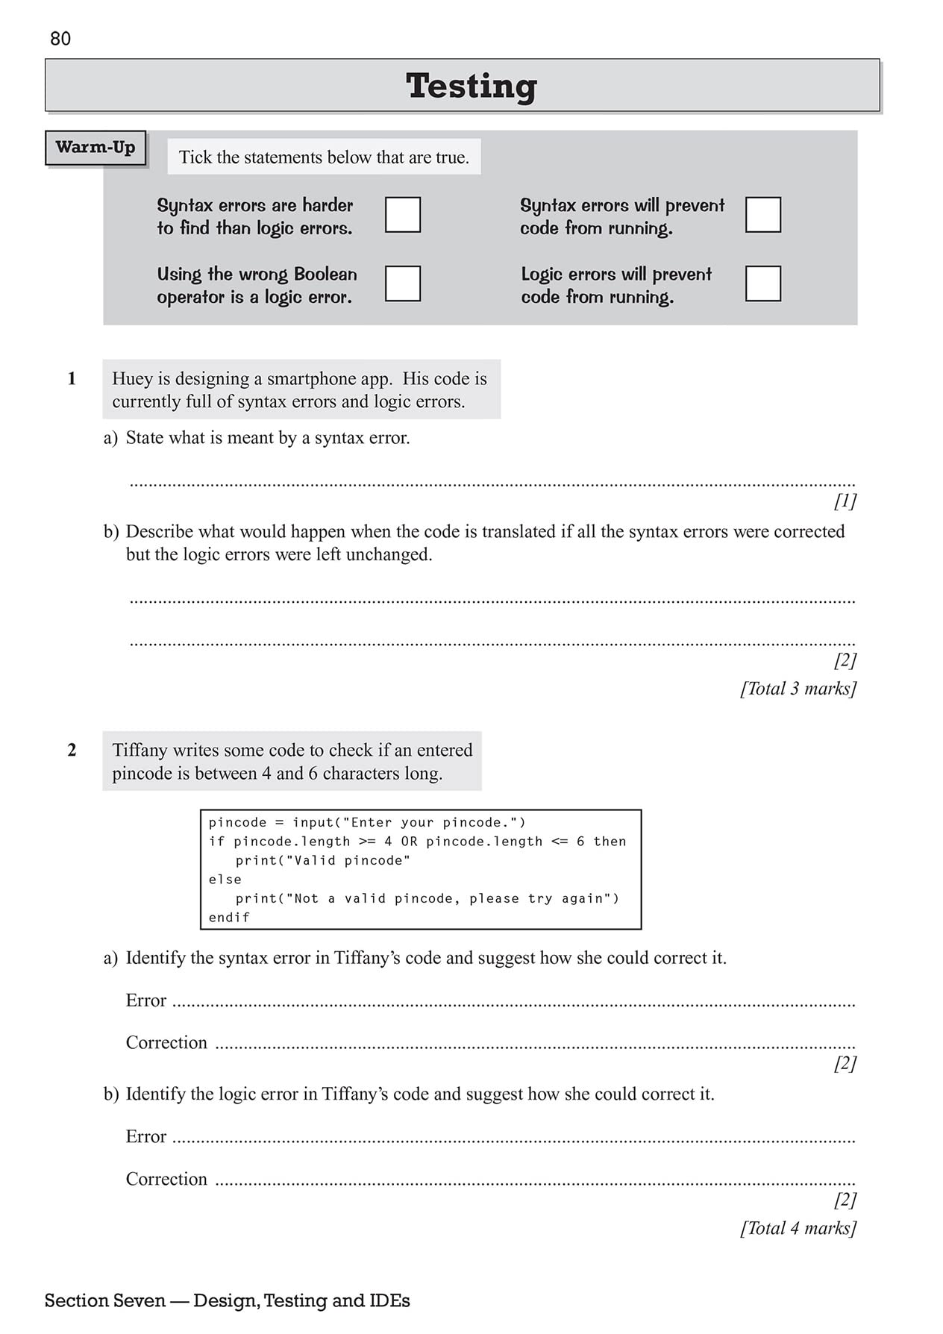Even though it can be argued that a high-level programming language can be interchangeable with ERL in the exam itself, many of the textbooks which are given to students use ERL in their explanations and exercises for students to do. This is as there is no set high-level language that any given school teaches, and the studied language is chosen by the school itself. Therefore, ERL is used within resources as a universal language utilised by the majority of textbook. This means many programming concepts, such as sequence, selection and iteration, as well as algorithms, such as linear search and bubble sort, will have their code written in ERL and this is how students will encounter and learn these key concepts for the exams.

This therefore presents ERL as a superior language than any alternative for the OCR GCSE, due to its syntax aligning with the mark scheme, and its wide usage within resources which are taught to pupils.

### **WHy are alternative languages more commonly used?**

The main issue with the ERL is the lack of a way for students to use it. ERL is not a pseudocode, and is an equivalent to a high-level language, so has been written in a way where it is interchangeable with real, functional code. However, there is no translator available which allows students to write and consolidate their skills with the ERL. This alone makes using the ERL mainly redundant, as students can only become familiar and comfortable with a language after using it for a prolonged period, as it this process of trial and debugging that allows their code to be reliable and ensures that they can produce accurate and correct code during the exam.

**Therefore, our problem is that students have no way to practice ERL, so are unfamiliar with it by the time the exam occurs.**

## Stakeholders

The target audience for our solution would be, obviously, for students partaking in the OCR Computer Science GCSE, however more specifically, they would likely be:

* First time programmers, with little or no prior programming experience.
* Using restricted school devices or poor-performance home devices.
* Unable to install and setup any complex software.
* Require a very intuitive solution with lots of help at disposal.

In order to gain a greater insight into the experiences of potential stakeholders, I have interviewed 3 different individuals to understand their experience with programming. I will also return to these stakeholders later to ask for their needs towards a solution I decide on.

### **current gcse student**

My current GCSE Student is Abigail Williams: a year 10 student who has been learning Computing for 3 years and started the GCSE content a year ago.

#### What are you past experiences with programming?

“My previous experiences with programming have been rather bad because I struggle to understand the computing language format and how it all goes together. On top of this, it takes me a long time to type it out in the language, and I would prefer it was simpler and more like English.”

🡺 This instantly outlines to me what a new and different experience programming is to anything else taught in school. As somebody with 3 years of experience still struggles to formulate the logic behind a language, it shows how schools need to focus more on practicing programming so that all students get it.

#### What’s been your prior experience with the ERL?

“What’s the exam reference language? I have used python before in the past, but I have never heard of this one until like 5 seconds ago.”

🡺 Shows how schools generally ignore teaching ERL content, and how they focus on high-level languages, despite some clear advantages which would help the student. After showing and explaining what the ERL is to her, she said that.

“Okay, that seems important to know if it’s going to be used in the papers, so I should probably make sure I learn about it a little bit”.

🡺 Even if students choose to not write their answers in ERL, a complete lack of awareness is slightly concerning, so teaching about the ERL needs to become more widespread.

#### What are your plans to revise coding?

“I’m going to make a revision booklet and write notes in it about the rules of the language that I’m going to use so I can try and remember. I know practicing is meant to be good, but I don’t know how to, and it sounds very difficult so I’m not sure if I will.”

🡺 A lack of an easy and obvious way to practice coding is very clear, as these techniques are far from ideal in order to build familiarity: so, as well as being unaware of the language, general revision techniques for computing have not been taught, as they are not as standard as those for other subjects.

#### Conclusions

Programming seems very unfamiliar to students like Abigail: where the focus needs to be on increasing their familiarity with programming as a whole, as they won’t be aware of the different languages or practice techniques available to them. Therefore, a specific solution for GCSE students, which they know will be useful in their GCSE because it’s built specifically for students like them, would help to simplify the process and ensure that students at this stage continue to develop their programming skills.

### **past gcse student**

Tanish Arjaria is a year 12 student who did OCR GCSE Computer Science last year and achieved a grade 9, who is now continuing to take Computing for A-Level.

#### Did they use ERL or high-level in GCSE?

“I chose to write in python in the exam papers. Although I know a decent bit about ERL, I am not as confident in using it as I am with python, so I felt as if it was a less risky choice. However, for the questions where code had already been written in ERL – such as the fill in the gap ones – I did write in ERL.”

🡺 This high-achieving student chose to use a high-level language, despite being clearly aware of the ERL, showing how his lack of practice in it led him to make his decision.

#### How did they practice using ERL?

“I looked at online ERL cheat sheets before exams and saw questions where it was used in past papers. Apart from that, I have never practiced using ERL at home, because I didn’t know where to find questions like we did in class.”

🡺 Students are not aware of how they can familiarise themselves – even the best achieving students struggle to practice regularly – forcing them to select a language without providing the choice for them to choose which one works best for them.

#### Find the experience of revising erl easy or difficult?

“I didn’t spend much time deliberately practicing ERL, so it’s hard to describe it solely as easy or hard. It’s more of a thing where a random ERL question comes up whilst revising different topics, but I didn’t have a single set way to revise it – so I guess in that aspect it was kind of difficult as there’s not much option available.”

🡺 It doesn’t even occur to students that they could be revising programming too, despite it holding so much value in paper 2 of the GCSE. It has been normalised as something which can’t be revised which should be changed.

#### Potential solution would have aided revision?

“I be so for real; it would have genuinely helped as I didn’t spend any deliberate time on ERL at all. Even though I am confident in programming generally, so it wouldn’t have helped in terms of improving those skills but making me more familiar with the syntax and stuff would have just made the exam a bit easier”.

🡺 Even for confident coders, just a way to help memorise the syntax would be useful, and this extends even further to less confident ones: so, a tool to practice would be useful for all kinds of students.

#### Conclusions

Overall, Tanish has made it clear that revising ERL is just not something that occurs to students, and it is never a focus in their revision. This highlights the importance of a potential solution as it could lead to practicing becoming more normalised, which would be very beneficial to all kinds of students in the exam.

### **computer Science teacher**

* Programming focused on high-level or ERL?
* Limitations on using ERL?
* Potential solutions be useful towards teaching?

We will return to our stakeholders later to ask for their needs in a potential solution.

# Problem Research

There are many other problems with pre-existing solutions, which can be analysed to provide useful insight into what my potential solution can be.

## Solutions FOR Erl

Initially, the focus will be on pre-existing ways that students can run ERL code.

### **trace tables**

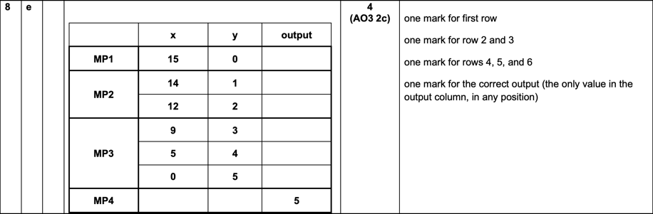Students should already be familiar with trace tables, as there are questions in the exam papers, for example this one from the sample paper, of students being required to use them to “run” ERL code. However, when used to run a student’s own code, it presents a slightly different task.

#### Advantages

🡺 Students are taught about trace tables, so it is an easy and familiar method for them to use on their own code, and it allows them to check if the logic behind their program is functional.

🡺 It serves as a form of debugging, as it allows students to analyse the logic behind the program that they have written and allows them to track the values of the variables throughout – much like a debugger – which can help produce more accurate code.

🡺 It does not require any software, just a pen and paper so it is a very feasible solution which can be done anywhere, making it very accessible.

#### disadvantages

🡺 There is no syntax checking at all, so whether the code is accurate cannot be determined as it is down to the students understanding of the language and may be incorrect in an exam.

🡺 This is also true of the logic, as if a student has a flawed understanding of how the logic of the language works, as they are the interpreter in this scenario it means that they may unintentionally gain an incorrect solution which they believe to be correct, as they have interpreted it based on their inaccurate knowledge of the language due to their unfamiliarity, and would lose them marks during an exam.

🡺 The task is very slow and tedious, especially when it comes to longer programs, so there becomes a point where it is intangible to use a trace table when the program reaches a certain size, because the number of variables becomes too tedious to track, and a much faster solution would be preferable.

#### What can i apply to my solution?

Although, overall, a trace table is a horribly unreliable and slow method of running a program, it does teach lessons about ease of use which are very important to my own program, in order to make it available to beginners. Also, the very accessible nature is of importance, as there is no use of coming up with a better solution if it is unavailable to a vast number of students.

### **translation to other languages**

This method involves a student writing the original code in ERL, then translating it to a high-level language of choice in order to run it and obtain a result.

#### Advantages

🡺 Does allow for the program to be ran, and the student can produce a result, which allows students to test programs and feel comfortable with their ability.

🡺 Allows simultaneous learning of ERL and a high-level programming language at the same time, widening the scope of the student and producing a more educated individual.

🡺 Having to re-read ERL to translate it allows the student to scan for errors more effectively, hence making them more accurate with the language,

#### Disadvantages

🡺 The ERL stage can become heavily redundant, with very minimal thought behind it, as the high-level programming language is what is ran, so the student would tend to become much more proficient in that, as the ERL was just an unnecessary stage which can become ignored and therefore not learnt by the student.

🡺 Very minimal focus is applied to how correct the ERL written is, as it is only the high-level language that is executed, so if a student makes lots of errors in the ERL, but produces a correctly functioning high-level code, it can result in them learning incorrect syntax for ERL in cases. This can make this method negative, as the false reinforcement could lead to very big flaws, as it is only their own interpretation of the syntax of the language which determines the result of the program.

🡺 Again, the process is very time consuming, and really discourages the student from attempting to write accurate ERL as it makes the programming process so much longer.

#### What can I apply to my solution?

The very negative evaluation of this method shows the importance of a fast solution that encourages the student to write in ERL, as otherwise using a different high-level language would be a much easier solution for them.

### **Conclusions**

The overall result of this analysis is that an interpreter for the ERL is required, as otherwise running ERL is such a time-consuming process for the student. This would require a program that would be able to be presented a program written in ERL, and directly produce a result from it, as otherwise students would be much better off with using a high-level language.

Therefore, researching how interpreters for other high-level languages function would be beneficial in identifying which key features are important for me to implement.

## Solutions for other languages

There is an abundance of interpreters available for other languages, and I will be analysing them based on their application towards our stakeholders as alternatives, not for their typical users.

### **NOde.JS in Terminal**

This is a command-line interpreter for JavaScript which can be run in a terminal on a device by calling it with “node” with no separate application.

#### Advantages

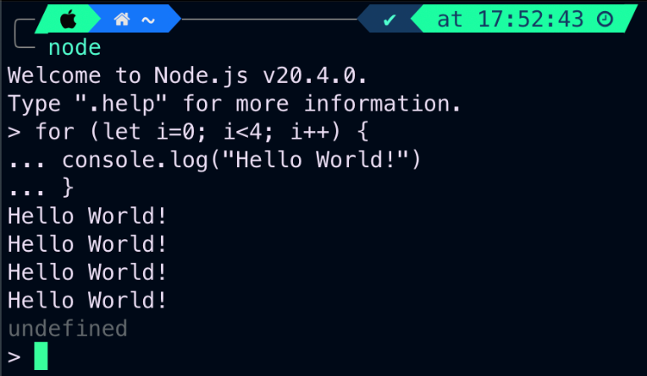🡺 The obvious first advantage, is that it successfully runs JavaScript code when entered. This may sound irrelevant to mention as a solution, but as there is no option for ERL that does this, it already presents this interpreter as much superior to any ERL methods that could be chosen.

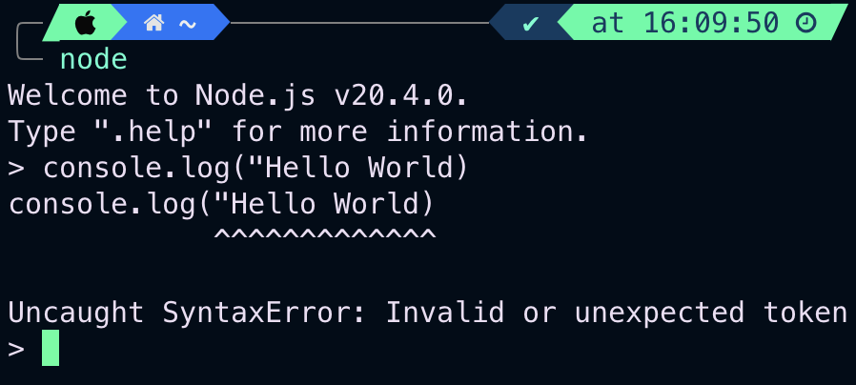🡺 It also contains error handling, referencing both the error type and where it occurred, which is very useful for anybody writing code, especially to students who are prone to mistakes, making learning the language much easier as well as aiding debugging.

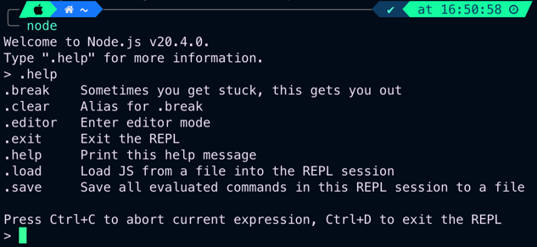🡺 Multiple use modes allow the students to use the program depending on their needs. The shell, for a few lines of code to be run individually; the editor for when a longer program is required, to all be interpreted as once; and the ability to select a file in local storage and run it. This makes the interpreter much more diverse and can adapt to the need of the user.

🡺 The basic help feature allows the user to be able to fluently use the compiler, as a reminder on how to operate it with the command-line interface.

#### Disadvantages

🡺 Lacking a graphical user interface of any type, this makes it very difficult to use, especially for the stakeholders who are first-time programmers. A command-line interface is very complex, and the terminal is often blocked on school devices, making it unapplicable for our student stakeholder who need to use it.

🡺 Installation is also difficult, requiring installation from the command line or downloads from the website, meaning a student requires an administrator to be able to access it, which reduces the scope of the interpreter.

🡺 The poor user experience stems from the command-line interface. Users must memorise many commands to access the different features of the interpreter. Although this makes it much faster to use for experienced programmers, for beginners it becomes much more tedious, and could do with a much more intuitive solution, as well as the shell being slightly clunky to use at points,

#### what can i apply to my solution?

🡺 Ensure that error handling is implemented as it is very important in an interpreter  
🡺 Provide an intuitive interface as the interpreter is intended for beginner students.  
🡺 Prioritise accessibility and that it is available to many.

### **Python Idle**

I will be building upon the previous analysis of node.js for this analysis, as many of the basic features, such as running and error handling are taken for granted, so will not be mentioned.

#### Advantages

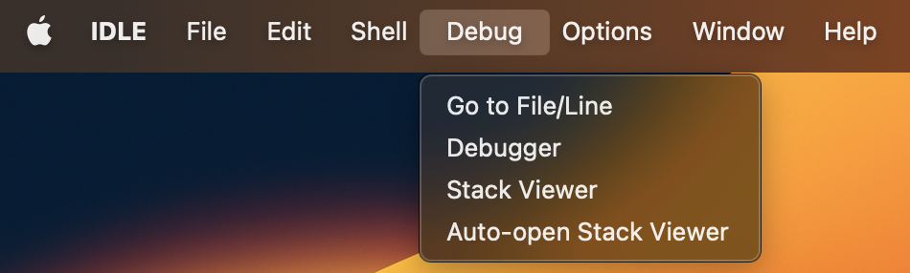🡺 The user experience is vastly improved, with use of the ribbon to introduce a greater array of options that the programmer can use, allowing equal if not greater functionality than node without the need to memorise all the commands, making it vastly easier to use for beginners.

🡺 Includes a debugger, with persistent breakpoints, stepping, and viewing of global and local namespaces, which can aid the students understanding of the language as, after all, it is correcting mistakes that allows a student to develop their understanding of a language.

🡺 Overall a more easy-to-use solution. Some examples being the syntax highlighting making it easier to identify blocks of code, as well as the shell element of the program being very logical to use, which runs after the program is complete, even allowing the previous file that is run to be referenced from it, making testing very easy. Overall, the interpreter is very well made and intutive for beginners to use.

#### A screenshot of a computer Description automatically generatedDisavantages

🡺 There are still accessibility issues present. The program still needs to be downloaded from a website or using a package manager, and will still require administrative permissions to install, which can decrease the scope of the program in terms of who can use it.

🡺 In terms of helping absolute beginners, the official documentation is still quite dense and hard for new programmers to undestand. Although there are a multitude of beginner guides avliable on the internet, when thinking soley about the official documentation, it would make the experience harder and is worth considering for an ERL interpreter which is aimed directly at new programmers.

🡺 Having to save files locally before being able to run them can be a nuisance a points: a very small critique but worth considering, as overall IDLE is a very strong interpreter.

#### WHAT can i apply to my solution?

Trying to replicate the visual, ease-of-use of IDLE is a strong target, as it makes focusing on the code itself very easy, as operating the interpreter itself is very straightforward. In terms of improvements, the focus is still towards making it available to as many people as possible, so considering low-performance devices and avoiding downloads would still be useful.

### **Replit**

Replit is an online IDE which allows people to write code on a website, where it is then run on their cloud servers and the results are returned to the client.

Again, the evaluation builds upon the points of the previous, as many of the advantages are shared with IDLE, including debugging features and syntax highlighting.

#### Avantages

🡺 The accessibility is the highest out of any solution. Being a website, it requires no installation, so can be run by any student without requiring assistance from an administrator. Additionally, the program itself is ran on cloud servers, so any low-performance devices are not affected due to the program being executed externally, resulting in the solution having a very large scope.

🡺 The community aspect is extremely prevalent, with an extremely large number of users sharing their code, and aiding others by providing advice and feedback. This positive loop leads to a very good environment for new coders in order to learn programming.

#### Disadvantages

🡺 A potential negative is that the functionality of the solution has resulted in the interface becoming very convoluted, and potentially confusing to a new user, which could make programming become a much less approachable experience for them.

🡺 It doesn’t run ERL!

#### What can i apply to my solution?

A website solution seems extremely promising, as it allows it to be extremely accessible to lots of students. Due to the huge size behind Replit, some features such as the cloud servers and community feedback will be impossible to replicate, but the focus on creating an environment where anyone can run code, with a focus on learning is a strong takeaway.

# Proposed solution

Through research, I have decided the solution chosen will be to create an interpreter for the ERL, and I have decided upon a small list of high-level objectives which are my main priorities for the program.

🡺 The interpreter is available on a website so it is accessible to many students  
🡺 The interpreter can execute the majority of ERL code, including  
 🡺 Arithmetic features, with correct order of operations  
 🡺 Different data types: strings, integers, floats, bools  
 🡺 Basic data structures: variables, constants and arrays  
 🡺 Logical features, such as if statements and switch statements  
 🡺 Iterative features, with counter-controlled, while and do while loops  
 🡺 Function and procedure calls which can be user defined  
 🡺 Input and output features, taking in from users and printing out to a shell  
 🡺 Typecasting, commenting and a limited amount of smaller features (to be expanded on)  
🡺 Users are able to type code straight into the website, upload files and use the shell  
🡺 An easy-to-use and minimal user interface for beginner programmers  
🡺 Error handling, with reports with details on why a program cannot run  
🡺 A help system targeted towards inexperienced programmers

This is just an initial draft, of what I feel are the basics for what must be included at this stage. I will continue to research and check with my stakeholders in order to refine this list later in greater detail, along with how I can quantitively measure the success of each objective.

## Stakeholder Needs

After showing them my list of high-level objectives, I asked for their feedback.

### **Current gcse student**

“Even though I don’t understand a lot of the things, it has got the stuff I know like variables, if statements and the loops. For me, making it have a way to explain how the different bits work would be very important, as without instructions that I can see I would get very confused, so I’d find that useful.”

🡺 Even though coding a functioning interpreter is the priority, the help features are almost as important, as without them the beginners – who are the intended user of our interpreter – will still remain very confused and it won’t be any help for them.

### **past gcse student**

“I think the list of ideas involve the majority of things that are included in the ERL. I know there are some other smaller features of it, but I’m not sure if he’s including those, but they would be useful but not absolutely necessary. However, the main other thing I’d like is syntax highlighting, as I think it makes the code much more readable and would be a lot easier for beginner programmers, so if he could colour-code the keywords it would be a very good feature.”

🡺 Confirmation that all the key features have been included is helpful, and I will discuss the limitations later. The idea of syntax highlighting is also a good idea, as it would overall make the program easier to use, which is my priority, so I will try to include it as its useful for those of all skill levels.

### **computer science teacher**

# Solution research

Waffle.

## computational approach

Solving this problem with a computational approach is clearly a very logical solution. I have already researched other methods of trying to execute ERL code, the only method being a trace table, which I concluded was a very inefficient method to use. It is in its nature to use a computer to execute code, so therefore it is very clear that using a computer is the correct solution.

## Technologies used

It is important to choose the correct technologies from the start of the process, as it is difficult to change halfway through a program.

### **Programming language**

The programming language that is used is a very logical first decision before making a program. As one of our high-level objectives is that it is a website, we must ensure that it is possible to run on a website.

#### Javascript

The obvious initial choice is to use java script. The modern, most frequently used language which runs on websites.

## Computational methodS

# NOTES:

Problem Recognition:  
Problem Decomposition:  
Divide + Conquer:  
Abstraction:  
Backtracking:  
Data mining:  
Heuristics:  
Performance modelling:  
Pipelining:  
Visualisation to solve problems:

Design

# Explanation

This stage will be describing the structure and logic behind my coded solution. As an interpreter is a very computationally demanding project, this section will be very detailed on the overall structure of how the solution works, and will link very closely to the development section, where the code I write will be mainly explained here, so I will follow the same general layout in both.

### References

I have compiled my research from a list of different sources that I have listed below. Note that I have never used and will not use any actual code from any of my sources for my actual project, but the overall technique for a compiler is standard so I have used lots of examples in order to learn how I will structure my project.

🡺 [https://youtu.be/SToUyjAsaFk](https://youtu.be/SToUyjAsaFk?list=LL)  
🡺 [https://youtu.be/JO_0e9mPofY](https://youtu.be/JO_0e9mPofY?list=LL)  
🡺 <https://craftinginterpreters.com/a-map-of-the-territory.html>

# An overview

This first section is going to be an overall demonstration of how my interpreter is going to function. We are going to take a relatively basic arithmetic expression, in plaintext, and go through the logical steps the interpreter will take to produce a result. This includes the three main stages: lexical analysis, parsing and then execution. I will later go into detail about the plans to code each stage, but this is a general abstracted explanation of the process which removes all the complicated details.

### Lexical Analysis

The interpreter will take a plaintext input, for example being the one below, which we will be using throughout this demonstration to eventually produce a result.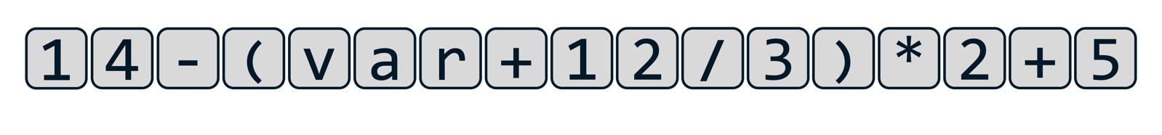Currently, to the computer, this string of characters holds absolutely no meaning or value, so in lexical analysis, the meaningless string of characters is converted into a list of tokens. This is done by a program called a lexer.

On a simplified level, the lexer takes a line of the input text, and goes character by character, looking at the type of character or arrangement of characters, and converts it into a list of objects, which are called tokens. Some characters are very easy to convert into tokens, such as parenthesis, however, when tokens which are longer than a character long become involves, it requires much more difficult code to distinguish multi-digit integers, strings, floats and variable names.

The lexer must also be trained on what to ignore, including white-space characters and comments, as what is produced at the end of the lexing process must be a list of meaningful tokens which can be given to the parser so the next stage can start.

In terms of the tokens that are produced themselves, they are all objects, as I am using an object-oriented approach to this project. Every single token has a token type, and every single token type has its own class, with different properties. Throughout the process, we will define and create different types of tokens, but for now we have four different groups of tokens.

🡺 Literal tokens hold values, with different types being integers, floats, Booleans etc. They will have a property called value which, obviously, holds their value.

🡺 Identifiers, at this stage, are variables, and will later include function and procedure names. For now, they would have a property which points to the location of their value in the program (to be expanded on later)

🡺 Binary operators are the arithmetic operations, including adding, subtraction, multiplication and so on.

🡺 Finally, there are other kinds of characters, such as parenthesis and dots, which may be included.

At this point, the objects still hold no logic or meaning behind them but is merely the plaintext described in a way that a computer could begin to understand it: the equivalent of us reading a sentence, but not yet understanding the grammar and meaning behind it.



Using our example, at the end of the lexical analysis stage, we have been left with this array of tokens which is equivalent to the plaintext, ready to be passed onto the next stage of the process.

### A screenshot of a computer Description automatically generatedthe very basic concept of Parsing

Parsing is the most complex stage out of the three and is where the tokens from the lexer are given a meaning, a grammar, that means something to the computer. This is where our simple list of objects is built into an abstract syntax tree, which is a type of data structure. Where each of our objects is linked in some way to another object, as its children. The job of the parser is to correctly link all these objects together in the correct structure based off the rules that we give it.

These set of rules become very complex, but in our example, the computer needs to arrange the objects based on the mathematical principle, order of operations. This has two key parts:

🡺 Precedence: the order itself. This is how certain features have priority, with items in parenthesis being calculated first, then any exponents, then multiplication and division, then addition and subtraction, according to the BODMAS structure of mathematics that we use.

🡺 Associativity: this is the order in which operations with the same precedence are executed. For example, a chain of subtractions will result in a different value based off whether they are calculated from left to right or from right to left. In BODMAS, this is from left-to-right for arithmetic expressions.

Based on these rules, the tree is created, with the calculations that need to be performed first at the bottom of the tree, and this is the overall premise of parsing before the result is produced.

Although this may seem simple with our BODMAS example, the premises of precedence and associativity are still present for all other aspects of the language. When keywords and different data structures and functions and all the specific features of the language become involved, it makes this parsing step extremely complex to create.

### What are the set of rules?

In my brief description, I described how a set of rules determined how the abstract syntax tree would be created. This sounds extremely vague, but it needs to be extremely precise in the actual code. This is where a special kind of notation is used, called Backus-Naur form - or BNF for short - is a context-free grammar used to describe the how the logic behind a grammar is defined.

#### A basic example of bnf

For this we will be defining what an integer is using BNF. There are a few key aspects of BNF. The definitions by themselves may not make much sense but will be clear with context afterwards.

🡺 name = a terminal (aka lexemes), this means it is in its lowest state, and cannot be expanded upon, for example the digit 1 is a terminal as it is clearly in its defined form

🡺 <name> = a non-terminal, which can be expanded and defined by a series of terminals or non-terminals

🡺 | = or, used when defining a non-terminal which can have several different ways it can be defined

🡺 ::= = the equals of BNF, where the non-terminal on the left-hand side of the ::= is defined by what has been written on the right-hand side of it.

This may sound extremely confusing for now but let’s begin the process of defining an integer. We must first decompose the integer into the smallest item that it is comprised of: a digit, which we can easily define with the following statement:

<digit> ::= 0|1|2|3|4|5|6|7|8|9

This statement shows how a non-terminal called a digit, is defined as a 0 or a 1 or a 2 or a 3 and so on. This may seem redundant and obvious information to a human, but every little thing must be explained to a computer. This is why this example is a good introduction to BNF, as it shows how every little detail must be considered so the grammar is built from the ground up. Furthermore, we can then expand on this definition.

<integer> ::= <digit>|<digit><integer>

This statement says that the non-terminal integer is defined as a digit OR a digit combined with an integer. This recursive self-defining forms the basis of BNF, as therefore this means that an integer is defined as 1 or more digits, with no limits on the number of digits available, hence defining the integer as every single possible integer ever. It is the structure like this that allows BNF to represent the grammar of entire programming language by building up from the most basic steps.

However, our definition of an integer is still wrong, because an integer cannot begin with a 0 as the first integer, or two zeros as the first two, as these integers have already been defined. Therefore, the actual definition for an integer would be as follows:

<non-zero digit> ::= 1|2|3|4|5|6|7|8|9  
<digit> ::= 0|<non-zero digit>  
<digits> ::= <digit>|<digit><digits>  
<integer> ::= <digit>|<non-zero digit><digit>

By ensuring that it does not begin with a zero, this has already significantly increased the complexity of the BNF by at least double, but it does show how important being precise is, and the attention to detail that is required in order to produce an interpreter that does not contain lots of errors.

#### Extended backus-naur form

Shortened as EBNF, Extended Backus-Naur Form is a more concise way of writing in BNF. Although everything in EBNF can also be written in BNF, it just makes the process easier to read whilst avoiding lots of repetition and reduces the amount of self-recursion. Taking our previous example, the new definition of an integer would be.

<non-zero digit> ::= 1|2|3|4|5|6|7|8|9  
<digit> ::= 0|<non-zero digit>  
<integer> ::= <non-zero digit>{<digit>}

The introduction of the curly brackets { } mean that whatever is contained within them can be repeated zero or more times. This eliminates the need for something to be defined by itself, and makes it overall clearer to read. Other additions to EBNF include:

🡺 (a|b) = an option that needs to be made, for example  
<x> ::= (a|b)<y> 🡺 <x> ::= a<y>|b<y>

🡺 [a|b] = an option that doesn’t have to be made, for example  
<x> ::= [x|b]<y> 🡺 <x> ::= <y>| a<y>|b<y>

Again, these shortenings just reduce the amount of repetition that needs to be made whilst writing BNF. There are different variations of the syntax that use different variations, but the only one I will really be using are the curly brackets, which for clarification has the example:

<x> ::= a{<y>} 🡺 <z> ::= <y>|<y><z>  
 <x> ::= a|a<z>

As this is very useful for shortening and occurs very commonly, but the main point to take away is that any notation that I write in EBNF is always able to be written in the simplest form of BNF, showing that the entire grammar of the language stems from these small definitions.

#### Order of operations in bnf

Just as anything in a language can be expressed in BNF, our order of operations problem can also be written in BNF. Below is the basic version which we can use to solve our solution. We will expand upon this later to include exponents and prefix operators, but for now we will just include the necessary addition, subtraction, multiplication, division and parenthesis needed for our example. The required EBNF is:

1) <expr> ::= <term>{(+<term>|-<term>}  
2) <term> ::= <factor>{*<factor>|/<factor>}  
3) <factor> ::= (<expr>)|identifier|integer

This simplified solution also defines identifiers and literals as terminals rather than non-terminals. It can be argued that they would be non-terminals, but for the sake of explanation I have defined them as terminals, with identifiers being variables and integers holding a value.

Take this small example for an explanation of the process, starting with this set of tokens:

Looking at the initial tokens, we have 3 literals, which are integers, and 2 binary operators, a multiplication and an addition. Just for clarity, we can label our integers, to distinguish them from the binary operators, which hold no value and are only there for logic.

Looking at our integers, our third line of EBNF states that a <factor> can be defined as an integer, so therefore each of our terms can now be labelled as a <factor>.

According to our second line, one of the definitions of a <term> is two <factors> multiplied by each other, so we can therefore group our <factor>*<factor> and label it is a <term>. The remaining 4 is also labelled a <term>, as a <term> can still be defined by a <factor> by itself, so long as there are no * or / binary operators next to it, which leaves us with two <terms> separated by a + binary operator.

Now, our first line of BNF defines an <expr> as a <term>, followed by a + or – binary operator, followed by a <term> (just once in this case but can be repeated). Therefore, we can now define our entire expression as a single <expr> non-terminal as shown below.

This expression is now completely defined, as an entire tree has been created, starting from the single <expr> non-terminal, which allows us to then progress to the next stage after parsing. This more detailed perspective of how the different steps of logic work lead to the following abstract syntax tree:

This holds the exact same meaning as the previous diagram, just presented in a different, less confusing way which is closer to how it will be treated for the final stage. In reality, each of the different boxes is an object, with each of the arrows being a property within the object that points to the other object as its children, so our diagram is just a visualisation. However, the key takeaway is that our parser turns our set of tokens from the lexer into this abstract syntax tree, stemming from a single initial object at the start, which descends into sets of different pairs until the whole expression is now defined aligning to the rules that we have chosen, so that our precedence (order of operations) will be correct.

To go back to our example, our original string of tokens will produce a BNF tree like this:

This clearly shows how quickly the diagrams get messy using this approach, and how complex the process of parsing is, so it is best to use abstraction, and remove the details of how the parser works, leaving us with our final parsed tree which can be passed onto the next stage.

This process of parsing is called recursive decent parsing, and the process itself is very detailed, and can cause lots of errors which I will not go into detail about now. In the later stages of design, I will explain the actual coded steps in order to perform this process, but for now it is just the logic behind it that is of importance. The key points from this are that:

🡺 The rules of the parses must be very carefully defined  
🡺 All possible inputs must be thought out  
🡺 The process itself is very long and complex  
🡺 The result that must be produced must start from a single object.  
🡺 The order in which the tree descends must match the precedence of the operations so that the execution stage is correct.

Our original other point of associativity has not been mentioned but it was defined in the DNF stage. If we were to reverse the way that we wrote our DNF rules, then the operations would have been performed right to left but ensuring that associativity is correct in the parsers process is something extremely important that I have not mentioned.

### Execution

The final stage is taking our abstract syntax tree and producing a single result. From now on, it is more useful to focus on the fact that the tree is a set of connected objects, rather than the very over-simplified diagram. Continuing from our small example earlier, we can represent the set of diagrams as shown:

This approach highlights a better way to visualise the tree, not just numbers connected by operations, but only integer objects, with their values being properties, rather than being the main part of the object itself/ Additionally, rather than them being magically “connected” to each other, the binary operator objects also have two properties: a left child property and a right child, which then each point to another different object. This focus on this object-oriented perspective will make the overall execution stage a lot easier.

There would be lots of different properties for the different types of objects that we could have. For example, any variable objects would have a property that points to the location where their value is stored. Or, the negate operator [for example –(3*2)] would only have a single child, rather than a left and right, as it is not a binary operator.

Despite all of the objects having different properties, one of the things they would all share is an evaluation method, called eval(). This use of polymorphism – one of the pillarstones of object-oriented programming.

The evaluation function of each object returns it’s “value”. The most obvious instance of this is for an integer object, which returns the value of its value property as the evaluation method. Similarly, a variable would return the value stored in the memory location that its property points to. These are all very straightforward.

Where the complexity arises is with the binary operators. The result of the evaluation method of an addition object, is the result of the evaluation method of its left child, plus the result of the evaluation method of its right child.

This is relatively straightforward with just one binary operator, but when one of its children is another binary operation, its evaluation method has to call upon a further two evaluation methods in order to get it’s value, which it then returns to the previous.

This means, that when you want to find the result of an expression, you call the evaluation method of the object at the top of the tree. In turn, this will then descend down the tree, calling the evaluation method of every “branch” object in the tree until the “leaf” objects are reached. The results are then returned back up the tree, so each method can obtain a value, back to the final starting object which returns the final answer

This is how the final evaluation stage of the interpreter. I will not fully explain our example, as it would merely be a lot of repetition, but the key focuses are the same. Descending down the tree, calling the evaluation method of each of its children, down to the bottom of the tree. Then, all the returns making their way back up to their parents, up to the top addition object, where the value of the equation has been determined.

Again, like lexing, this process is relatively straightforwards when you understand it, and it definitionly presents parsing as the most complicated step in the process, as it’s finding out the order of what to do that’s the most computationally complex.

Note that, in our simple example, the evaluation method only returns a value, but when we begin to impliment more complex features, such as seting variable values, iteration and function calls, this evaluation method will contain a lot more steps than merely returning a value, in order to actually change something in the code. But, for now, all we need to do is return values.

# Bodmas lexer

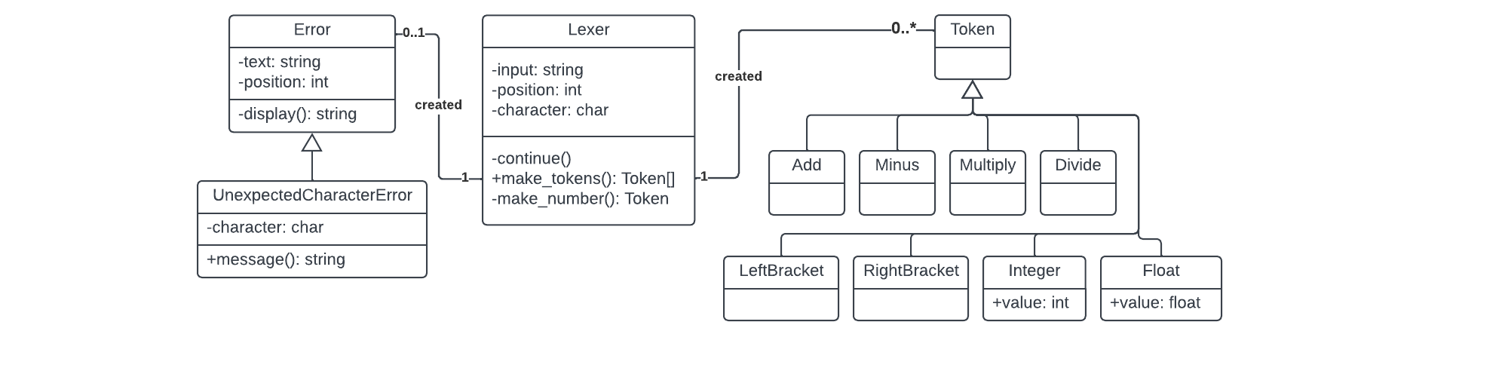For each phase of development, I am going to create a UML Class diagram which will represent the classes in the program which I will need to create, these are just a basis however, and may be changed in development to create new and updated features. The one for our initial lexer is as follows:

I will then go ahead and explain each new section that has been added.

### Lexer

This is the main part that has been implemented and will draw on the other aspects of the program. It has an input property, for the plaintext, as well as a position and character property which will cycle through the input string with the corresponding values. In the constructor, these will be given values and the continue() method will be called once.

🡺 continue()

This method will be called to advance through the input string, incrementing the position property and changing the character property to the corresponding value. However, if the end of the string has been reached, then the character will be set to null.

🡺 make_tokens()

This is the main method of the lexer and will comprise of a while loop which repeatedly runs until the character property is null. For each iteration, the current character will be repeatedly compared against characters, and then the corresponding token will be added to the end of a tokens list. At the end of each cycle, the continue() method is called to proceed to the next character, or if the current character did not compare anything, then an instance of an UnexpectedCharacterError is returned. Once all the characters are cycled through, the list of tokens is returned.

🡺 make_number()

This method will be called if the character in the make_tokens() function encounters a digit, because it needs to be handled separately. This will then continually call continue() and add the characters to an array until a non-digit is encountered. This excludes full stops, which will be added and will increment the value of a fullStops variable. When a non-digit is encountered, it stops the loop and the method will return an instance of an Integer or Float Token, depending on the number of full stops, with the value set as the array of characters type casted into a Number.

### Tokens

For now, these do not hold much code, but there will be a subclass for every kind of token which can be produced. The constructor methods will be empty, except for calling the parent class’s constructor so that they can be expanded upon later, as the whole point of implementing these now is to build a framework for later.

🡺 value

The only token classes with properties for now will be the Integer and Float classes, which will be set in their constructor methods so that they can be accessed.

### Error

This, again, is a base class which will be expanded upon in the future, which will take in the current line and the position of the error as an input in the constructor method. There will be a subclass for each more specific type of Error, for now only including UnexpectedCharacterError()

🡺 display()

This is a method which will be used for all Error subclasses, which will use the text and position properties and return a two-line string of the line of text with an arrow “^” below, which will be used to point to the position of the error, in order to provide useful error diagnostics.

#### Unexpected Character Error

This subclass will also take in the character which causes a problem in the constructor class.

🡺 message()

This will return a string with an error message describing the issue in English for the user to understand, with the display() method also being called so the position of the error will be shown below the error message so that a single method can be used to relay all the information that needs to be known about an error. In the future, all subclasses of Error will have a method called message(), to provide consistency so that an error message can be easily displayed regardless of the type of error itself.

# Bodmas parser

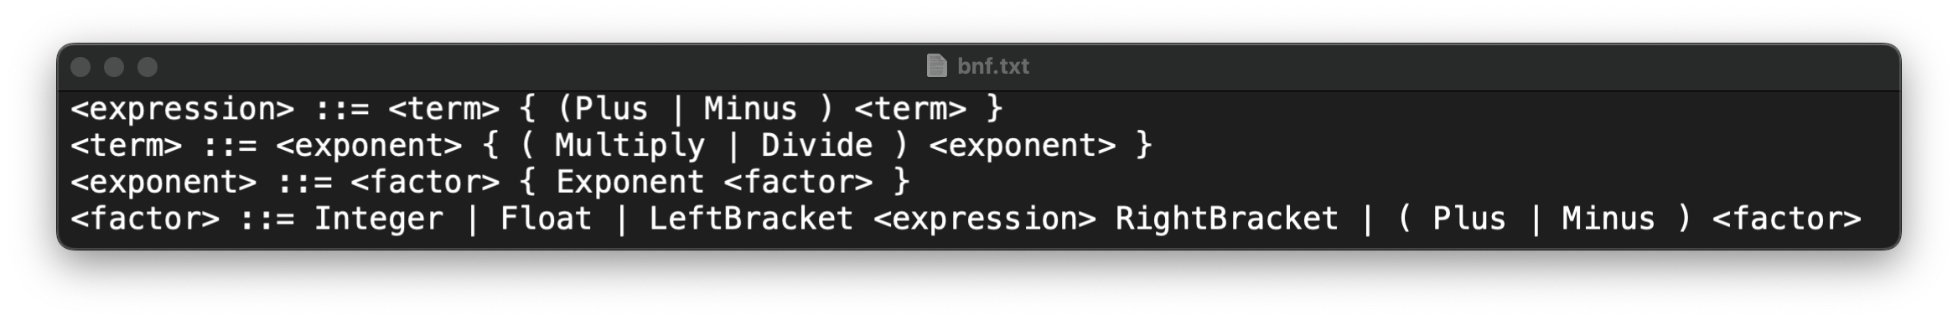The BNF for our parser is slightly different to our simplified version from earlier.

This is slightly more complex, but before we go into the details alongside the UML class diagram, we need to go into more depth about how the parsing algorithm functions on a code level.

## The complexities of parsing

In our previous example, we thought of parsing being constructed from the bottom up: from <term> to <factor> to <expr>. This process occurs the other way around, using recursion, from the top down, with <expr>s constructing the <factor>s, which make the <term>s.

In our code, we will have a different method for parsing the expression, the term, and the factor, each of which will call upon the next. The important point here is that they are all members of the same object. The required tokens aren’t passed as an argument to the next method, but the character property, in conjunction with the continue() method are used.

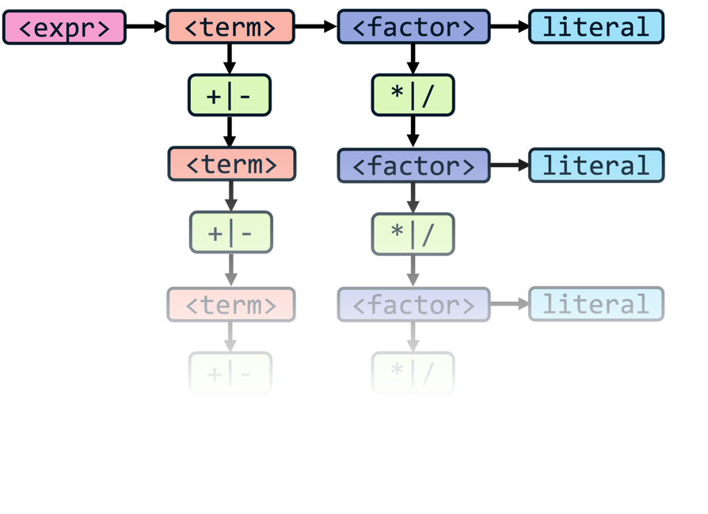This means that, after one method has continued parsing, you can call it again and the current position and character are maintained. So, for each method, the next method is called, and then it is checked if the next token is one of the corresponding operators. If it is, then the next method is called again, and the process repeats: checking if the next token is corresponding, and then calling the next method.

🡺 This sounds complicated, but it is easier to use examples. For example, the expression method calls the term method, then checks if the next token is a + or a -. If it is, then the term method is called again, and this repeats. Likewise, the term method will call the factor method, and then check if the next token is a * or a /. If it is, then the term method is called again, and this also repeats.

I think this diagram is useful to visualise this repeated pattern, because that is the best way to thinking about it: a long chain.

It is also now important to visualise the code itself. Diagrams are important to visualise the overall structure but explaining it in pseudocode helps to bridge between the logic into the code itself.

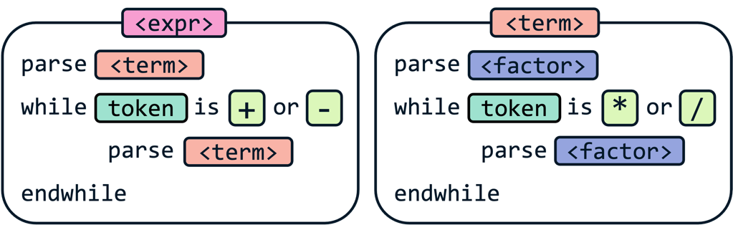This is the same concept in a different form factor, but a very overly-abstractified version of the real version. It is crucial to understand this fundamental format however, as it will be repeated and used in some equivalent throughout the entire program.

The concept that took me the longest to understand is that it is the equivalent of filling in the gaps, and that each time the next method is called, it is “completed” and that – as long as there are no syntax errors – the next token will definitely be a +, or a -, or the end of the input has been met.

This level of decomposition makes each stage of parsing by itself simple, by abstractifying away all the complexities behind it. However, this incorporates our two main principles of parsing. The precedence is maintained by having the first method to be called being the most general one, with the lowest priority operators, and each following method that is called is more specific, with higher priority operators.

The associativity is also maintained, which is logical as the while loop in each method goes from the leftmost token to the rightmost, ensuring that the correct order is maintained, however this makes more sense when we develop our methods slightly more.

### Construction

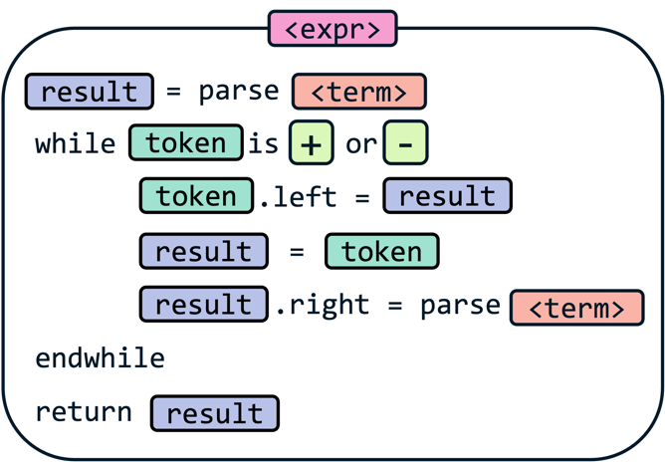Now that we know in which order we build our tree, we must actually construct it.

The basic pseudocode is as shown, and it takes the current token, and sets its left and right to the result of the next stage of parsing. In this case, the expression method takes the first + or -, and sets its left and right property to the result of the term method for the tokens on the left and right of it.

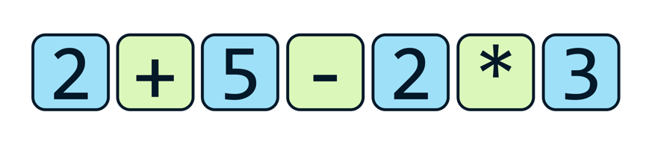From here, if any more iterations occur with new operator tokens, the left property of that token is set to the previous operator token, and the right is then set to the next stage of parsing, continuing from that point.

That was not a very succinct description, but again, examples are useful.

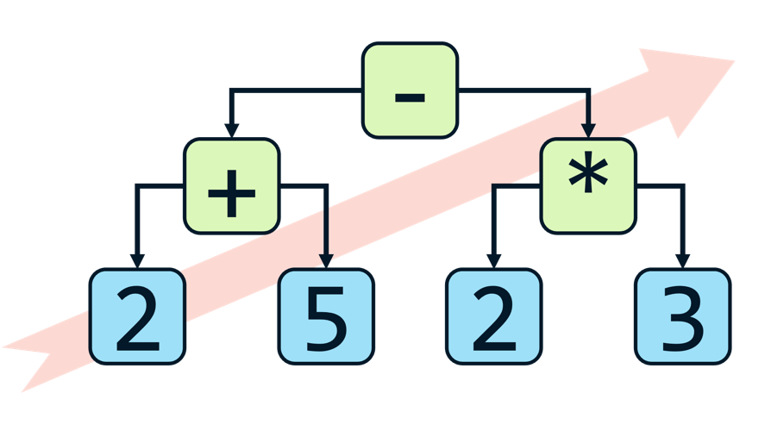The expression method is called on this stream of tokens:  
🡺 The term method is called and returns an Integer with value 2  
🡺 The current token is a Plus, and its left property is set to an Integer with value 2  
🡺 The term method is called again and returns an integer with value 5  
🡺 This result is set as the right property of the Plus token  
🡺 The new current token is a Minus, and its left property is set to the previous  
 🡺 This means its left property is now a Plus token which has two Integer children  
🡺 The term method is called again, and now returns a Multiply Token  
 🡺 This Multiply Token has a left child of Integer 2 and a right child of Integer 3  
🡺 This Multiply Token is set as the right child of the Minus token  
🡺 There is now no new current token so the expression method is complete and returns the Minus

As you can see, this results in this abstract syntax tree being formed, which is built from the bottom-left to the top-right. It is good to try and visualise each one of the steps as this tree expanding, with each arrow in the diagram being one of the child properties of the parent set to the child.

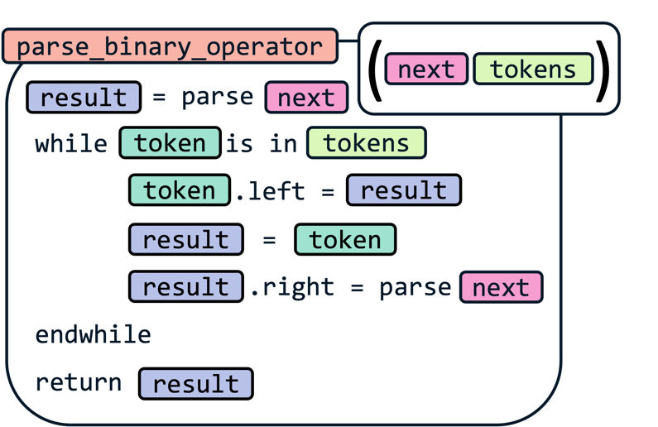Finally, it is worth thinking about how this solution can be generalised, to reduce code repetition as a whole, so the following is adapted to take in additional arguments of what the next parsing stage is, as well as which tokens are corresponding to this stage of the parsing.

Now we have built up a foundational understanding of the parsing process, it is important to see how this links back to the whole program as a whole, as we return to our UML diagram.

## Integrating parsing

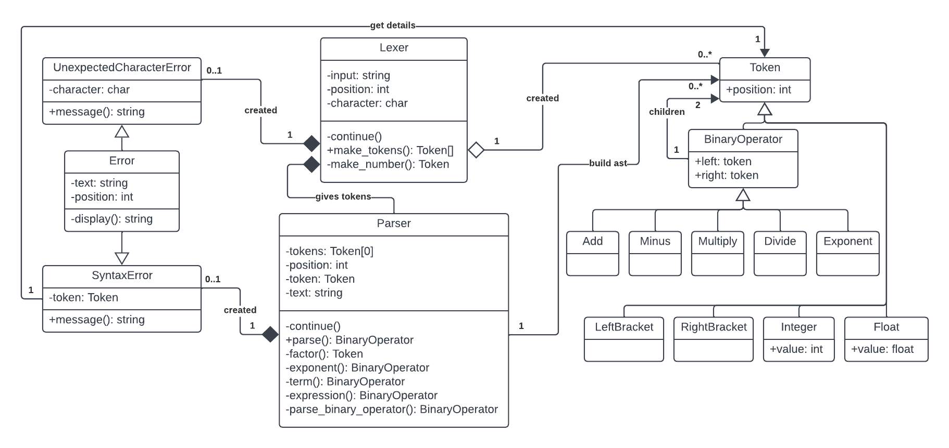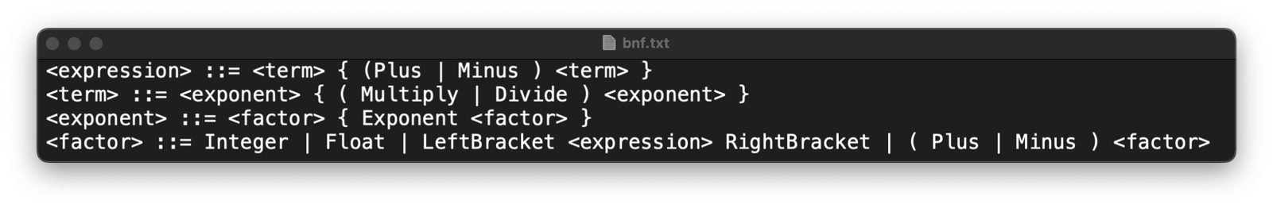Now let’s get back to our implementation and have a look into how our properties will allow us to parse according to our BNF rules.

### Token updates

No huge updates in terms of new code, but mainly additions of small features:

🡺 Position attribute given to all Token classes.

This allows for error handling to still use the display() method in the parsing stage.

🡺 Binary Operator class is a parent class of all arithmetic classes.  
🡺 All Binary Operator classes given properties for left and right child nodes.

This allows us to construct abstract syntax trees using the Tokens, but it is the new Parser class which changes these left and right properties to the correct values.

### Errors

The addition of a new Syntax Error class for the Parser to use. This will take in the parameters of the text and the token which caused the error to occur. It will use the position property of the token for the display() method, and the new message() method will be updates based on the token which flagged the error.

### Parser

The main addition. In its constructor class, it will take in the stream of tokens from the lexer, which will be stored in the Tokens’ property, as well as the original text, stored as text, to be passed to any syntax errors that occur so the correct message will be displayed.

It will also include a position and token property, which are direct equivalents of the position and character properties in the Lexer, allowing us to cycle through the tokens and keep it consistent.

🡺 continue()

Again, replicated from the Lexer, incrementing the position on each call, and setting the token property to the corresponding token in the tokens list. This will also set the token to null if the length is exceeded.

🡺 parse()

This is the main method to be called, which will return the Token which is at the top of the abstract syntax tree. This token will therefore contain every other token as its children and grandchildren, and the result will be used in the final stage of code execution. Additionally, it may also return an Error if any problems occurred in the parsing process.

In the future, this method will also recognise which “type” of line the code is. For instance, whether it is an assignment, an if statement, or just an expression. It would then call the corresponding method for whatever is required. However, for now, it will call the expression method, as we are only parsing arithmetic expressions, so this is the correct method to call, and will return its result.

Finally, after the expression() method has been called, if the current token is not null it means that the entire stream of tokens has not been parsed, meaning that there was an error in the syntax. In this case, it would mean that there were two literals in a row in the expression, as otherwise the expression would be able to be continually parsed, so therefore a Syntax Error is returned, with the current token being passed into it.

🡺 parse_binary_operator()

This is our generic property which we discussed in our explanation. Therefore, it takes in the next property to be called and an array of the corresponding tokens. In addition to this, we will require error handling to be implemented throughout the parser.

The way I will deal with errors is that every time the next property is called, I will check if what it returns is an instance of an Error. If it is, only that will be returned, rather than building the error into the abstract syntax tree. Therefore, if an error occurs at any stage of the parsing, it will be passed up through all the stages of parsing, back to the parse() to be returned. This means that every time a different method is called in our code, we will be checking if the result is an instance of the Error class a lot of the time.

Apart from that, this method works exactly as we expected, but also calls the continue() method in the correct places, as I decided to abstractify that detail in the example to make it simpler.

🡺 expression()

Calls the parse_binary_operator() method with the next method parameter being the term() method, and the array of valid tokens being Add and Minus and returns the result. This is the equivalent of the <expression> line in our BNF.

🡺 term()

Calls the parse_binary_operator() method with the next method parameter being the exponent() method, and the array of valid tokens being Multiply and Divide and returns the result. This is the equivalent of the <term> line in our BNF.

🡺 exponent()

Calls the parse_binary_operator() method with the next method parameter being the factor() method, and the array of valid tokens being only Exponent and returns the result. This is the equivalent of the <exponent> line in our BNF.

🡺 factor()

This stage is more complicated than the prior stages, as there are a few different cases in our BNF representation, as it as a more complex line than the prior.

Firstly, we check if the current token Is either an Integer or a Float, and if it is we return that token, as a <factor> can be either an Integer or a Float

Secondly, if the current token is a LeftBracket, then we continue() past it and call the expression() method. This is important as it ensures that any arithmetic inside of brackets is executed first. After the result is obtained and checked for errors, it is important to make sure if the next token is a RightBracket. If it is, then continue() is called and the result from expression() is returned. This removes the brackets from the AST, as they do not hold any value apart from indicating the precedence of the operations. If the next token is not a RightBracket, then an error has occurred and must be created and returned.

Thirdly, unary operators can exist. This allows negative numbers to exist, as otherwise an error would be flagged if -7+3 was entered into a calculator. So, if the current token is a Plus, then we continue() past it and call the factor() method again, returning the result after checking for errors. This recursion allows inputs like ++++++++3 to also work, which is as intended.

If it is a minus however, we still call <factor> again, but instead of directly returning the value, we return a new Minus node, with the left child being a new Integer token with value 0, and the right being the result of factor(). This may be a slightly lazy solution, but it seems like an easy method, and allows the recursion to still function, so that inputs such as -+----+--+++-12 are still valid.

Finally, for error checking, if the current token was not an Integer, Float, LeftBracket, Plus or Minus, it means that an error has occurred, and that there were likely two operators entered in a row. Therefore, this must flag a syntax error, passing in the current token as the reference. Now the <factor> line of BNF has been completed so our parsing is complete.

# bodmas execution

For this final addition, no extra main class is created for execution, but instead the Token classes are finally getting expanded to include some significant code.

The concept behind has already been explained prior, but in short, all Tokens which could end up being incorporated into the abstract syntax tree (excluding punctuation therefore) all have an evaluate() method.

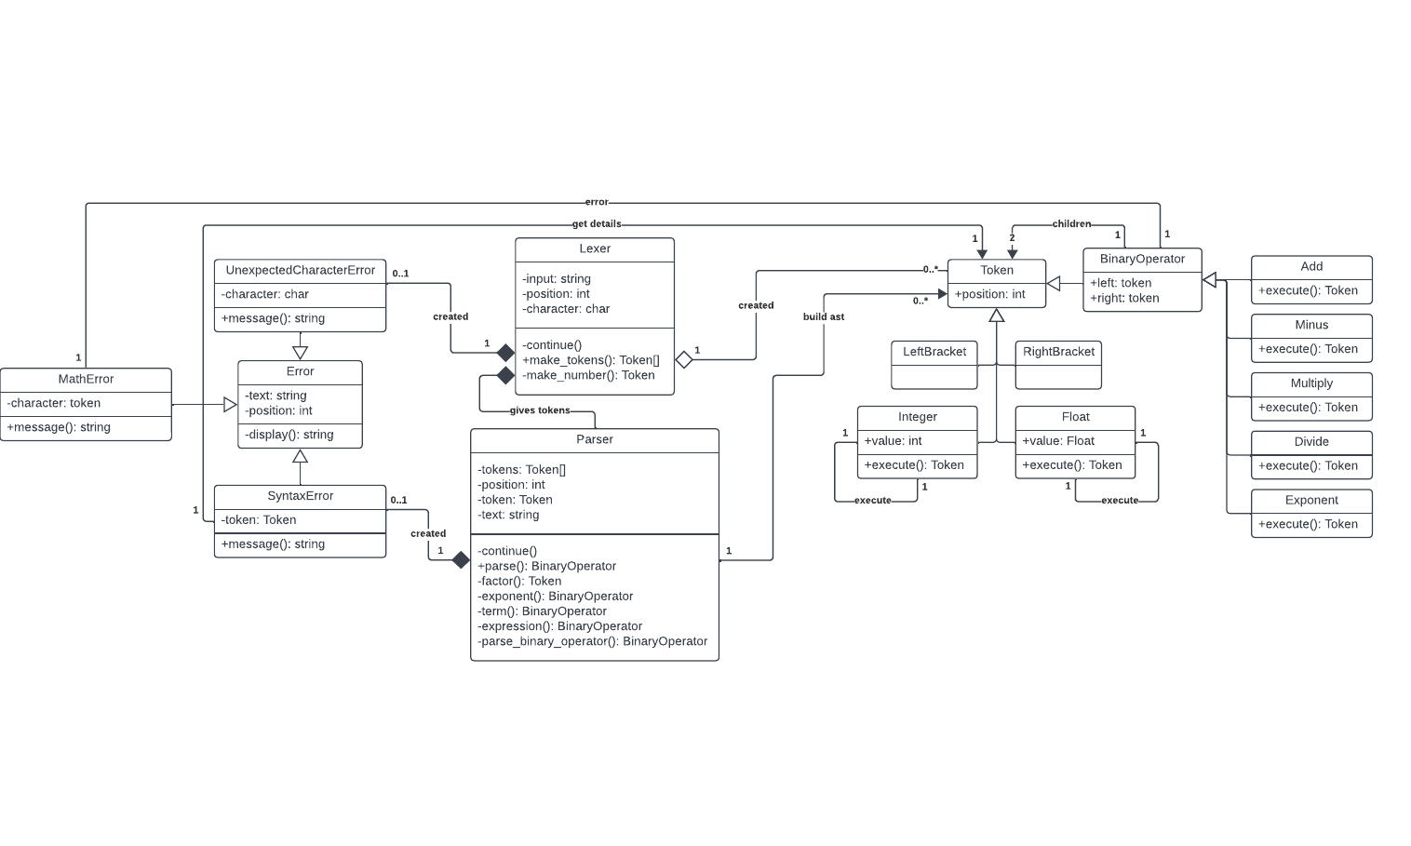This will return their “value”. This is simple for Integers and Booleans, which return their own value property when their evaluate() method is called. For binary operators, they will call the evaluate() method of their children and then operate on that instance. For example, the Plus tokens’ evaluate() method will return left.evaluate() + right.evaluate().

This stage is relatively simple to implement, but error handling also needs to be considered.

🡺 Math Errors

Some arithmetic operations are illegal. The two instances of this are attempting to divide by 0, as well as raising certain negative numbers to certain powers which create imaginary numbers. Therefore, in the evaluate() method of Divide and Exponent, we will check if this occurs, and if it does, we return the new Math Error. Then, we need error checking in every Binary Operators evaluate() method to ensure that if either of its children returned an error, it returns that error too, without crashing the program by trying to perform arithmetic on an object.

So, therefore to execute the abstract syntax tree, we just call the evaluate() method of the root node, and from there the program should execute, and we can output the result.

Development

I’ve had some experience with JavaScript in the past, but I still make a lot of small syntax errors, some of which I will be including, but a lot I will be excluding for the sake of conciseness.

# Bodmas lexer

## Character cycling

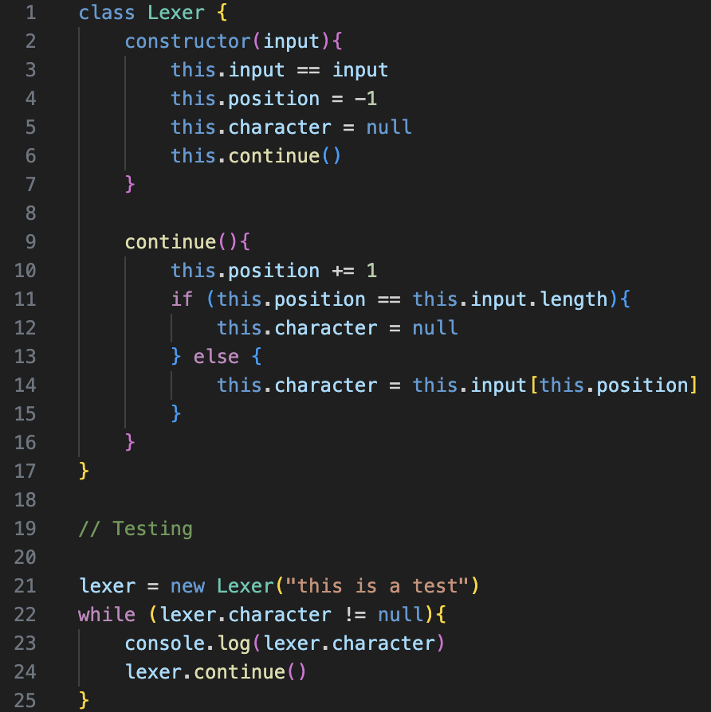I’ll start by creating our Lexer Class, which will follow the description in the design section. A lot of the time when writing a new section of code, I will do a quick test at the bottom of the file to ensure that it is working, and will sometimes show the errors, such as now, but a lot of the stupid small syntax errors I may include.



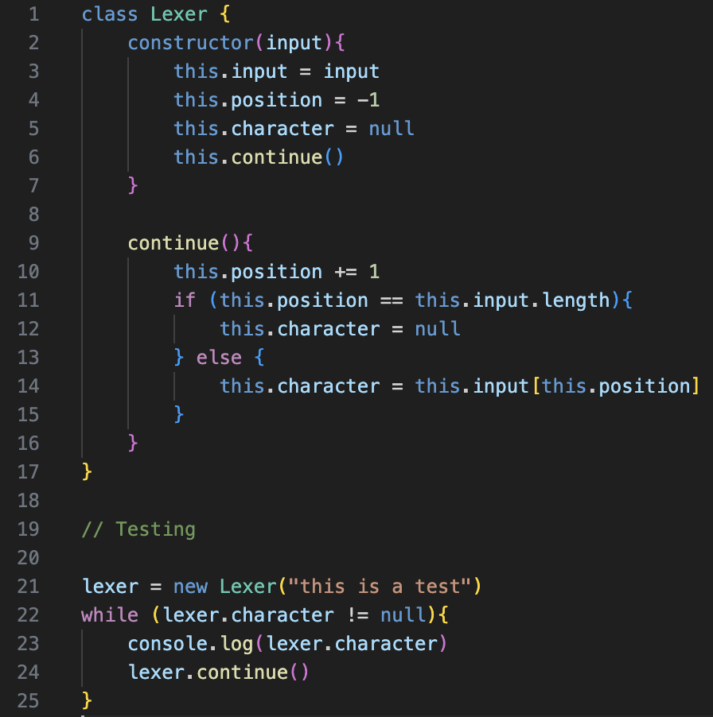This is one of those examples, where I accidentally used == instead of = in the token definition, which cause a runtime error. After fixing, it shows that the continue() function works as intended, and the output has been rotated for space saving reasons.

## Token Definition

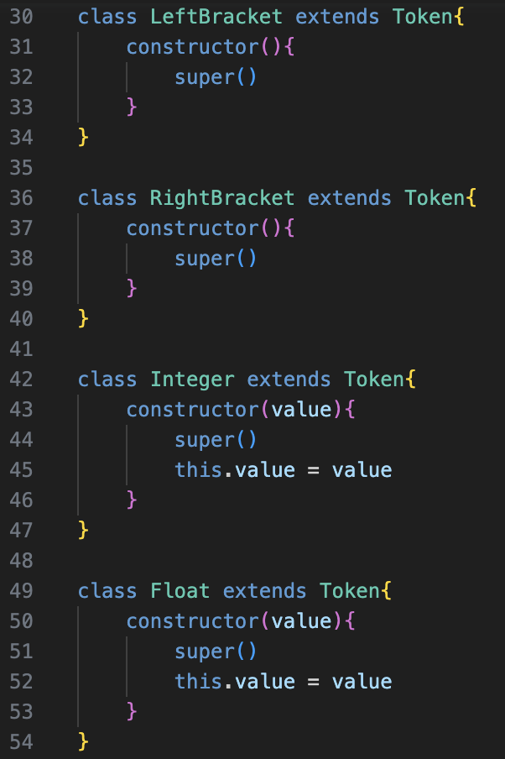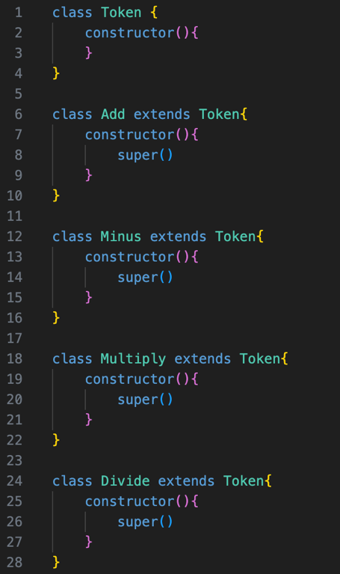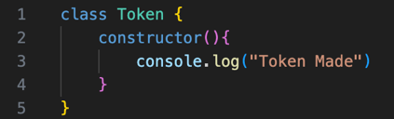Again, another straightforward implementation, with a temporary line being added for testing purposes.



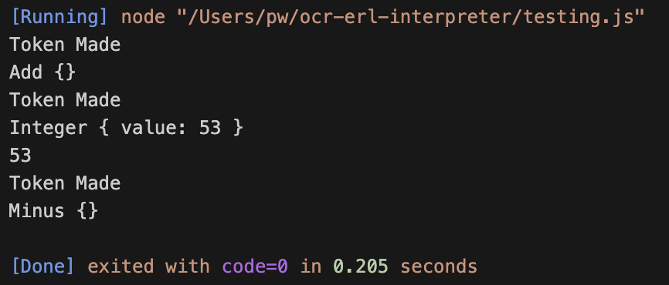

The intended values are returned, so therefore the tokens function correctly.

## Basic token generation

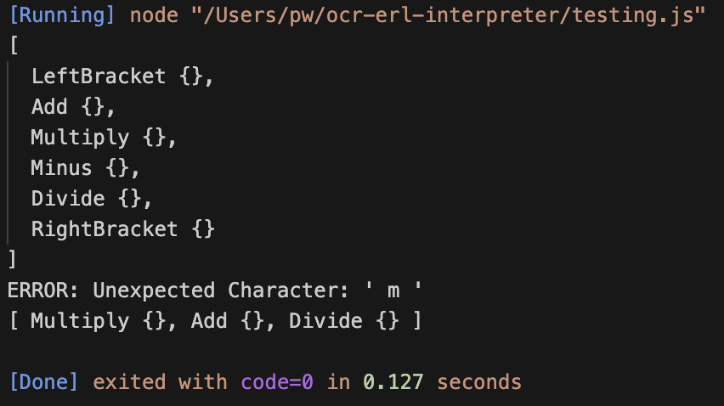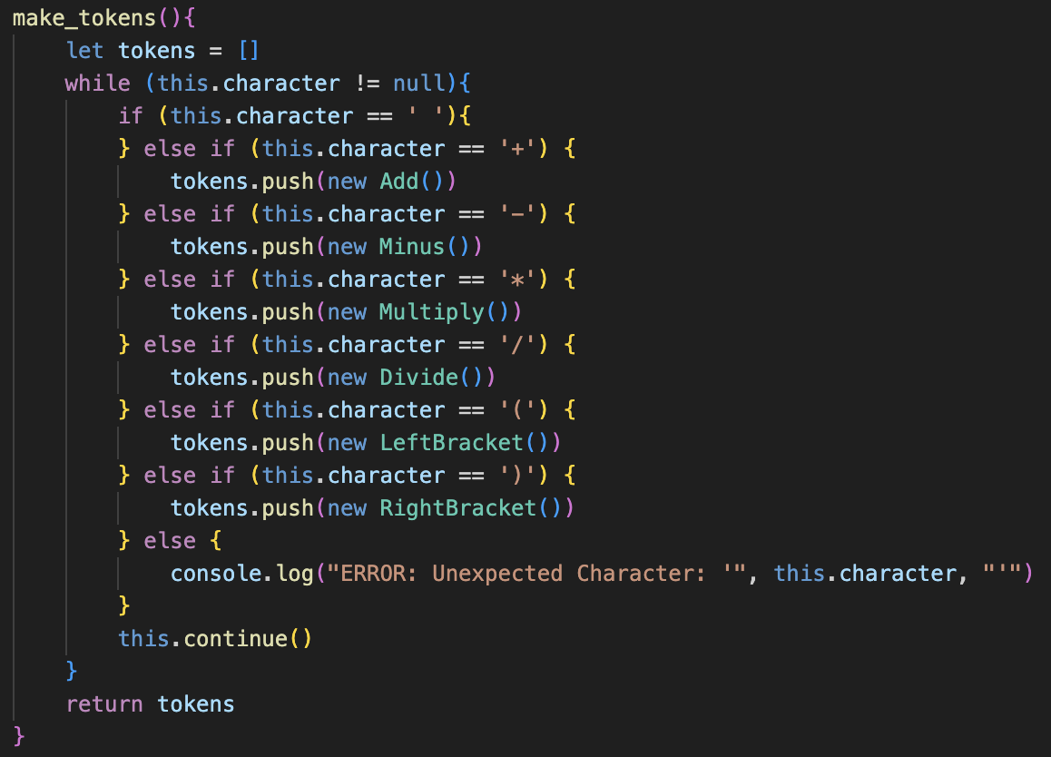All working, using a directly printed error message temporarily

## Number tokens

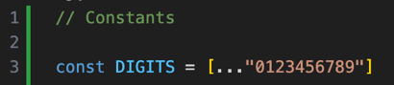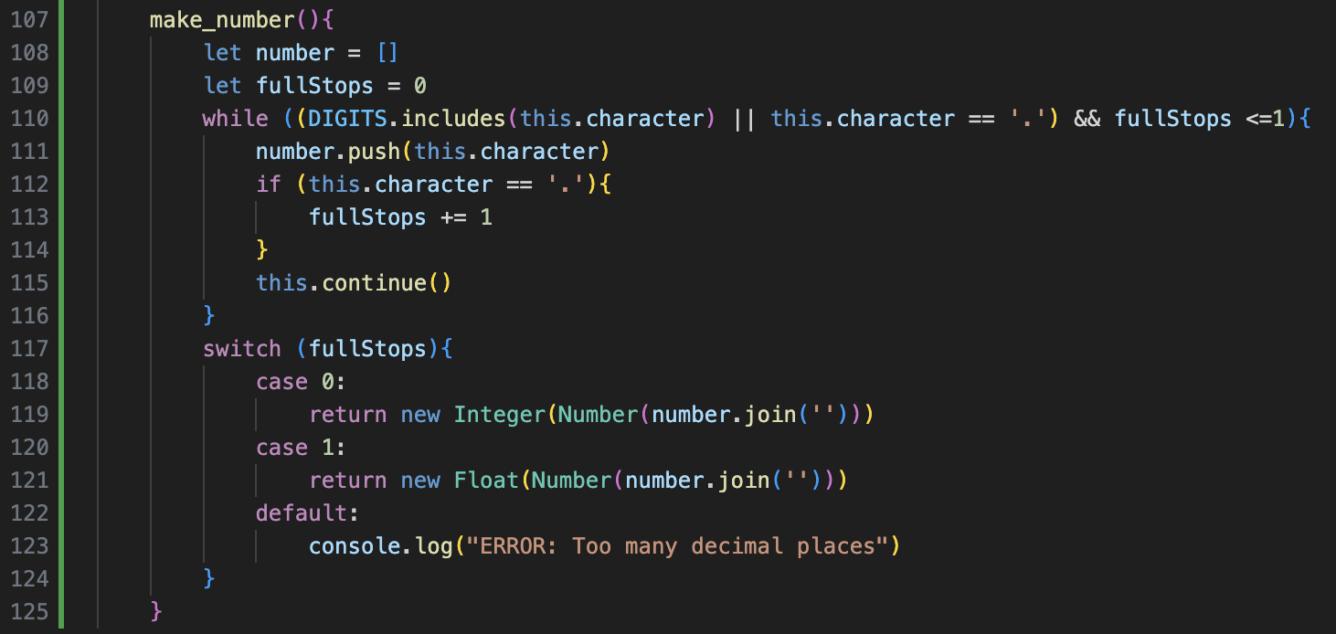DIGITS is declared globally as a constant so it can be re-used.

The make_number() method is added much like in the design description, but the while loop also checks about the number of full stops continually, so no unnecessary cycles occur when the number format is invalid.

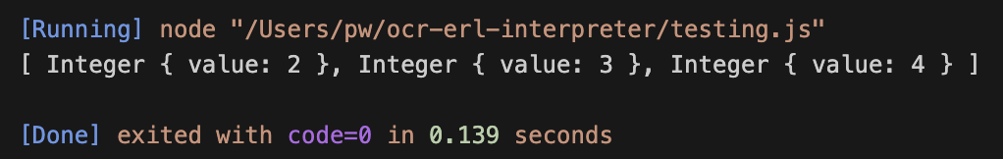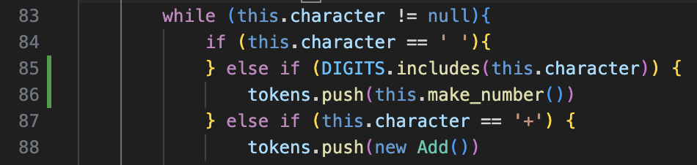The make_tokens() method is also changed, so that the current character is checked if it is a DIGIT, and if it is the make_number() method is called, and the value that it returns (an object) will be pushed to the end of the list of tokens.

When this new implementation was added, the output was incorrect. Somehow, only the integer values were included in the final result.

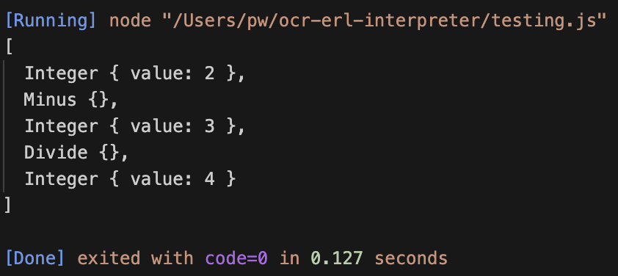This led to me doing a series of small tests to debug the error. My initial thought process was that something went wrong with the make_tokens() method with the new addition of the DIGITS checking, however, the following case of testing made me realise that the symbols could still be parsed, but it was just the character directly after the number that was skipped, which had to be something to do with the continue() method being called incorrectly, because only the symbols directly following a number were ignored.

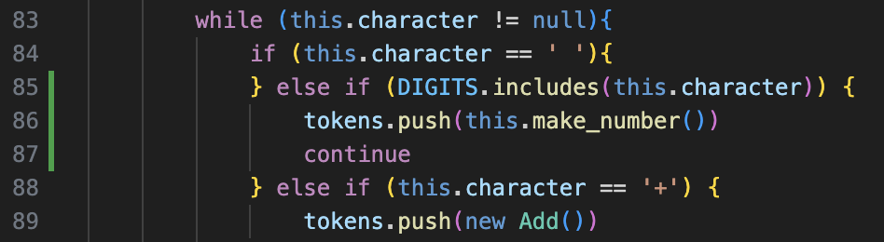I did then realise the continue() method was called twice after a number was completed, once in the last iteration within the make_number() loop, to check that the next character is not a DIGIT, but then it is also called at the end of a cycle in the make_tokens() loop, which therefore ignores a character.

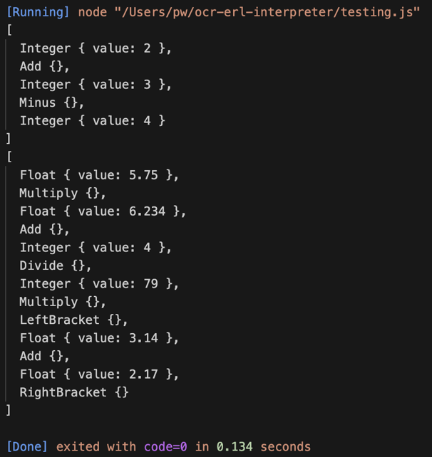The solution to this is including a continue statement in make_tokens() at the end of where a number is created, which skips to the next cycle of the while loop without completing the rest, which therefore ignores the continue() that will come.

Although not the cleanest solution, it avoids a lot of repeated code that would have to be included if continue was called individually in every other character check.

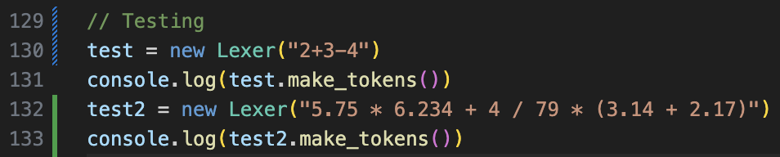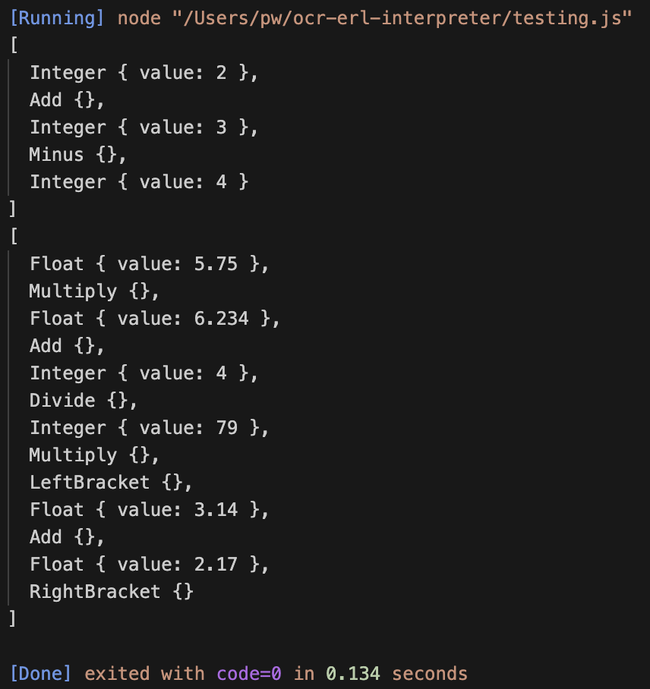Just to ensure the solution is working as intended, I completed the following tests and it was proven a success.

## Error handlIng

### Displaying Error message

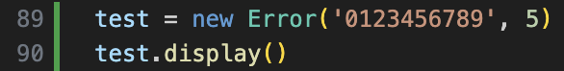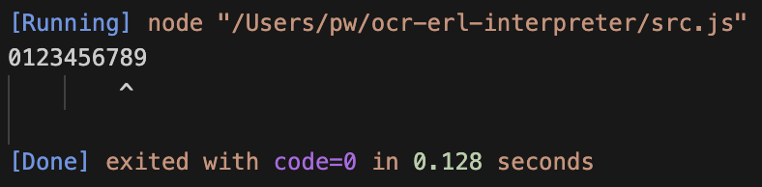This was my initial attempt at creating the display() method, which involved repeatedly adding a space to a list, and my test case expects the arrow to be pointing at the 5.

This is clearly very far off what is expected.

I first realised that using commas for string concatenation automatically adds a space to the string, which would add 2 incorrect spaces, so therefore + can be used instead, to remove this source of inaccuracy.

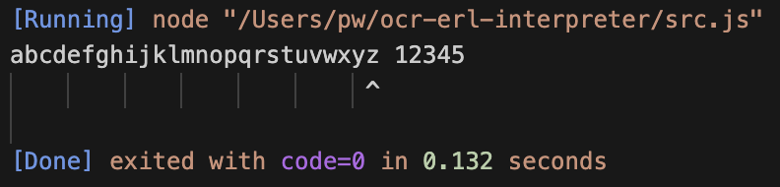However, this still didn’t fix the solution, as there was still one more space that had been falsely introduced, and this was because I used a <= comparison in the loop rather than using a <, so after this had been fixed and tested, it produced the correct result, and even worked with one, longer test just to be absolutely certain.

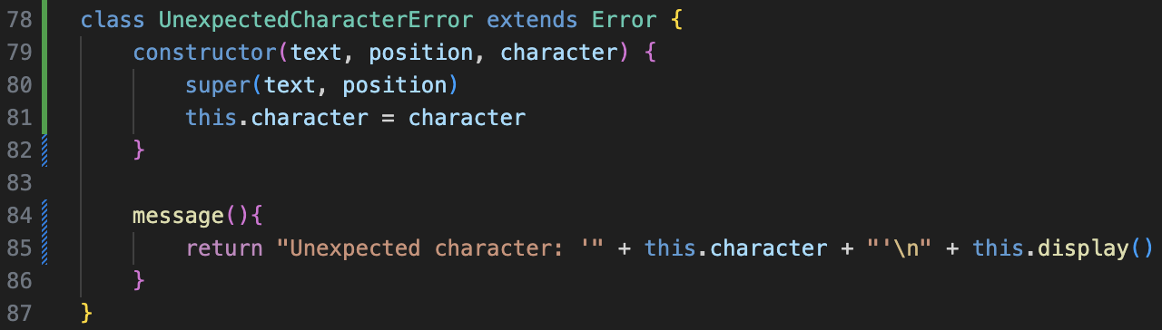

From there, creating the Unexpected Character Error class was very simple, and the test case correctly worked first time.

### Errors implementation

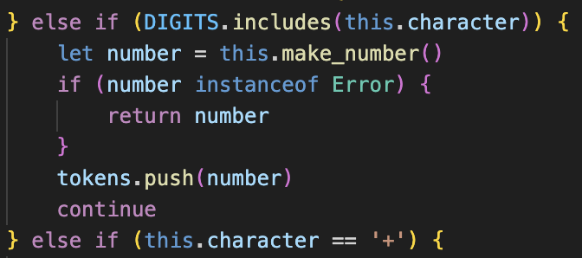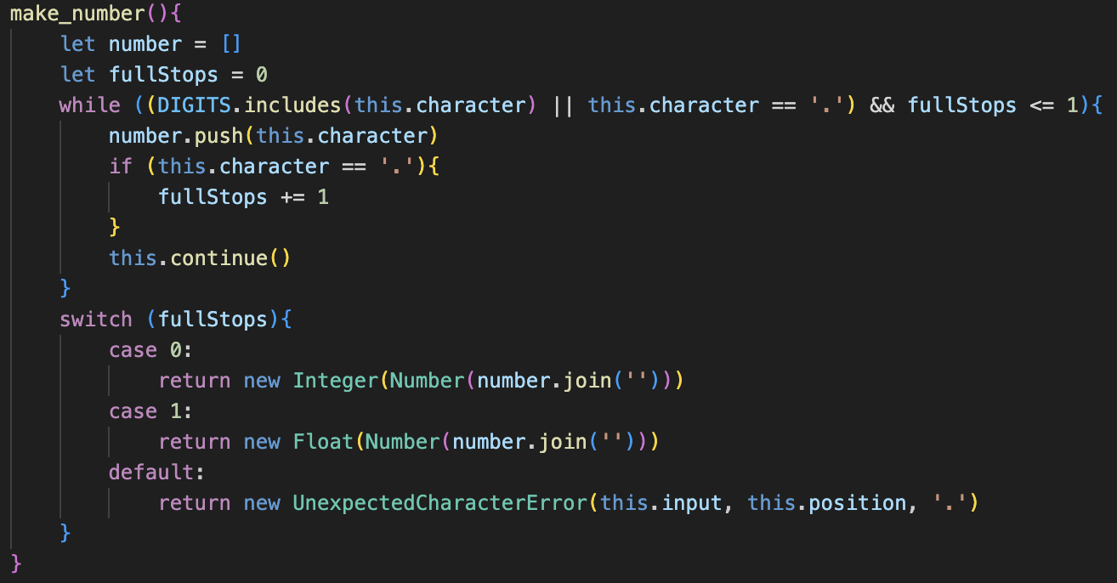Firstly, all the temporary Error print statements can be directly replaced by returning a new instance of the Error in make_tokens() and make_number()

However, when an error is returned in make_number(), it would currently just add the error to the tokens array, so we need to check if what is returned from make_number() is an error, and if it is we return that error in the make_tokens() function, which would stop processing, and otherwise we would just add the result to the end of the list as per usual.

For the medium-term, I have created a new Run class, which I am not planning to keep in the long-term solution. However, for now, it will be useful to link the different stages of lexing, parsing and code execution and will speed up the testing, as the whole sequence will not have to be rewritten, and can all be tested with one line.

We now must test all of the different types of errors to ensure that they work as intended.



Unexpected character errors work as planned, but errors with too many full stops in make_number() return the error with the wrong position. This could be fixed by changing the argument in the Error’s constructor method to this.position – 1, however I decided to refactor the whole code for the sake of it.

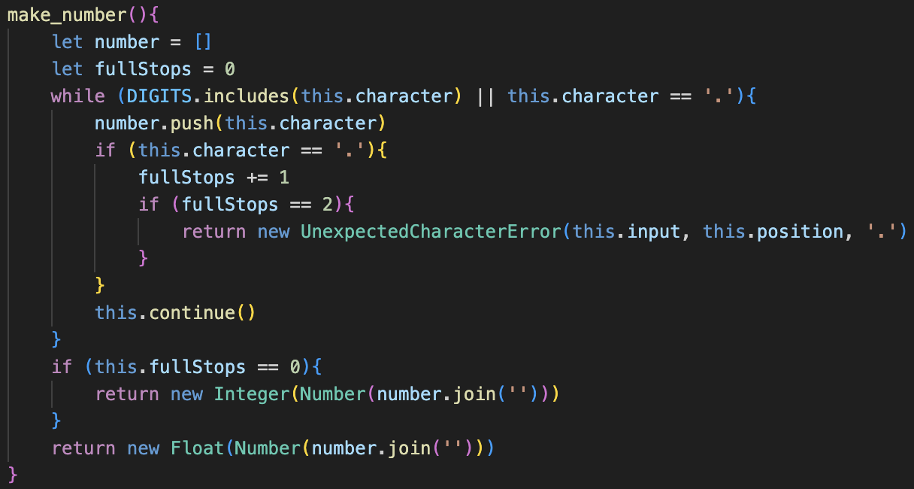This new method no longer includes checking for full stops in the while clause, and instead does it inside of the checking for full stops if statement, where the error is directly returned then, rather than after calling continue so the position will be correct.

It works properly now.



It is still important to check that it works without any errors at all, and it turns out that the new make_number() had a small syntax error (writing this.fullStops instead of fullStops), showing the importance of re-testing, which allowed me to correctly restore the function of the program.



## Cleaning Up

Although I have now added all the features that I want for this stage of development, I think it is important to come back and refine previous code, adding commenting and making improvements so that I don’t get as confused when I return later in the development process.

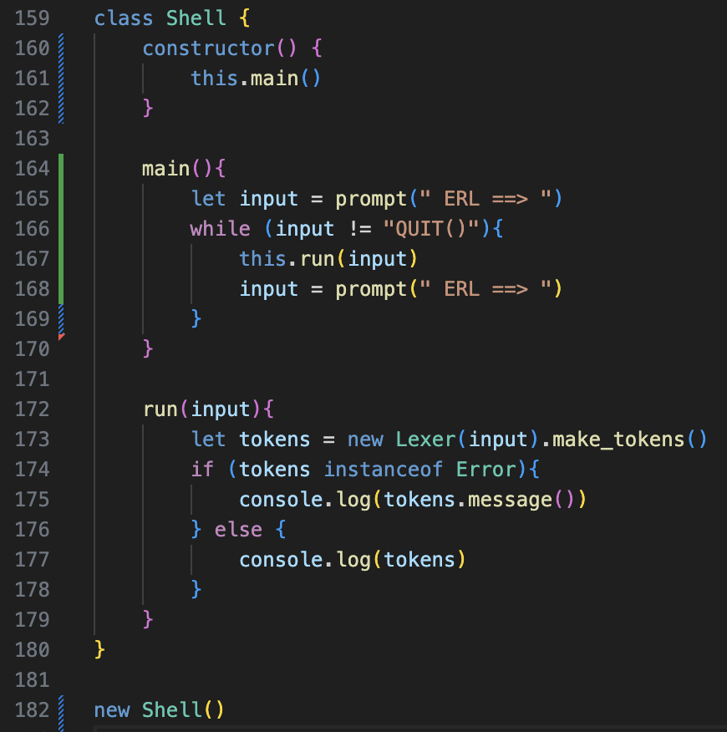I firstly changed the old Run class into a new Shell class, which I planned to be an even easier version to use, which would make testing significantly easier for the rest of development, by taking a direct user input.

My lack of experience with NodeJS began to show, as it took a very long time for me to find a working user input, as my first two attempts completely failed, and some methods used techniques I was not comfortable with, such as asynchronous methods, which I felt were a bad idea to use as I would have no idea how they worked, so I decided to use prompt-sync for inputs.

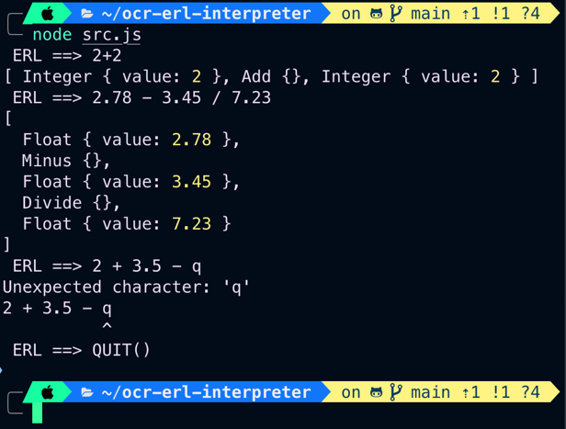

This is, again, a medium-term solution, as the final version will take the user input in graphically on the website page, but for the development of the translator it will work, and I have decided to use an arbitrary “QUIT()” input to exit the program.

In further research of JavaScript shortcuts, I discovered template literals, which are an easier way to concatenate strings, much like the f-strings of python but requiring a $ sign, which I implemented into Error messages for greater readability, and tested.

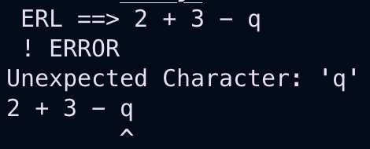Additionally, the repeat method saves needing counter-controlled loop in the display() method of the Error Class, which simplifies the code significantly. I also tested this to ensure it still correctly worked.

The next useful feature is the conditional ternary operator, which can be used within JavaScript with an expression ? statement : statement syntax. It is the equivalent of checking if the expression is true, and then returns the first statement if it is true, or the second if it is false, and removes redundant if statements.

For example, I used it within the continue() method, to check if the position is equal to the length, which then sets the current character to null if true, or the corresponding character if false.



Other examples include in the fullStops statement, to check whether to return an Integer or a Float, as well as checking if what has been returned from the Lexer is an error, so the Shell instance can output either the object or the message property of the object if it is an Error.



# ParseR

## Addition

### A screen shot of a computer Description automatically generatedBasic addition

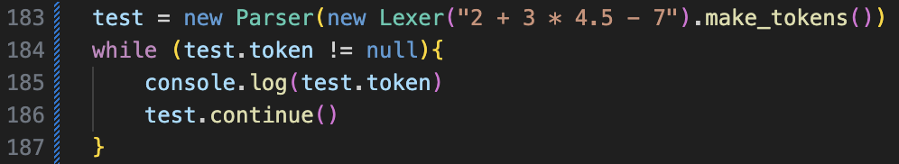Copied from the Lexer, works as intended with the test.

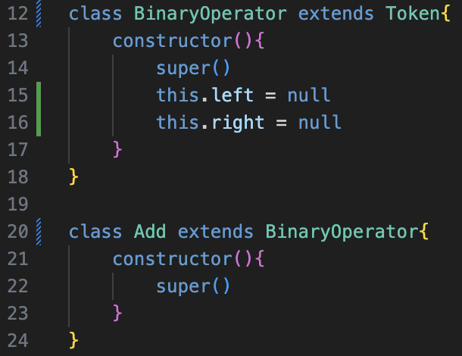

Added the Binary Operator class which extends Token, and then changed Add, Minus, Multiply and Divide to extend it as well. This just reduces code repeating.

Then began implementing the expression() method, which will use the following code for every single test that I do, so the end goal is to have an Add token, with the left child being an Add token with 2 Integer children of 2 and 3, and the right being an Integer 4.



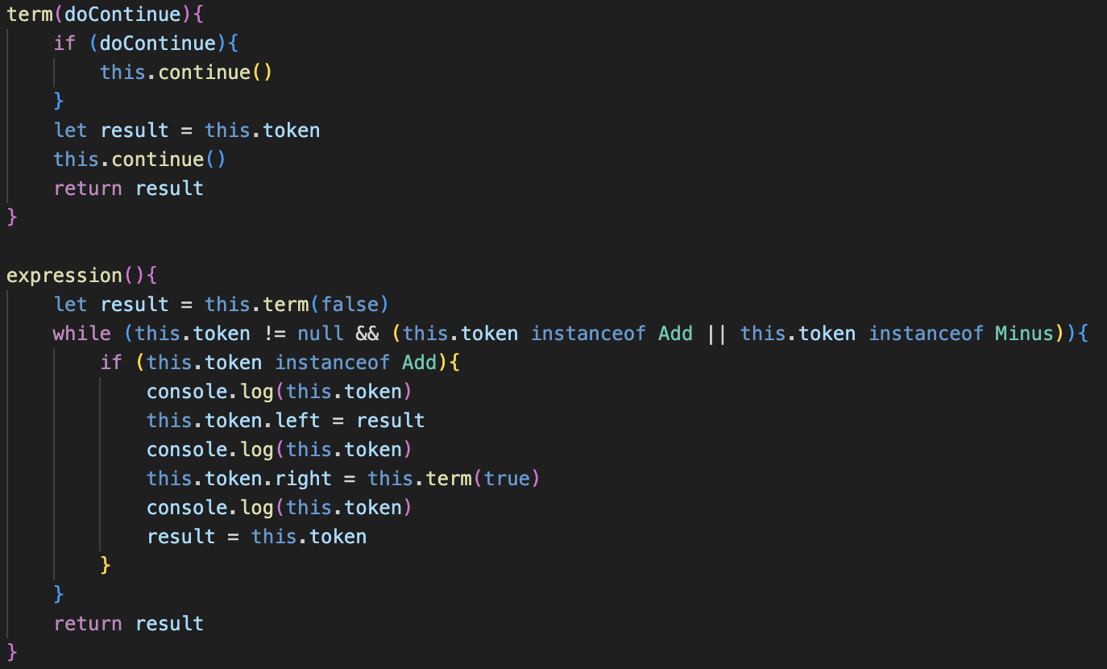This was my first attempt at getting the parser to work. My initial thought behind the doContinue parameter is that I would not have to create additional variables to save the current token to before using the continue() feature. This was, with hindsight, a very messy implementation, but at the time the term() method was only temporary so I thought I would come back later and alter it.

Regardless, when trying to run the console didn’t output anything so it was non-functional.

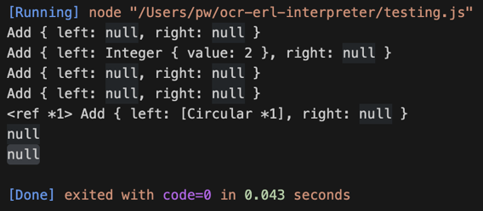When trying to add output statements to help to debug, it was very clear my code did not work, but this output didn’t help my thought process much: the <ref *1> and [Circular *1] completely confused me so I then decided to add even more output statements to the term() method to see if that would provide any more insight.

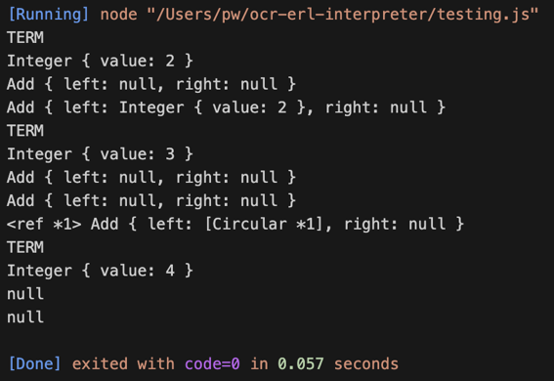Adding this made me realise that the first element of the process worked: with the term being correctly yielded and set as the left child of the Add, however when the send term() was called, the Add token suddenly had removed the left child and the right child and they were both back set to null like before.

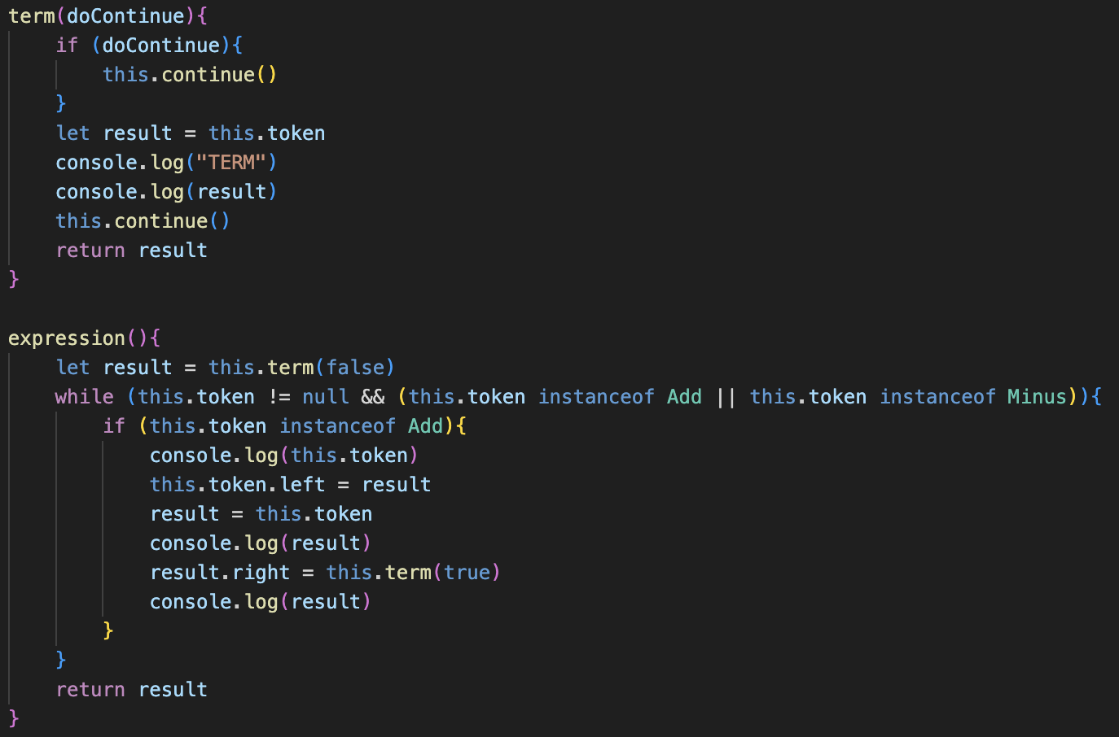However, this would not have been possible, so the issue was that the program had already proceeded to the second + node, and continued from the first which revealed the main problem: using this.token was not the correct approach for changing the properties of the Add node because it would change when the other properties were called due to the object-wide nature of the continue() function.

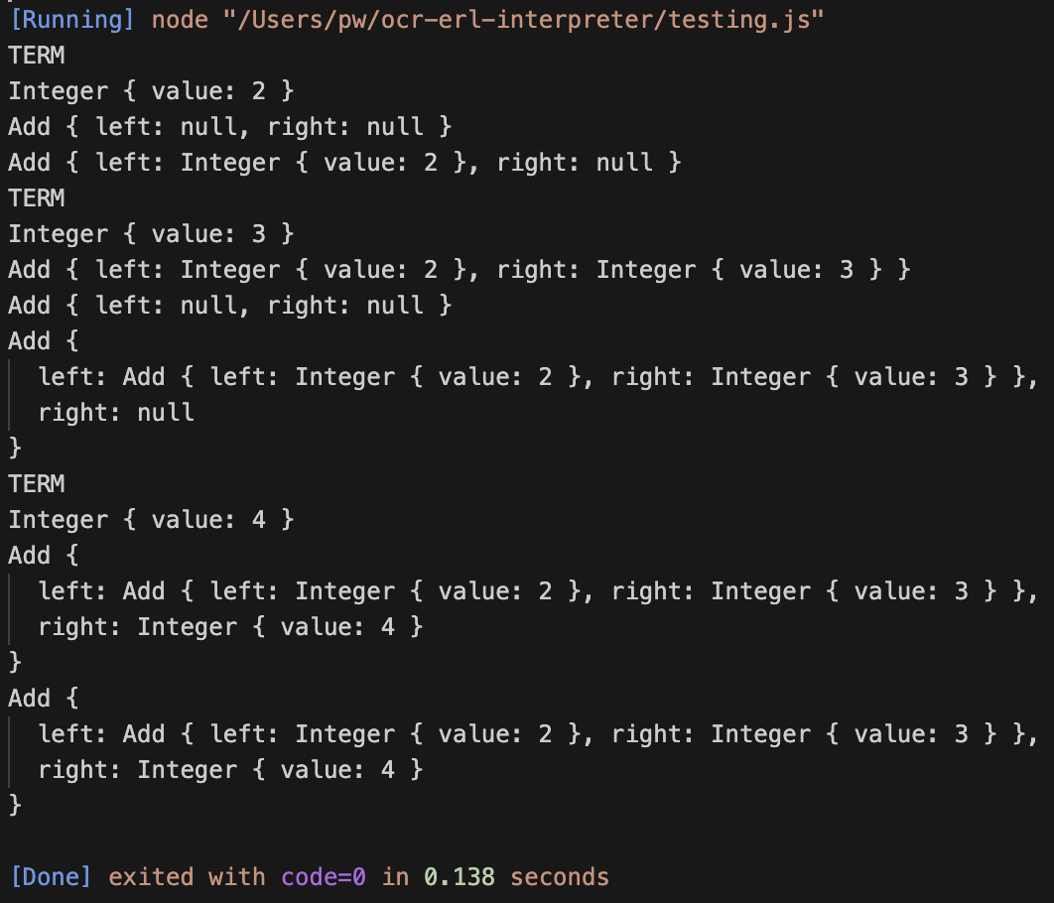Therefore, I would be forced to re-use the result variable throughout the program to ensure that I was modifying the correct token’s properties, and when changing the output statements to correspond with this, the program produced the expected result.

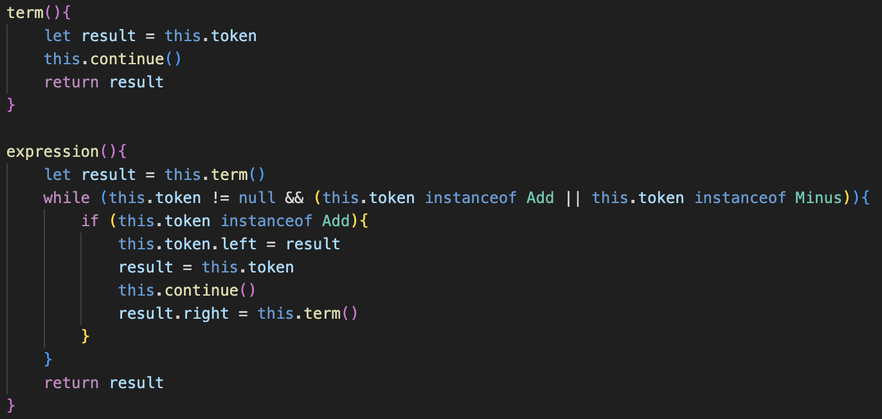From there, it was a matter of removing all of the output statements and therefore the code still worked as expected.

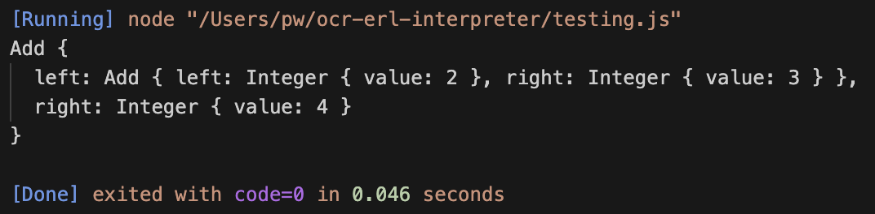Furthermore, I also realised I could further remove the messy doContinue implementation, as the fact that the current token was stored in the result variable meant that I could implement the continue() call in the expression() method rather than at the start of term(), which significantly cleaned up the code and still produced the correct abstract syntax tree.

## OTHER OPERATIONS

Now I needed to add the three other arithmetic operations

### subtraction

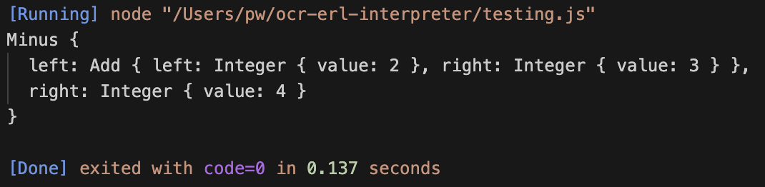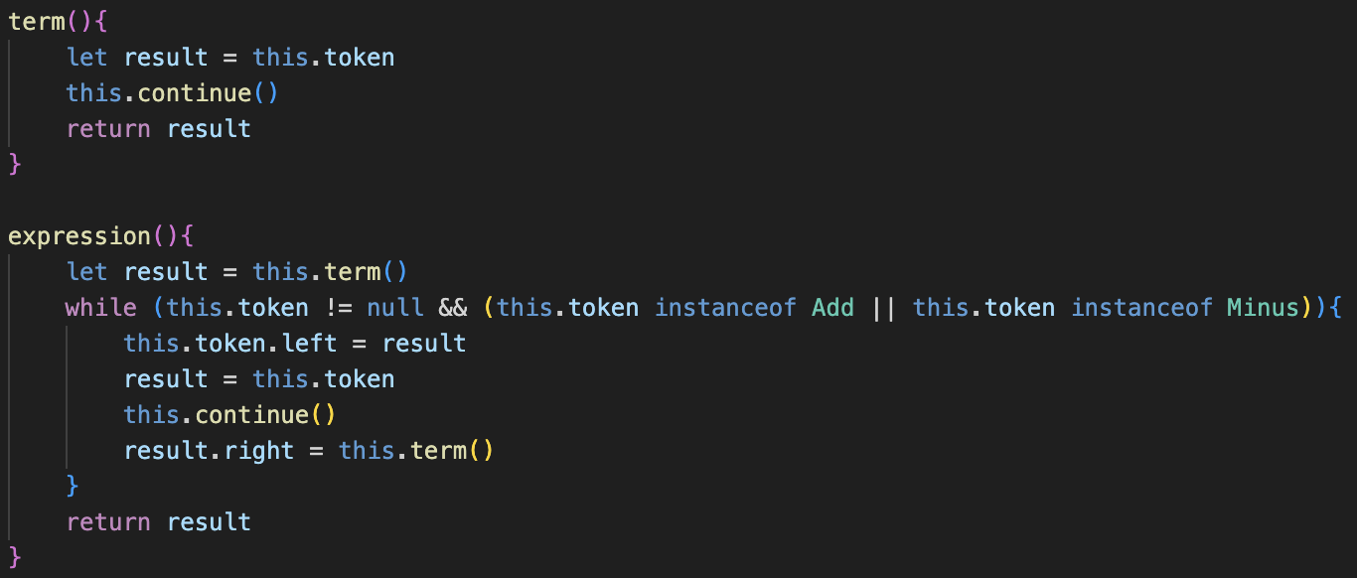This was extremely straightforward and even helped to modify the code from earlier, as I realised that that if statement which checked it the operator was a Plus or a Minus was completely redundant, as the same step of operations would be carried out regardless of the type because they had identical precedence.

This further simplification allowed the code to work for both addition and subtraction.

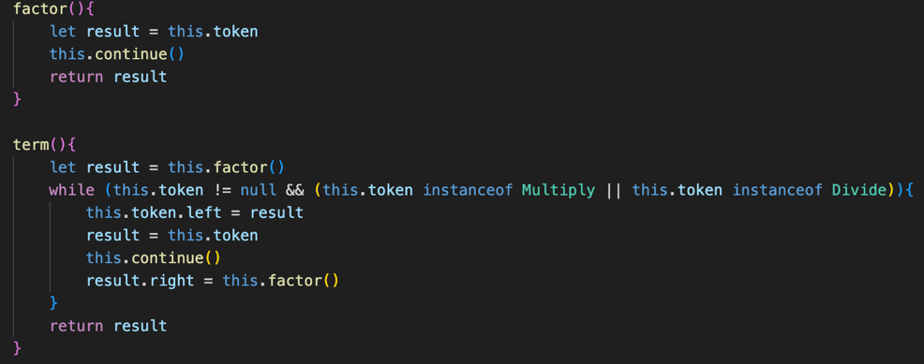From here, adding Multiplication and Division was a matter of duplicating the code from expression() into term(), and changing Add and Minus to Multiply and Divide. Finally, the old term() method was renamed to factor(), and from there it correctly builds the abstract syntax tree.

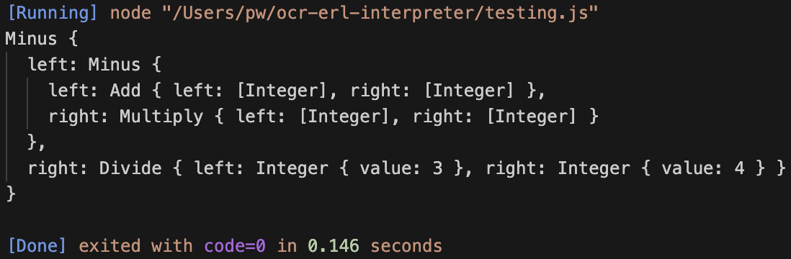However, this is a lot of repeated code, because the expression() and term() are identical apart from the next method and tokens accepted, so the next stage is implementing the generic method which will be able to make our code a lot more efficient.

## generalising.

This new method was not involved in the plan, but I thought it would help improve the code readability. It will be used in the parse_binary_operator() method, and it takes in an array of classes. It then checks if the current token is an instance of any of the classes and returns true or false accordingly.

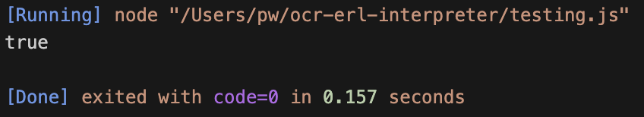It will be clearer when we implement the main method as to how this is used, but for now the test performed as expected so I continued to develop the generic method.

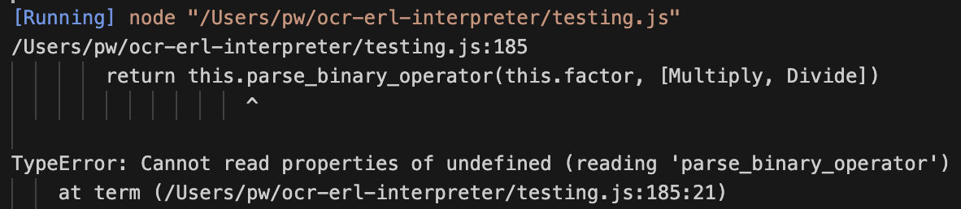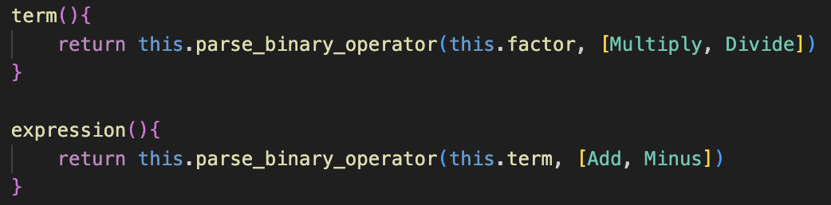The first trial was again, duplicating the code from the original expression() method into parse_binary_operator()

I decided to name the parameter for the next method nextFunction, which is potentially slightly inaccurate naming (nextMethod may have been better), but it still relays the meaning of the code.

This is where check_instance() comes in, as we pass it the correct tokens to cycle through, so for expression() it is Add and Minus, and for term() it is Multiply and Divide. It is essentially the same as the old or statements that were in the old examples however now it works for a list of tokens of any size, and the separate method makes the code a lot easier to read.

Now we can replace the old term() and expression() methods by making them simply call the parse_binary_operator() method, with their corresponding values.

However, instantly an error occurred, with the message saying that parse_binary_operator() was undefined. At first, this confused me, but after some debugging using lots of output statements, I realised that the problem was not with the method itself, but the this keyword in JavaScript.

The this keyword represents the instance of a class in JavaScript, so it can be used to access all of the attributes and methods easily without having to worry in the code about the current instance. However, this is not specific to only classes, but as JavaScript is an object-oriented language, what this references changes based on the context. This was a problem in our case, as when we began calling methods through methods in the way we have, the definition of this managed to change, so that it no longer referenced the instance of our Parser, but instead referenced one of the methods, which had no parse_binary_operator() method associated with it specifically.

This may sound like a complicated fix, but the solution was to replace this with a different identifier which we knew would always reference the parser itself. My approach to this was using self, which would always reference the parent parser, and would be passed as an argument to all of the different parsing methods to ensure consistently arose.

This is how the implementation occurred in the parse_binary_operator() method, with all of the this keywords being directly replaced, alongside a new parameter which – for code consistently – I will always keep as the first parameter for methods which require it.

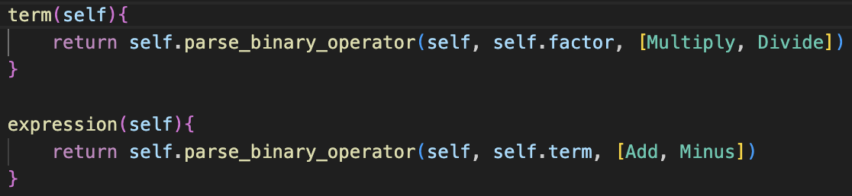This new self syntax would also have to be used in the term() and expression() methods, in order to ensure that the instance of the Parser could always be reference and is passed down through the stages.

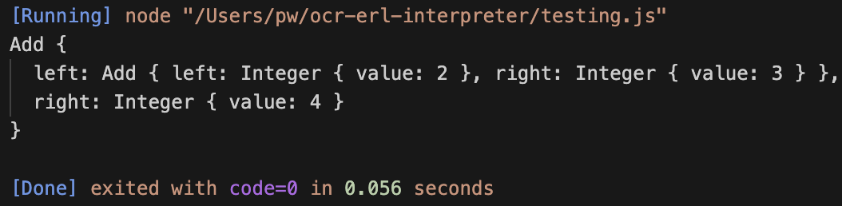The way that self is initially defined is in the new parse() method, which calls the expression method normally, with the argument being this: referencing itself to be passed down throughout.

This may not be the cleanest implementation of this, but it worked so I have used it from this point onwards for the rest of the program.

## Exponents

The whole purpose of constructing our code in this style is so it is a foundation for the future and can be easily expanded to include new features into the interpreters, such as exponents.

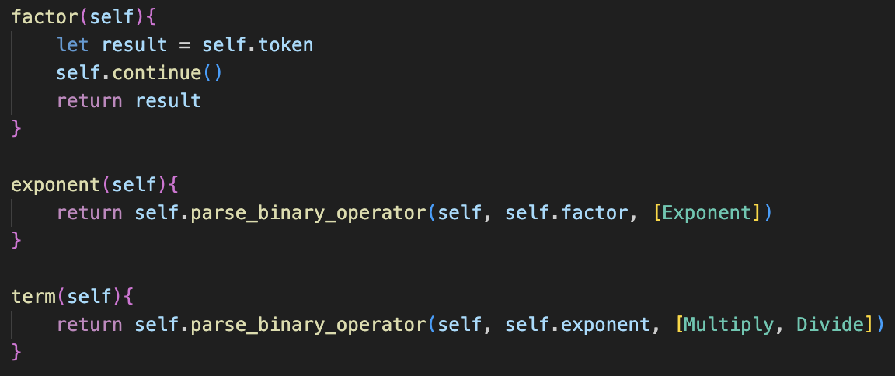In order to add them, firstly the new class must be defined and extend the Binary Operator class, and the make_tokens() method must be extended to include a new line which adds an instance of the Exponent class if the corresponding character “^” is encountered.

From here, as exponents have a higher precedence than multiplication and divison in bodmas, the exponent() method can be added, with the nextFunction being factor(), and the valid token being Exponent, as expected, in an array format as that is needed for check_instance()

Finally, the term() method must be changed to call exponent() instead of factor(), as it has a lower precedence so must call upon it before factor(), as stated in our BNF implementation of our code.

Running a simple test immediately works, without any errors at all at any point in implementation. This shows the positives behind constructing our code in this format, as it is incredibly easy to expand as our approach has been so generalised as to allow for this to occur.

## Brackets

Now that the other lines of BNF have been implemented, it leaves us with the factor() method to work on, for now I will be ignoring unary operators and only implementing the bracket handling.

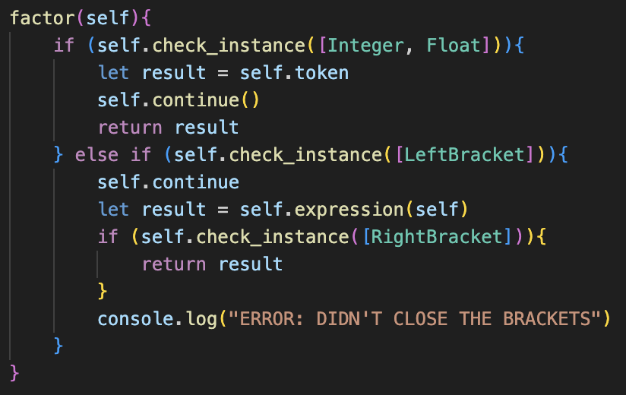My first attempt of implementation matched the description in the design phase. The new Left Bracket check had a temporary outputted error message if the token after expression() was called was not a Right Bracket, to be changed later.

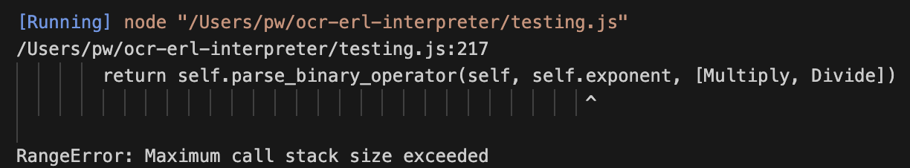However, when trying to run a test, a Range Error occurred stating that the maximum call stack size had increased. This confused me at first, and then I decided to add output statements to the factor() method to see if they would help with debugging.

Again, the same error, but it showed that the program got forever stuck on the Left Bracket token, which made me realise that my continue call was forgetting the () afterwards, which meant that I could not continue past that token which caused this recursion.

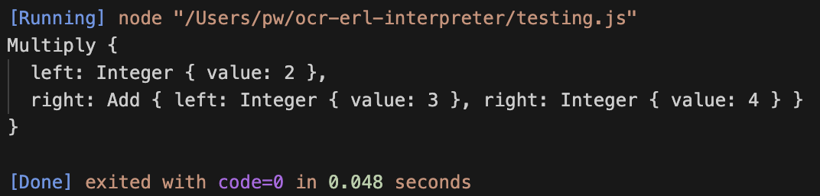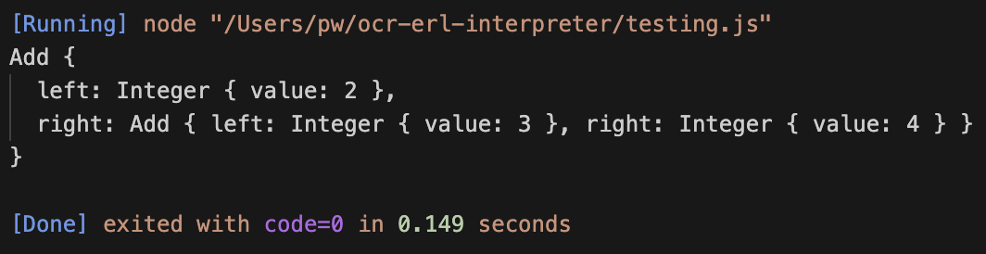

With this being fixed, the test case then worked. The other test cases I thought were important were a case for brackets in the middle of an expression, a case where the brackets were never close, and finally a case with brackets being inside other brackets.

The first case did not work, as after the brackets had close the rest of the tokens were ignored, so the to the power of 7 was excluded from the ast.

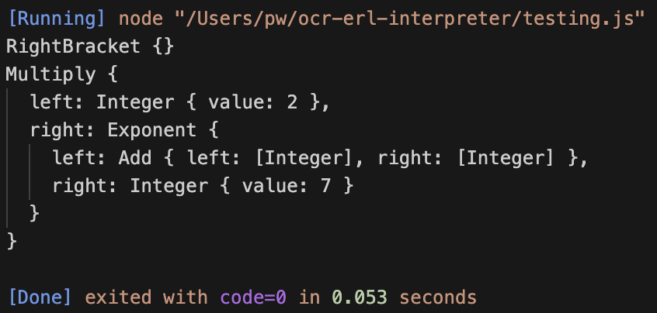After some debugging with output statements, I realised that the problem was that continue() was never called to proceed past the rightbracket, so after that was added the program functioned correctly.

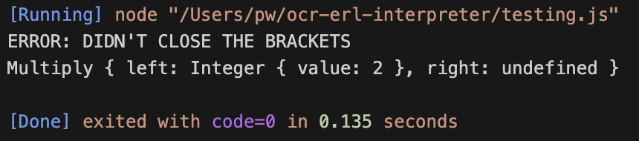Next the non-closed brackets test case was checked, and it correctly outputted the message. Later this will be improved to not also return a half-completed AST a with better implementation.

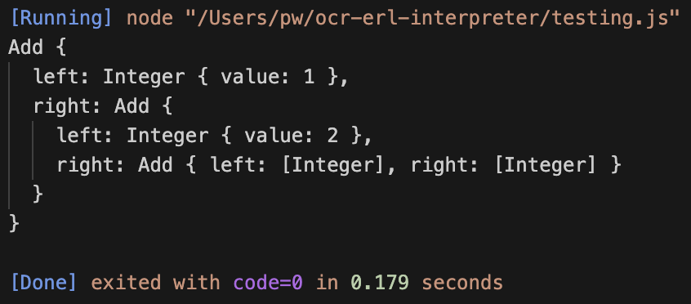Finally, the test case with brackets inside of brackets worked perfectly first try, because of the nature of our recursive implementation.

This now completes the implementation of brackets, with only unary operators required to be added in order to complete the BODMAS parser

## Error handling

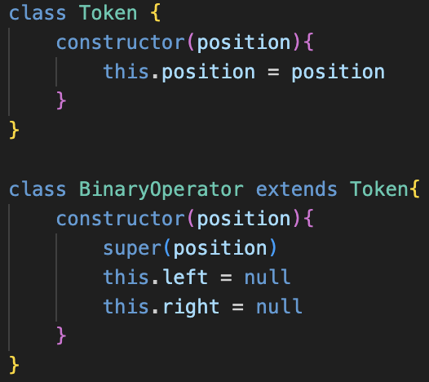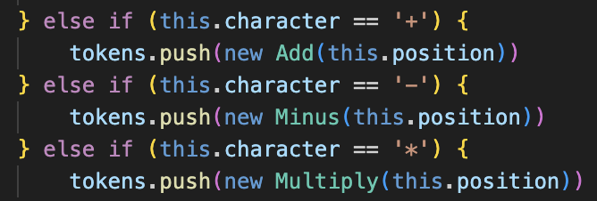As you can see, currently if the input string has invalid syntax, the Parser returns an attempt at a broken abstract syntax tree, rather than reporting an error, which is what the next stage of implementation is going to be, with unary operators coming later in the process.

The first stage is adding a position property to all token classes, which is needed for the display() property in the Error class to point to the error.

Because the position property needs to be given on creation of the token, this needs to be added to the Lexer. Therefore, in the make_tokens() method, the Lexer’s current position is passed into the constructor of the tokens, so therefore the position corresponds correctly with the plaintext, rather than other methods which may cause issues with whitespaces.

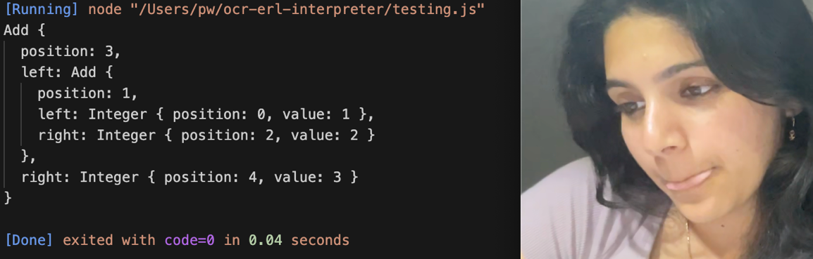For tokens which take up more than one character, I’d like the position property to correspond to the position of the first character, so therefore for the make_number() property, we will have to assign the position to a variable at the start of the property before using continue() so that it is correct, and then use that variable for the construction of the Integer or Float, as shown in the code below.

Just to check that this is correctly working, I ran a quick test and all the positions were correct in the abstract syntax tree.

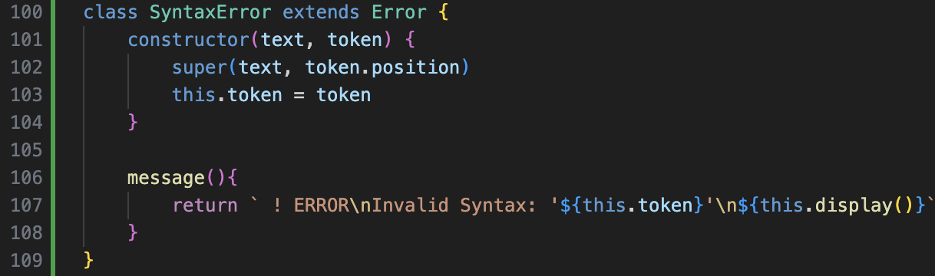Now we can create our new Syntax Error class, but this accepts a token and the text as an input unlike the others.

The position property of the token given will then be passed to the super() call so that the Error’s position can be assigned.

The custom message() for syntax errors has also been added, with the same identifier so that any error can easily be called.

To implement errors, the Parser’s constructor must take in the plaintext input.

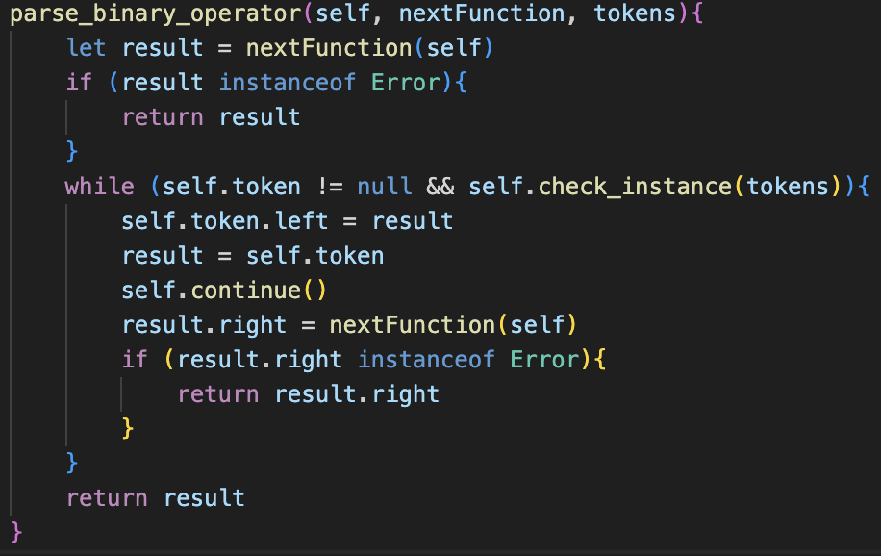Then, throughout the code, with examples shown on the left, the error calls can be inserted when required. For instance, replacing the old, printed message for not having closed a bracket, as well as a new addition at the end of factor(), which will be flagged when a token which was not a literal or a bracket was entered: such as two tokens in a row, which then throws an error referencing the token with the issue so that the program knows.

Additionally, the parse_binary_operator() method must not build these Error objects into the abstract syntax tree, so every time a different method is called, it must be checked if the result was an error.

If it was, that error is returned by the method, and is not build into the tree, and if it isn’t then it can continue as normal. This therefore ensure that any error will surface as the result in the parse() method regardless of where the error occurred in the parsing process to that point.

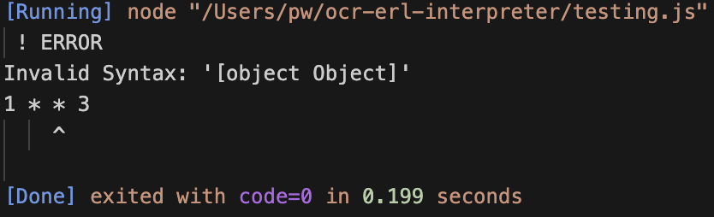When testing, the error message was flawed as it was trying to print the object, so I changed the message() to a different message that would not be as confusing.

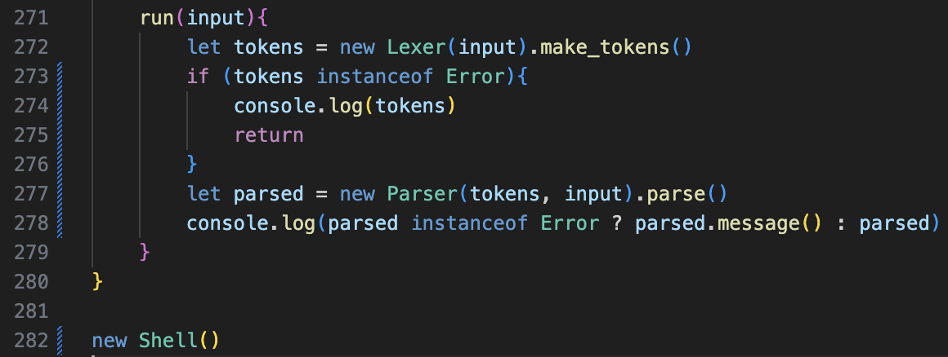Finally, I implemented the system back into our temporary Shell feature, so that our run() method would now correctly also parse the result from lexer whilst checking for any error. Although this is not long term, it will make checking for errors in the medium term significantly easier.

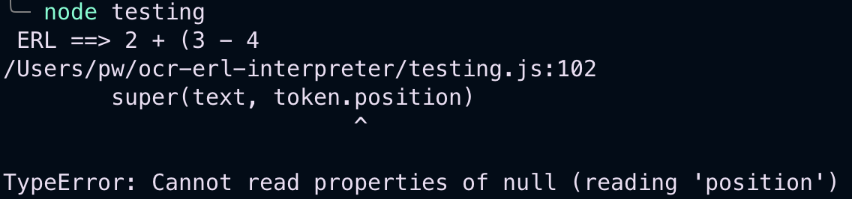For example, when trying to get an unclosed brackets error, it causes the program to crash, because a non-existent token is trying to be referenced for its position.

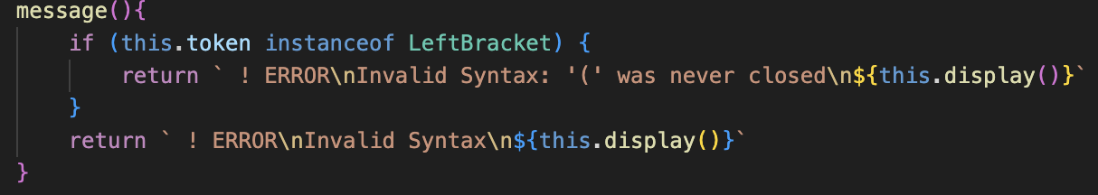The solution here is storing the initial bracket in a variable and returning that as the token with the error because it seems like the logical solution. I also updated the message() method to help explain better.

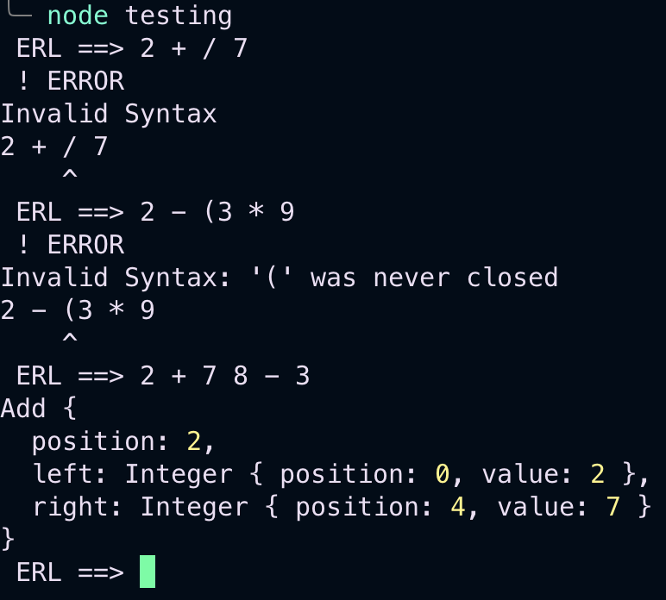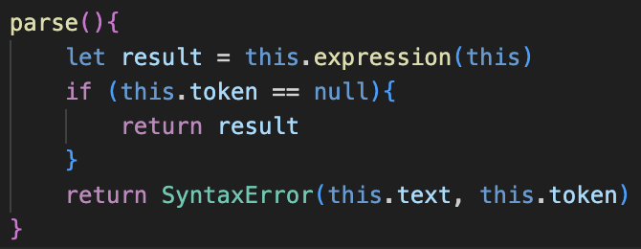Now you can see that two out of three of the main errors can be flagged, but having two literals in a row still causes the program to produce an incorrect result.

Adding this at the end of the parse() method, as explained in Design, will catch any of these errors with two literals occurring in a row. Initially, an error occurred as I did not use the new keyword, but afterwards it worked as intended and then flagged the error.

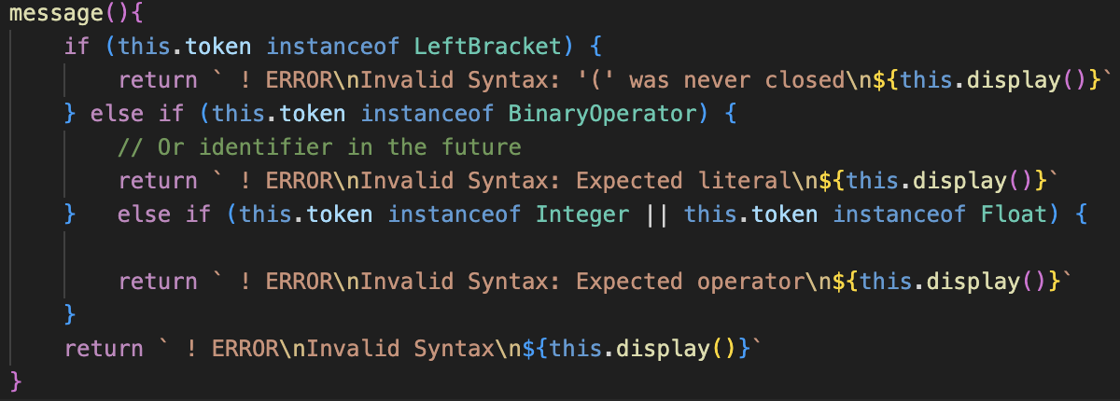The final addition was customising the message() method in Syntax Error to give a more detailed description on what the error is, based off the token that flagged the error. This overall gave us the result on the right, which I am happy with for this current stage.

# EXECUTIOn

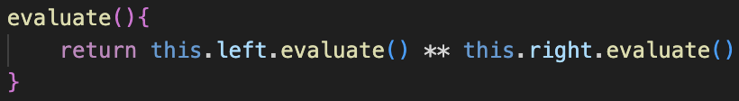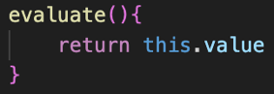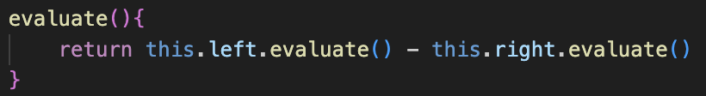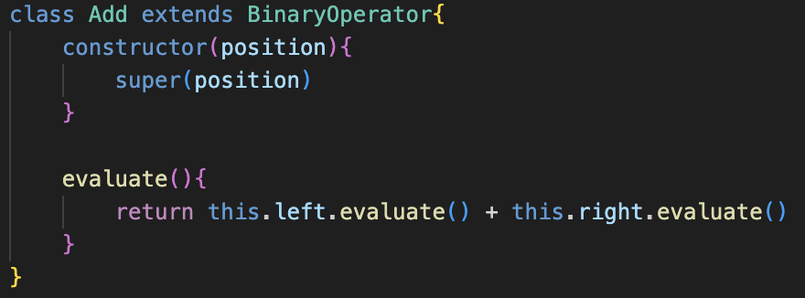Extremely simple implementation, and you can see a few examples on the left. The one returning this.value is for Integer and Float nodes, and the others are Add, Minus and Exponent, with very similar implementations for Multiply and Divide, as you can expect, without any error handling yet.

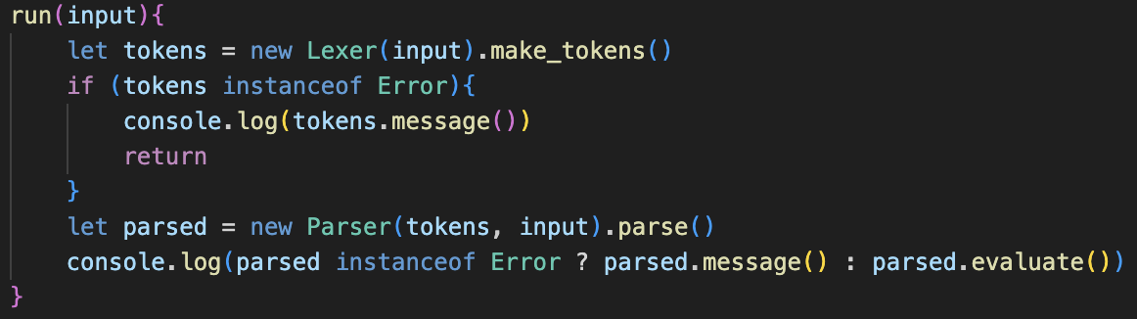Then, the run() method in Shell just has to be slightly changed to call evaluate() on the result of the Parser, which is the root node of the abstract syntax tree, and then output the result.

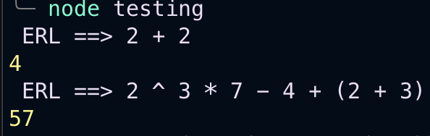This immediately works, and as you can see it proves that our precedence and as you can see our precedence is working from earlier.

## ERROR HANDLING

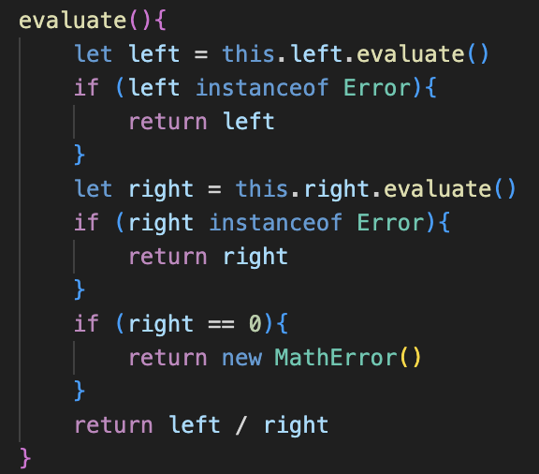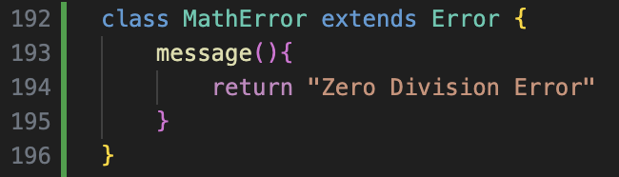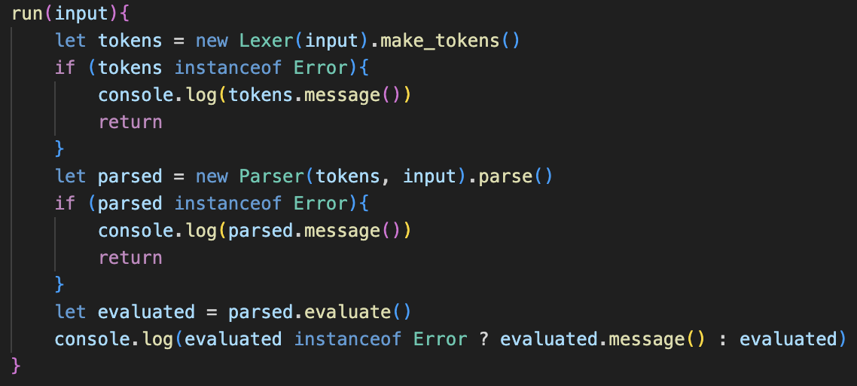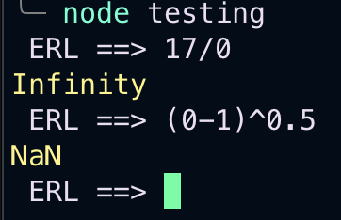Currently, when we try to perform our illegal operations, we just get returned with the default JavaScript responses, which is not what we want as they are not at all clear to the user, and if they became involved in other steps of calculations then an error would occur and break our program.

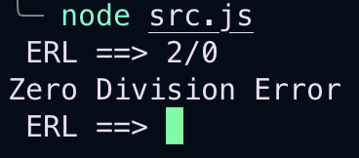In terms of a basic implementation, it is relatively straightforward, and in each evaluate() method has the same code as on the left, to check if the left and right children return errors, with the divisions addition of the Math Error.

This does work however it is not the solution that I would like.

With all other Error classes, the text was also passed as an input, which allowed for the display() method to work, and to therefore show where in the string the error occurred. I would like this to also happen for Math Errors, but passing in the text as an argument is a really inefficient solution.

This would mean that every Token instance would need to have the plaintext stored as one of its properties, and all of these duplicate references is not a very clean way to handle it.

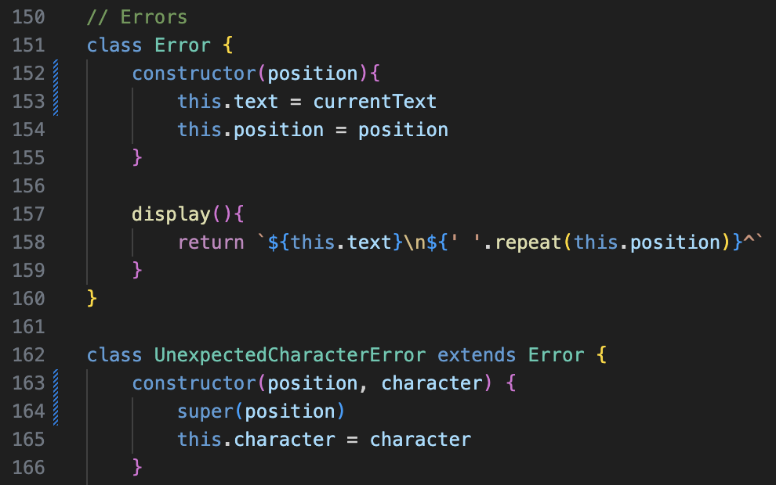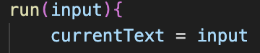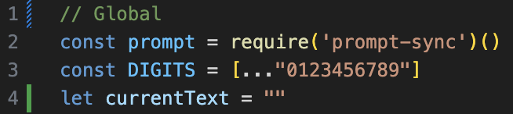My solution is to create a global variable called currentText, which is reflects the plaintext of the line that is currently being run. Now, for all Error classes, rather than having the text passed in as a parameter, the Error class sets the text property to the current value of currentText, which makes the process significantly simpler.

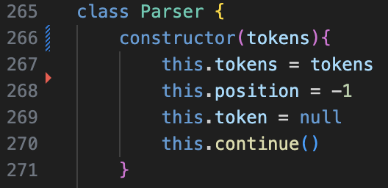We therefore also update all subclasses of Error to no longer take in the plaintext and to only pass position to the super() call. From this, we also no longer need the Parser class to store a copy of the plaintext as it no longer needs to pass it for inputs, so that can be removed which makes for a much more logical approach to errors.

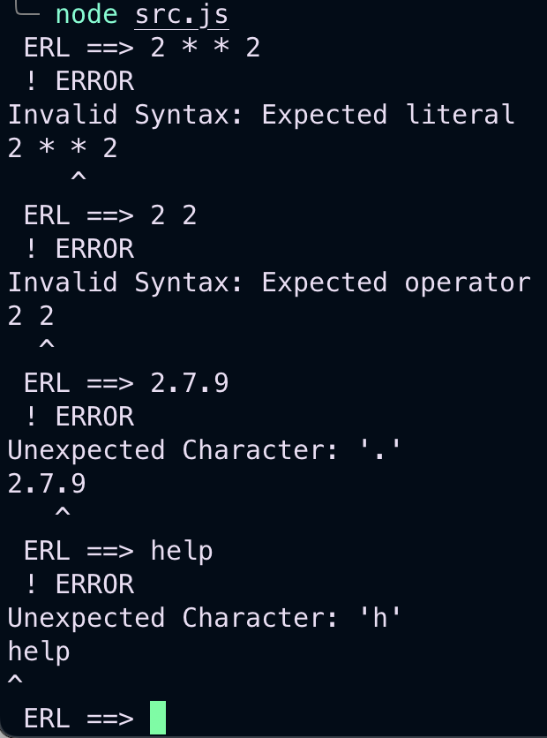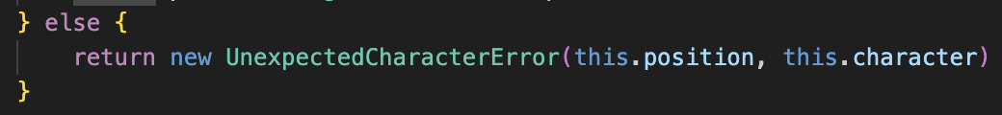Finally, all the old error messages must be updated to no longer pass in the text.

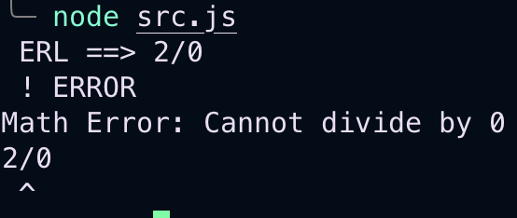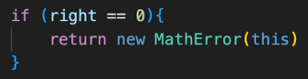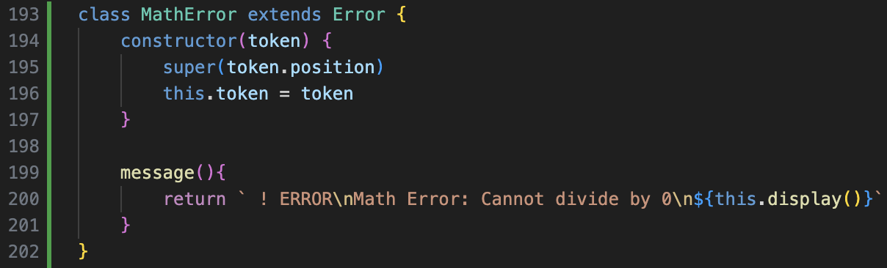After several Errors involving me forgetting to update some of the old calls, testing all the old errors then worked as intended, and still provided the correct display() result.

Now the Math Error class can be properly implemented as shown, and I decided that returning the operator as the error token was most logical rather than the 0.

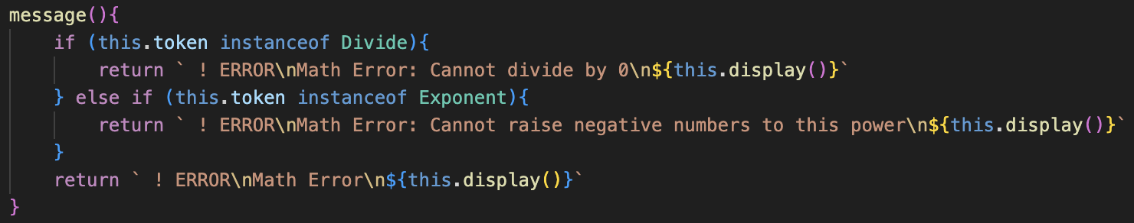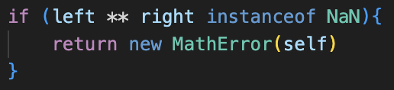The implementation for imaginary numbers is very similar, adding an if clause into Exponent’s evaluate() method to check if the result of attempting the calculation gives NaN.

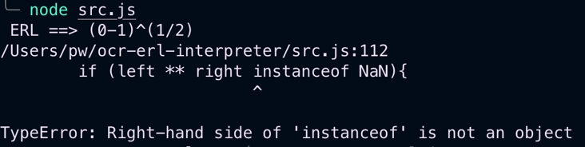I also added a new error message if the token which raised the Math Error was an Exponent for clarity.

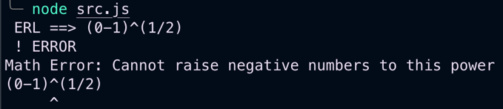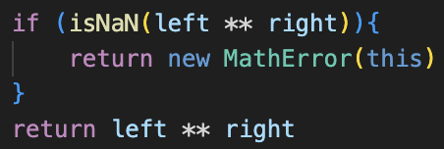However, my presumption of how the syntax worked was incorrect, so I had to use the built-in isNan() function rather than checking the instance.

This therefore worked so from there the Math Errors were completed.

### Error issues

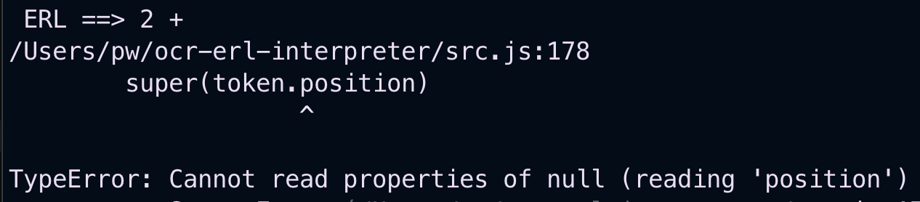When running some tests, I realised that trying to write an incomplete expression caused the program to completely break, which therefore needed addressing.

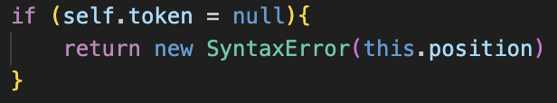The fix was simple enough: in parse_binary_operator(), after continuing past the operator, the current token must be checked if it is null, as otherwise it attempts to parse a non-existent token which causes lots of errors.

This line is simple; however, it revealed a huge flaw with how the error handling in the program was implemented and led to me writing some very messy and very poor code.

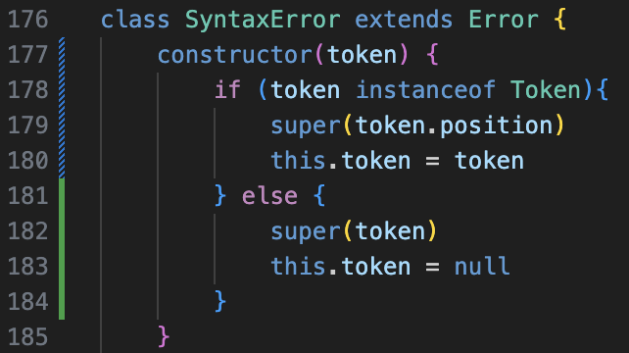This is because if I were to just pass the operator Token into the Syntax Error call, it would see that it was an operator and therefore would output that it expected a literal when this type of error is a different kind to having two operators in a row in the input. My message() presumed that there could only be one type of error per type of token, which is very inaccurate.

Instead of deciding to fix this, I instead decided that I would not pass a token but pass an integer if there was an incomplete input error, and this integer would correspond to the position of the operator token which was incomplete.

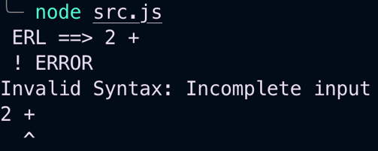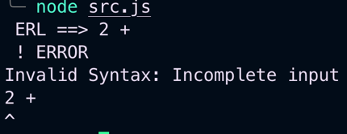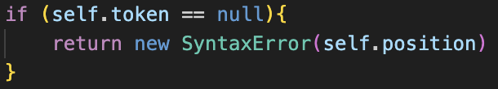At first this bad implementation didn’t even work, but after realising that I’d used both a single = and this instead of self after a lot of debugging output statements, it then functioned.

Regardless, this solution was a bad idea – and just led to me being forced to redesign error handling later anyway. This to me felt extremely messy in the moment of writing it, but I procrastinated cleaning it up, which – with hindsight – is really poor development and something that I avoided doing moving forward.

## Unary operators

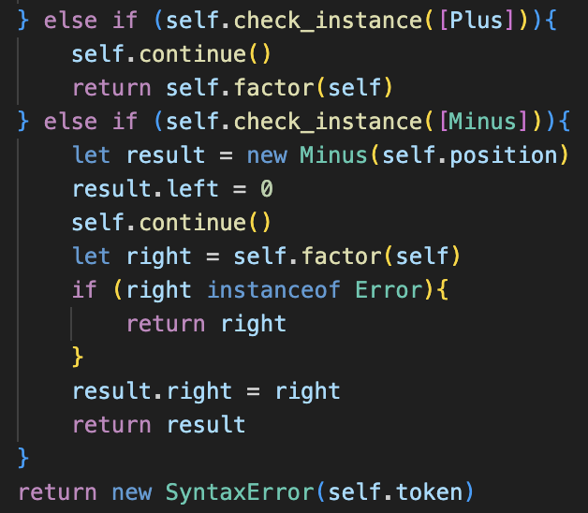Deciding to ignore the state of errors for now, I moved on to implementing Unary operators. My first attempt and implementing this was along the right lines, but with a lot of Errors. Firstly, I had was checking for Plus when my it should have been Add.

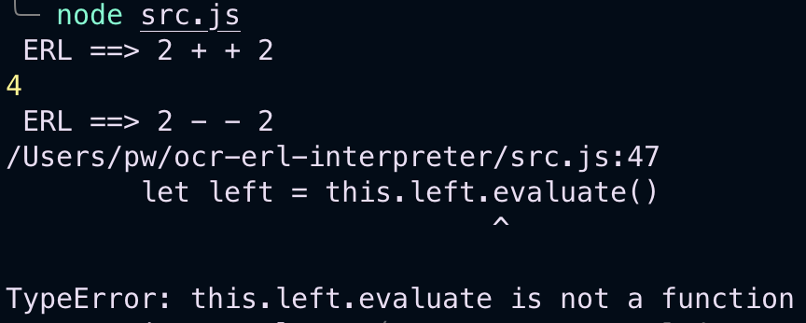After fixing this, I tried to run the code and found that addition worked, but subtraction resulted in an error.

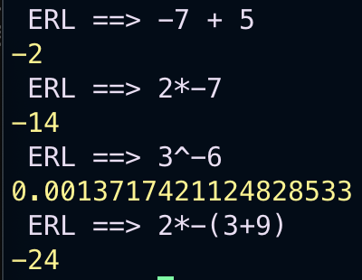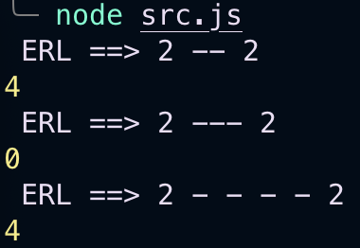This is because I was attempting to call evaluate() on just a basic JavaScript Number data type, rather than my custom Integer data type, so therefore I had to change the left to my own custom 0 and then it worked properly.

Now I had all of the arithmetic features of the BODMAS stage implemented into the program, but before I continued I had to deal with the absolute mess of error handling I had left the program with, as it would not be sustainable long term.

## Fixing errors

### Unary operators

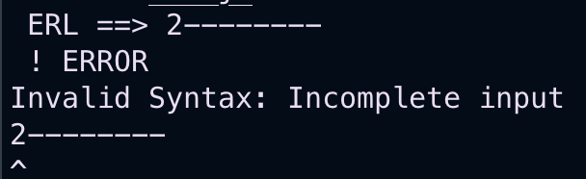When testing the new unary operator for errors, I realised that the error message pointed to the completely wrong position for the incomplete input.

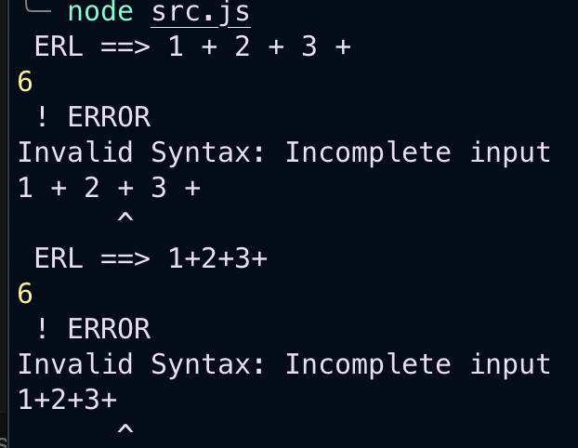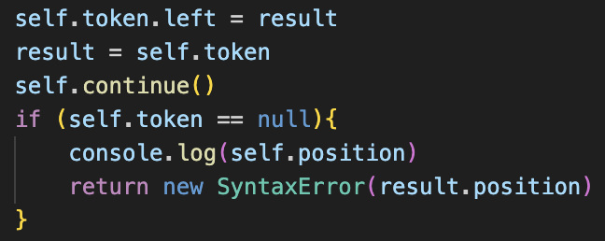When adding output messages to check this, I realised that it was not just for unary operators, but all incomplete inputs. As you can see, the pointer pointed to the same position, regardless of if there were spaces between the different tokens or not, which made me realise that the error was being passed the parser’s position, rather than the token’s position, as the parser’s position is about cycling through tokens rather than the character in the plaintext.

This was simple to implement through storing the token before using continue() in a temporary variable called errorToken, and then passing its position if the next token was null.

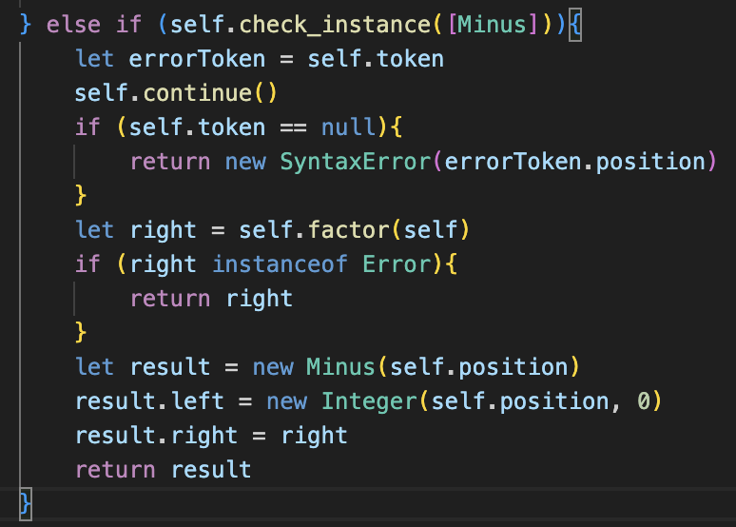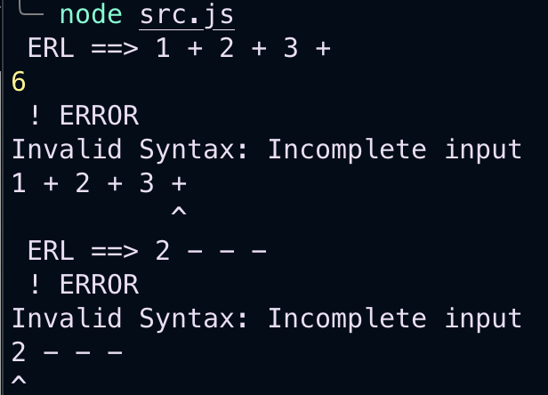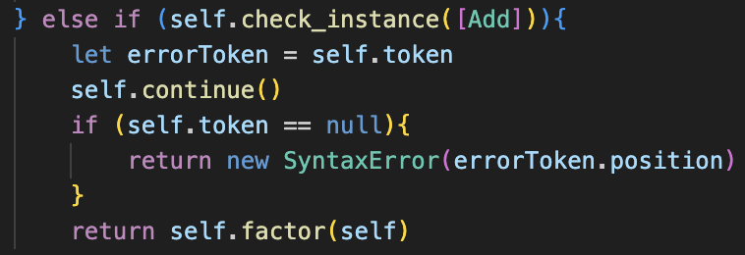The same approach could be used for Unary Operators, as shown below in the factor() method.

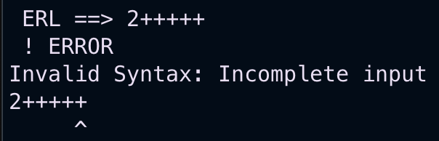

This worked, but again felt extremely messy so it was now finally time to redesign the whole error handling system.

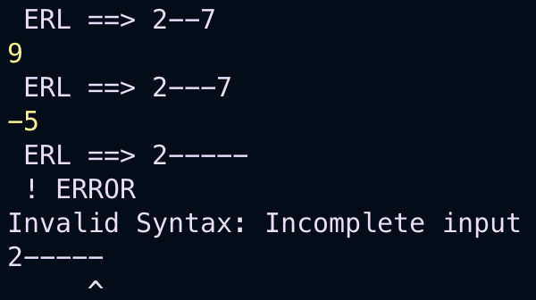

### Redesign

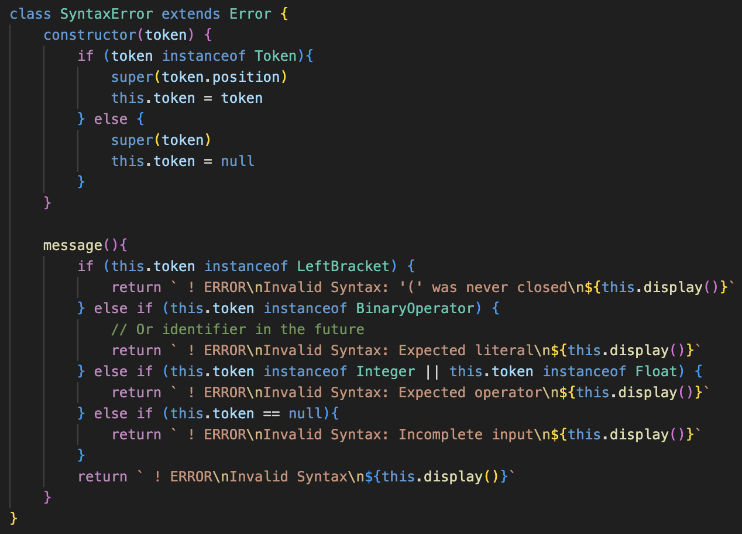The flaw is with the really messy code on the left: we guess which kind of error occurred based off of the token passed to the Error message, rather than explicitly stating the error when we call it initially.

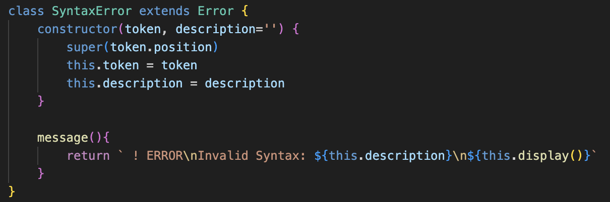This has led to our messy solution of using integer inputs for incomplete inputs and all sorts of bad implementations so it is finally time to change this system.

I have decided to do this by adding a new argument for the constructor for all Error types, called description, so that the issue can be described in the moment rather than afterwards.

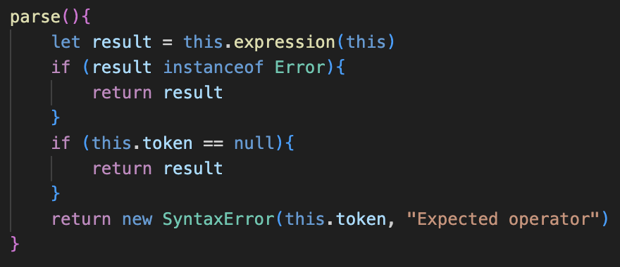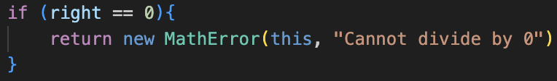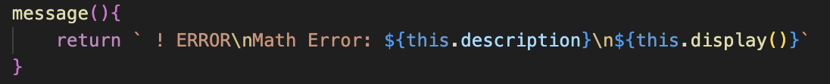This also significantly improves the readability of the program, as it makes it much clearer to see why an Error occurs in this stage of parsing as there’s an explanation.

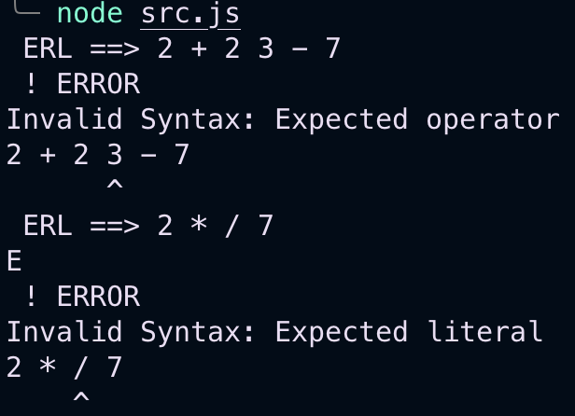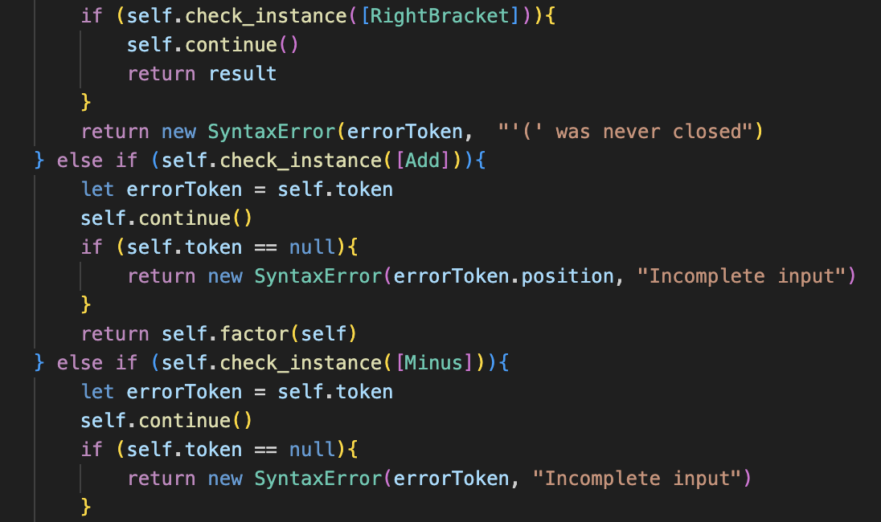

There are a few examples above of these changes, as it had to be done to the entire program in every single place that an error occurred. It made reading through the source code so much easier than I expected, without me having to guess about the error types.

There were quite a lot of errors when testing all the cases, as I had forgotten to update a lot of the error messages, but at last I managed to get all of the errors to work and I was much happier with this new system.

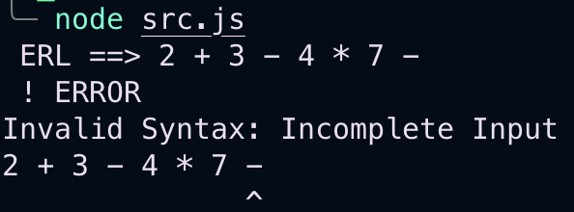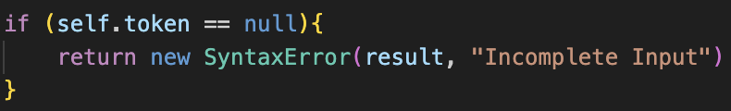The best part was that the incomplete input could just be given the token directly, rather than the integer position.

This just made the code so much more consistent and logical, and I was finally happy with the way that the errors were dealt with, as there was just one set way without small exceptions.

### Less repeated code

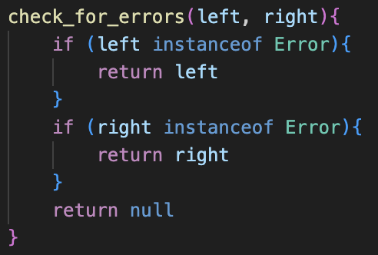My last issue is that there is a lot of repeated code in the error checking for the Binary Operator’s evaluate() methods. My solution for this is creating a new method in the Binary Operator class called check_for_errors(), which takes in two inputs: the result of the left evaluate() method and the result of the right.

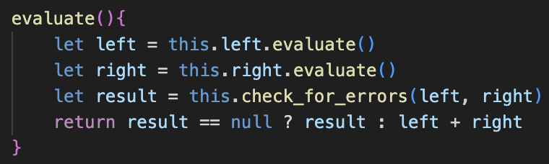If either are Errors, it returns the error, and if they’re both not errors then it will return null.

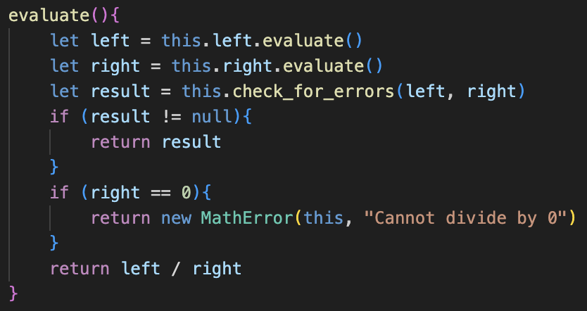This significantly streamlines the code, as this method is called in evaluate(). If it is null, then the program does its typical operation. If it isn’t then it returns the result of the method, which will be the error. The implementation of this is shown on the left.

This then has to be repeated in every other binary operator, which is still a decent amount of repeated code but significantly less than before. In future I could further simplify this by combining all of the classes but for now I am comfortable with how it is.

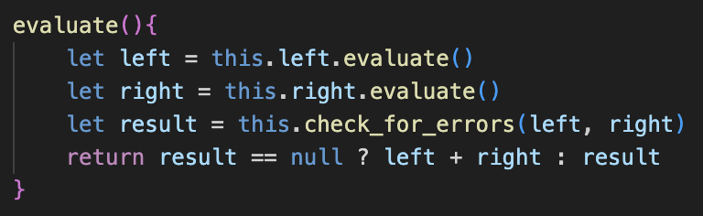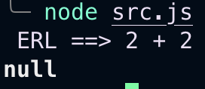For classes with extra error checks, such as Divide shown on the left, the extra error check occurs after calling check_for_errors().

Initially when testing, this didn’t work because I mixed up how to use the ternary operator, but after fixing it worked as usual and I was happy.

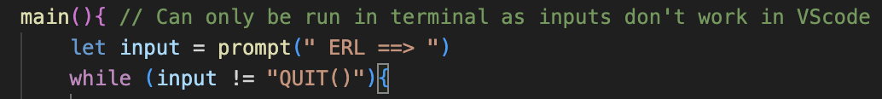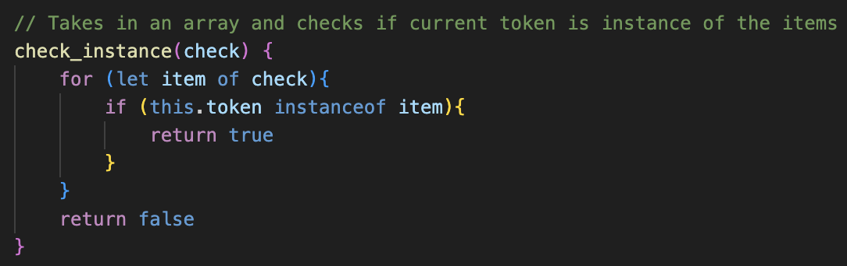Finally, I added a bunch of comments throughout, just to explain certain methods My aim is to write code that explains itself, but I thought these ones were required.

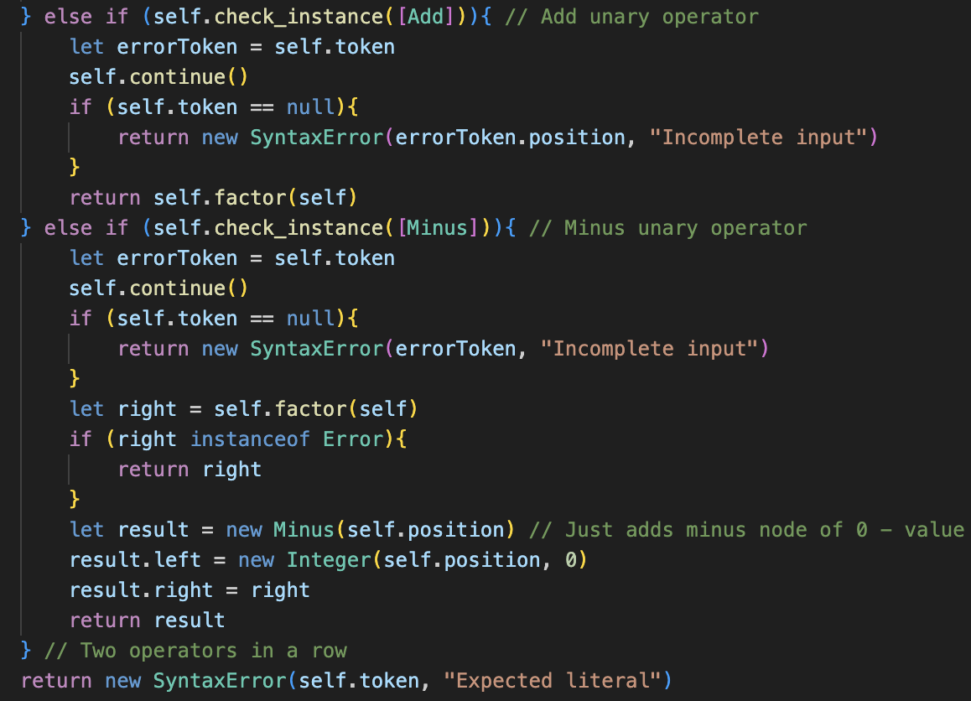

# Variables

## LEXER

<https://codegolf.stackexchange.com/questions/71613/generating-the-alphabet-in-javascript>

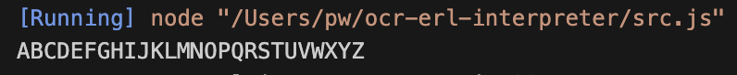

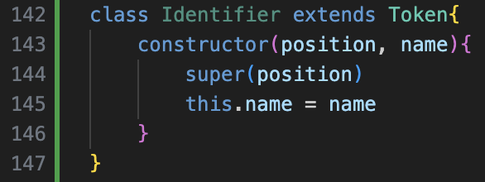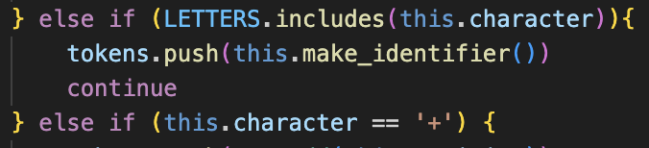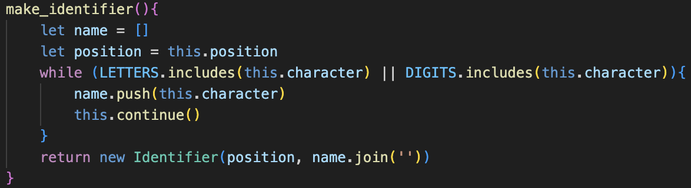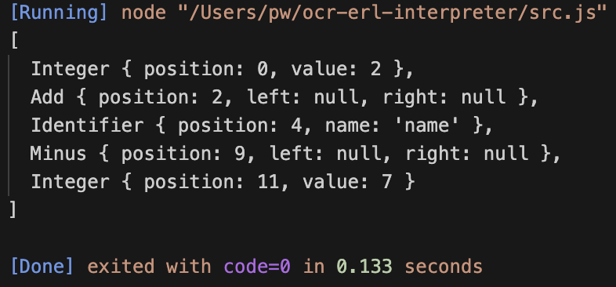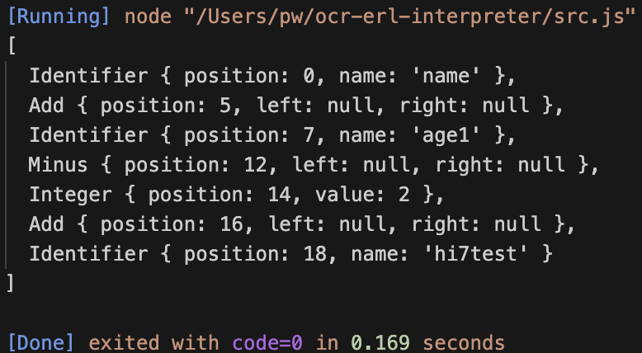

## Symbol table

Dynamic data types

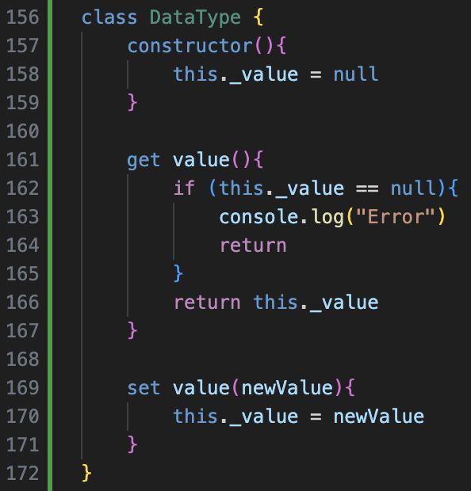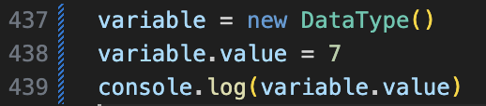

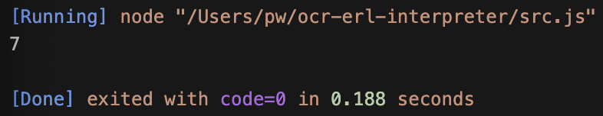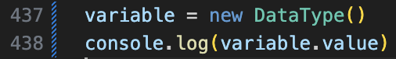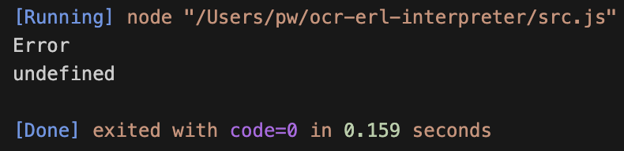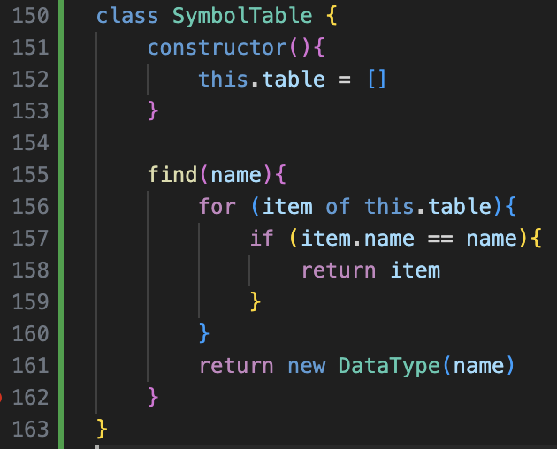

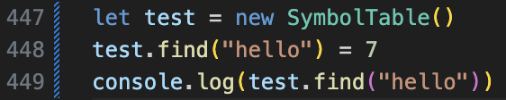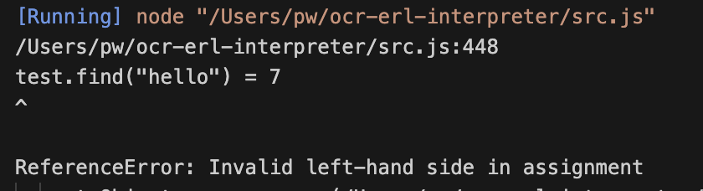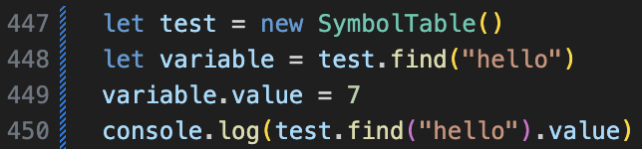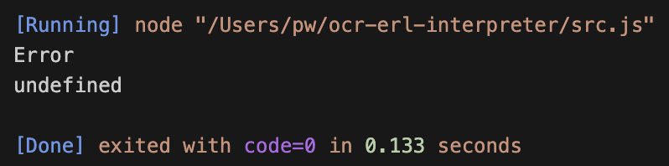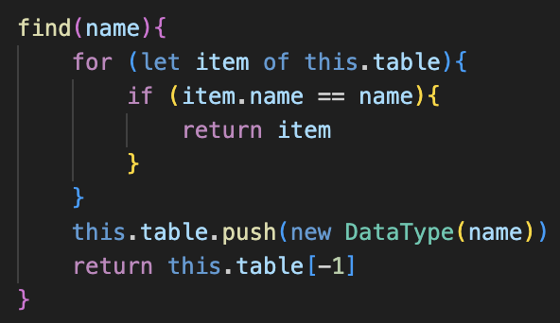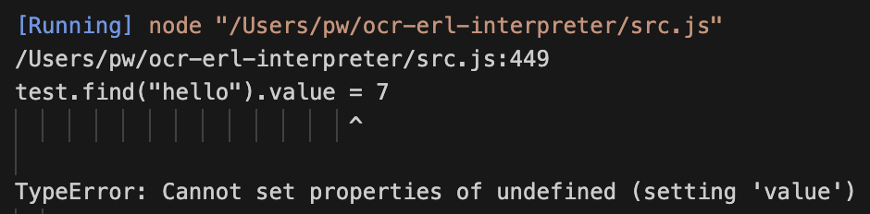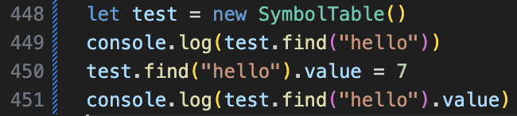

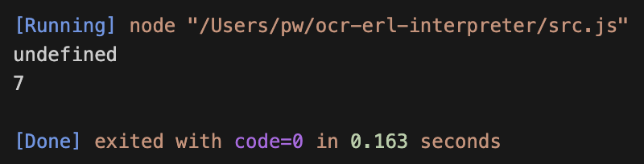first call doesn’t work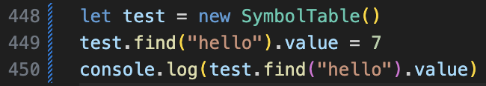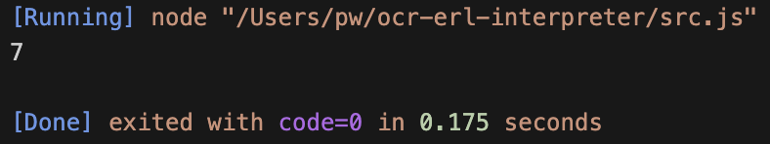

## implimnet

allows expanding for global constants later

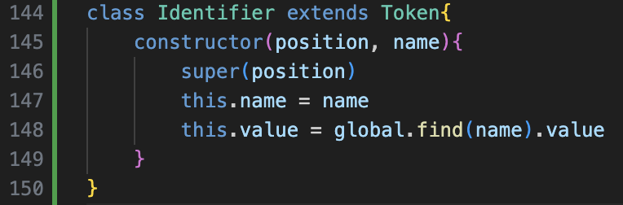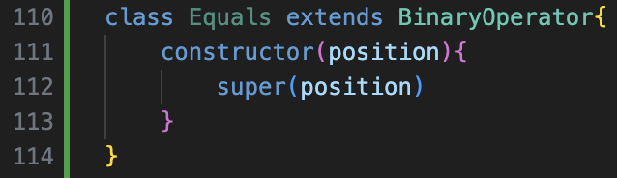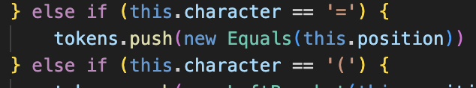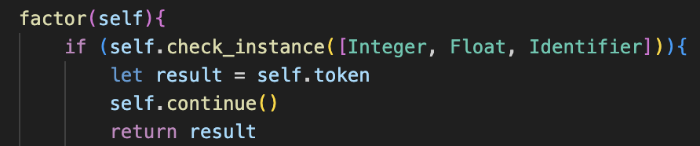

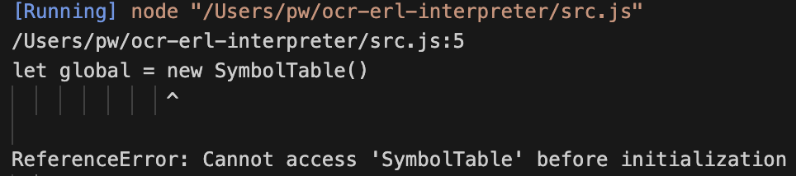moved to top

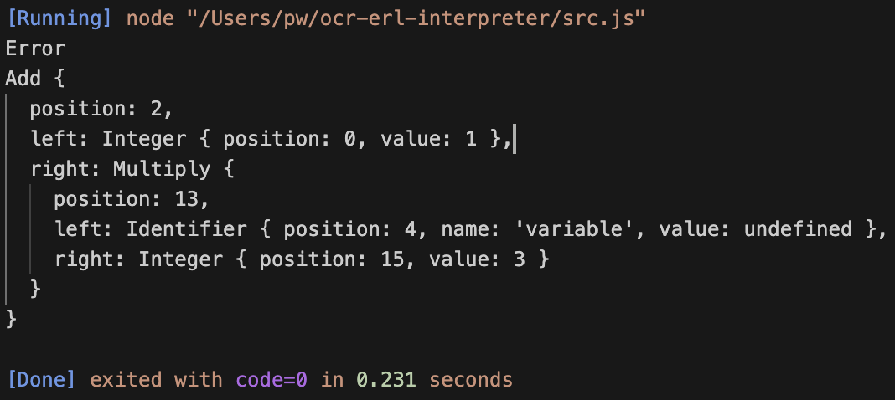

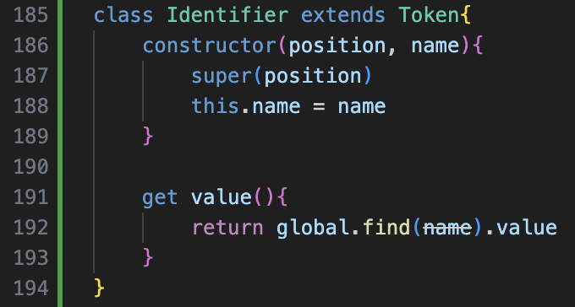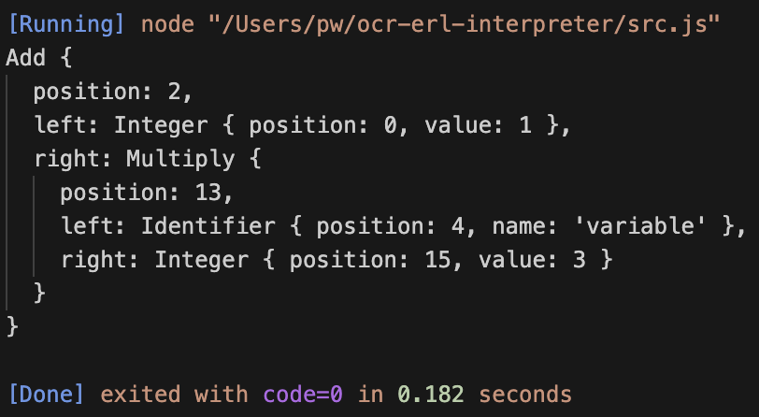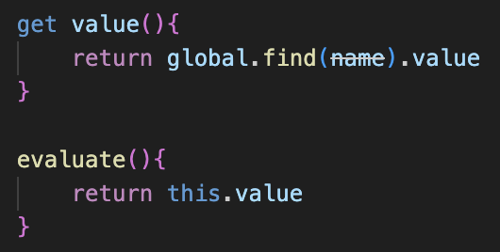



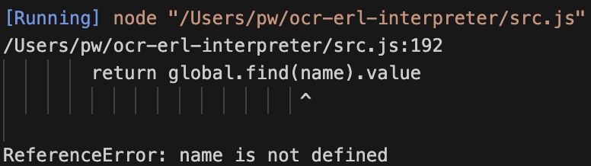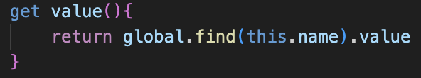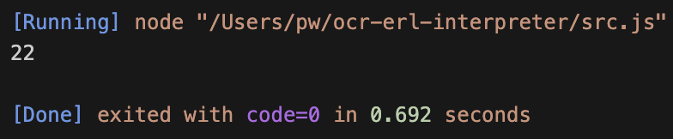

## Assignment

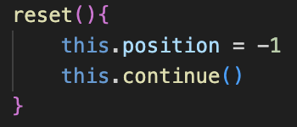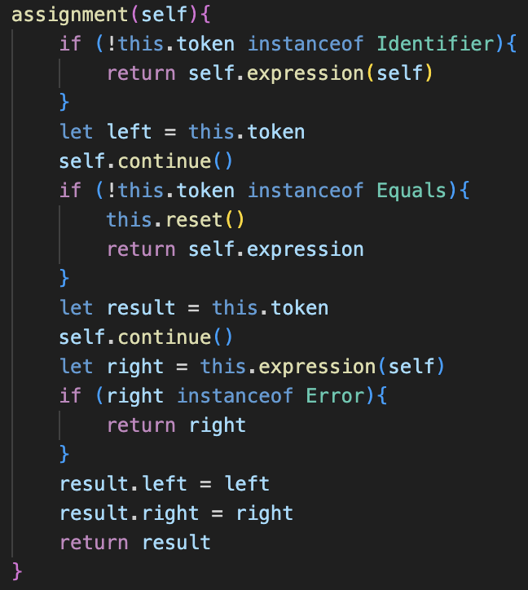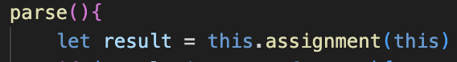

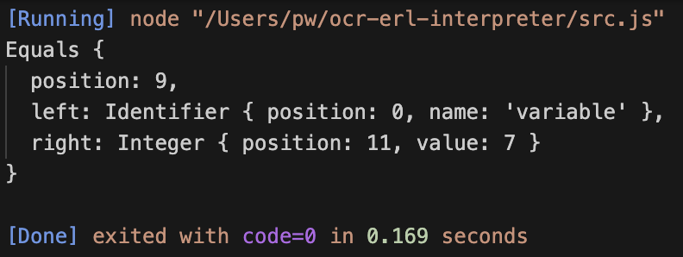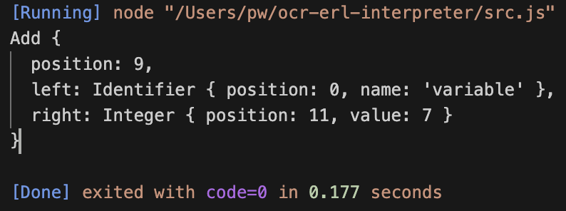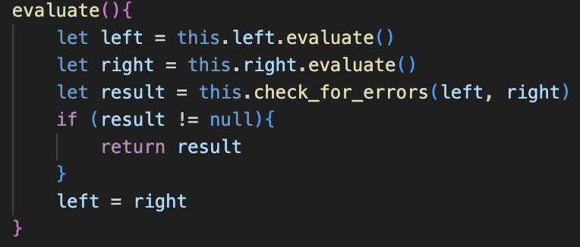

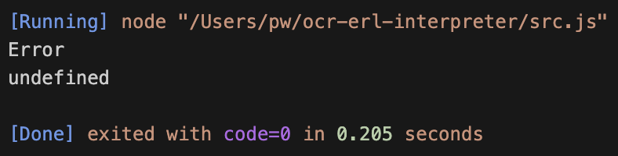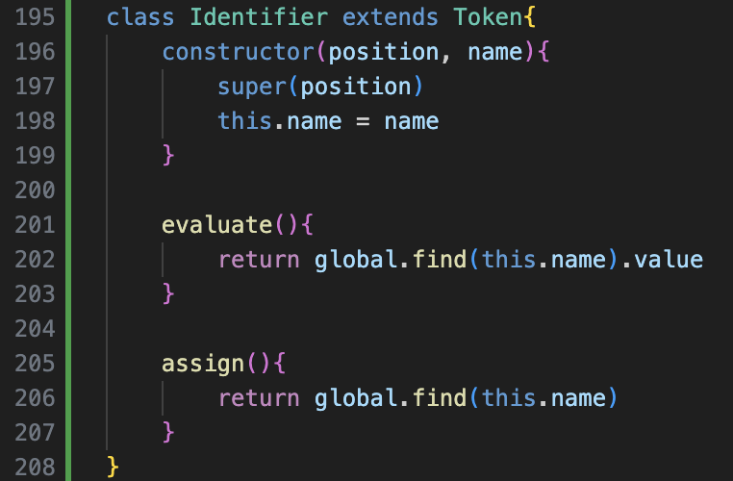

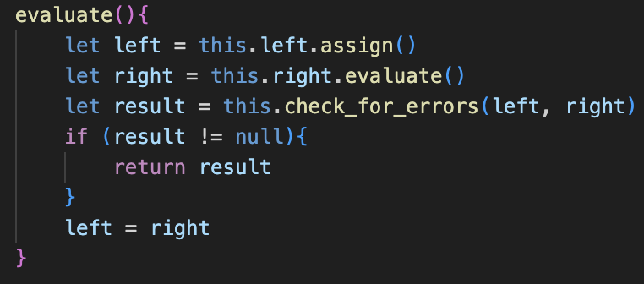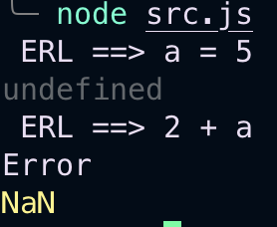

Testing example

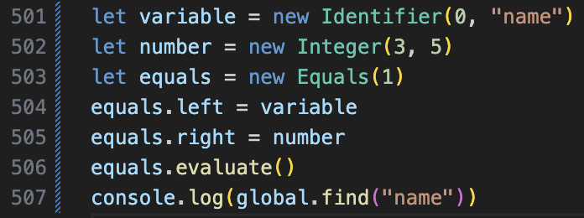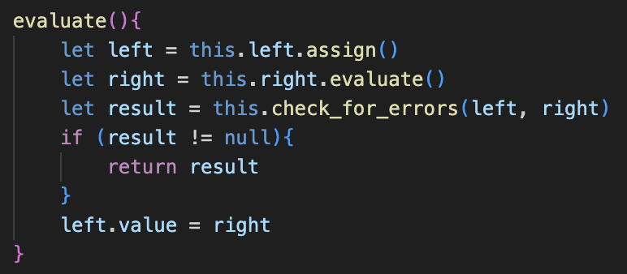

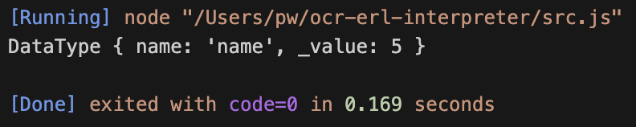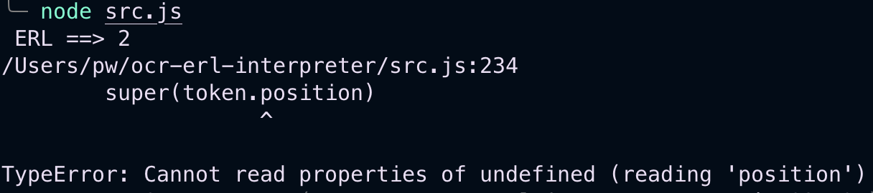

Lots of debugging with console.log everywhere

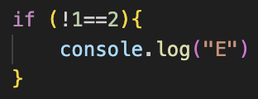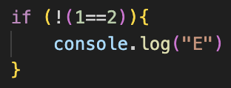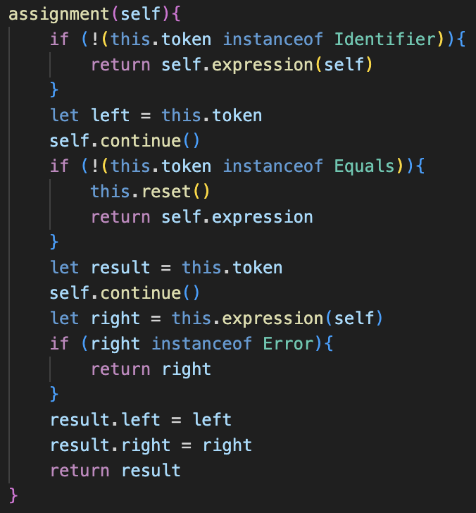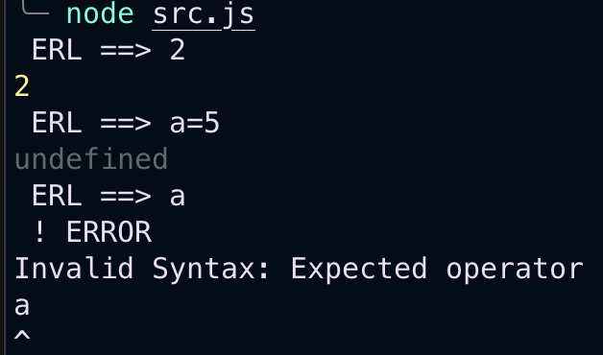

Again, loads more checking for erros

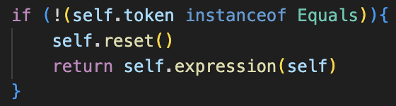and changed this to self

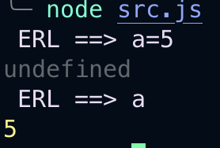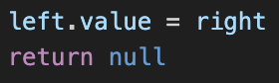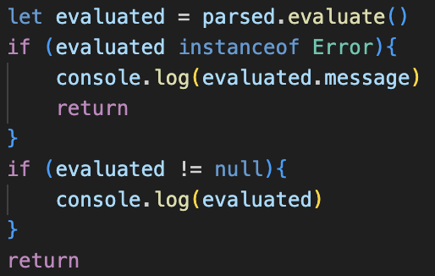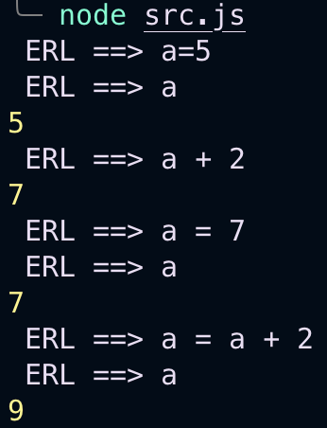

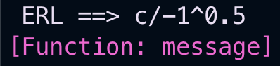would previously crash if nothing was entered.

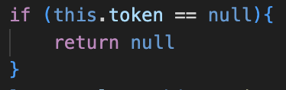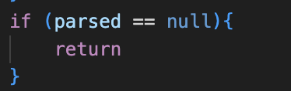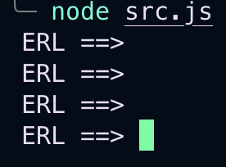

## error handlung

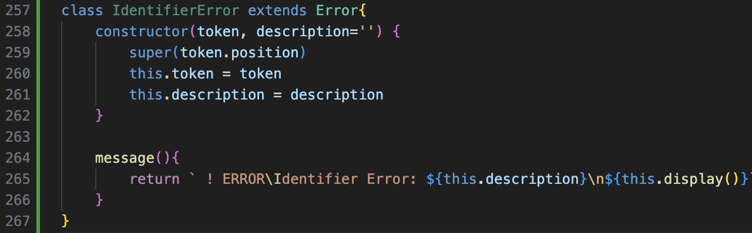

Need access to the whole token not just the name

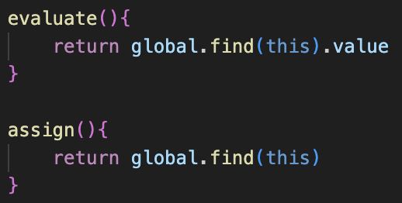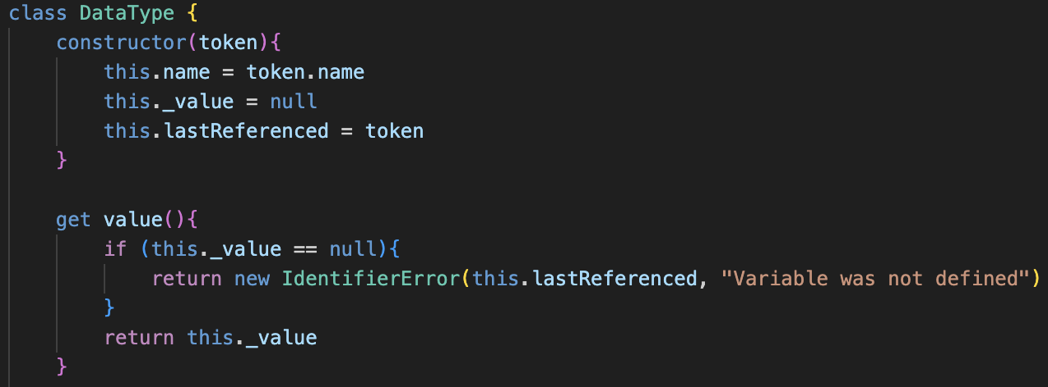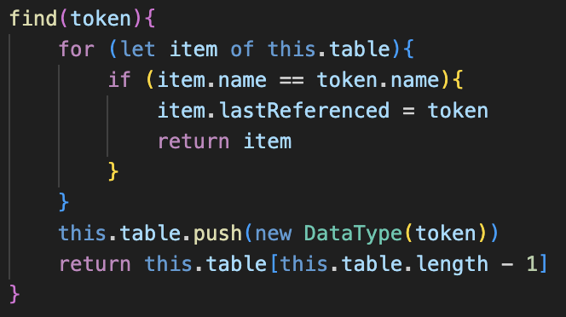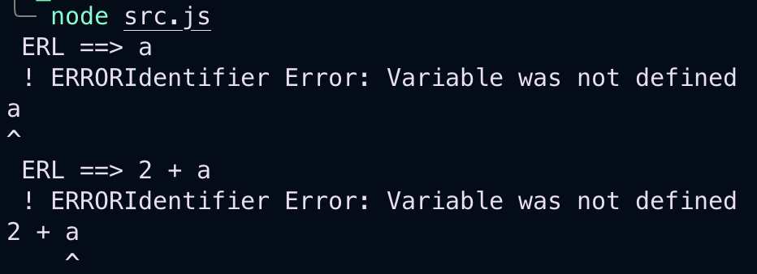

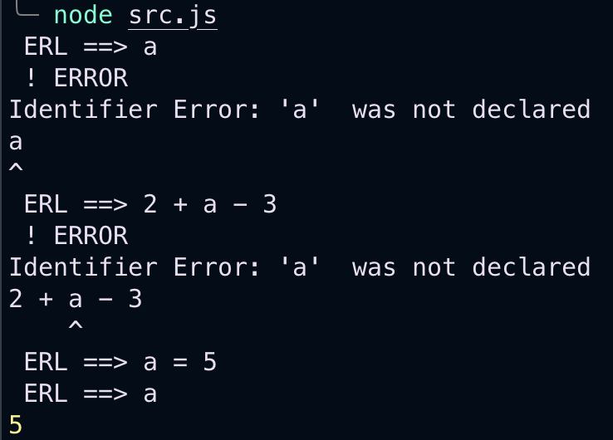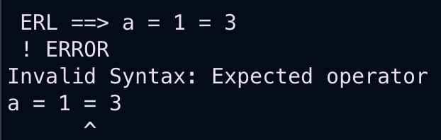

## constants

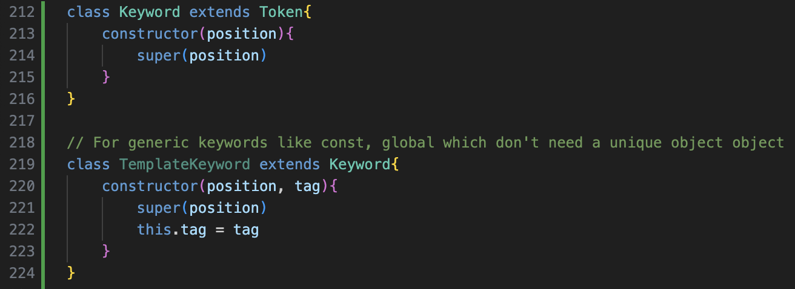

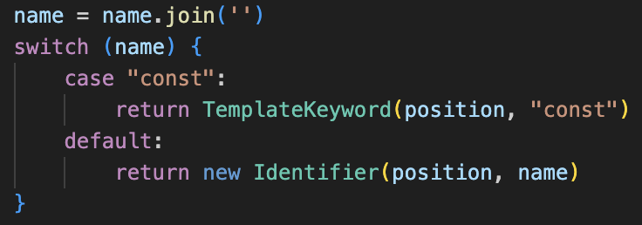

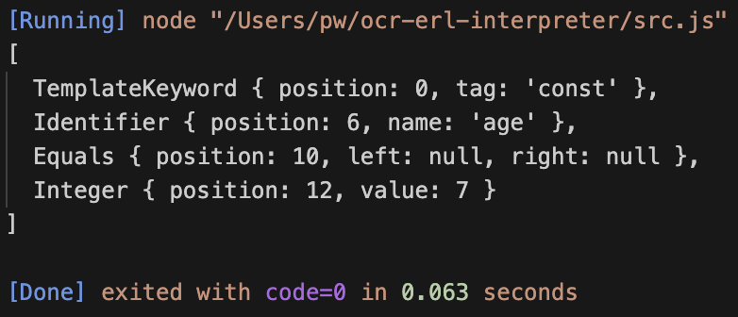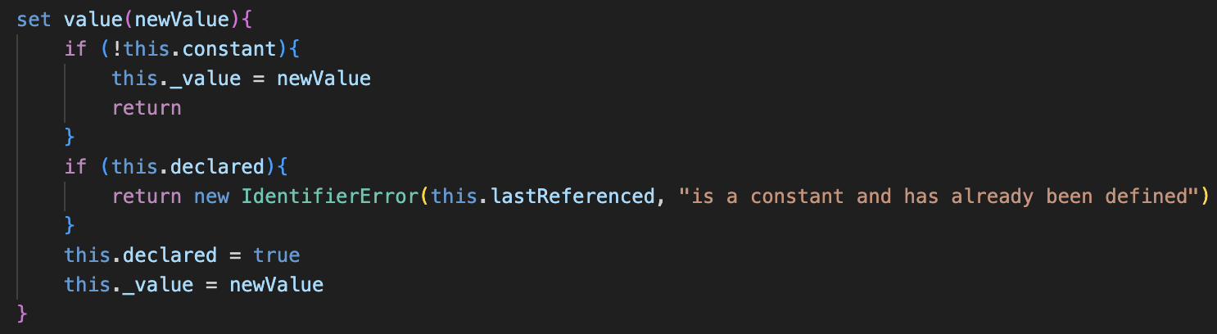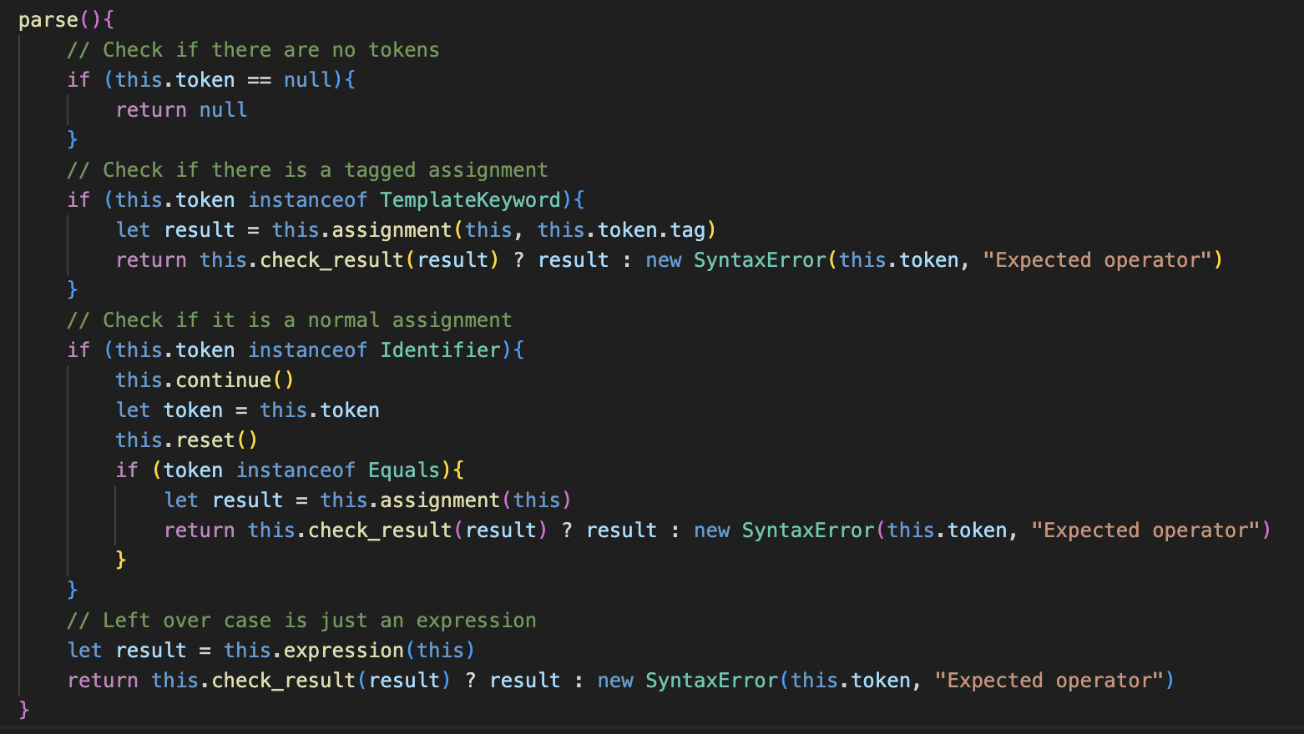

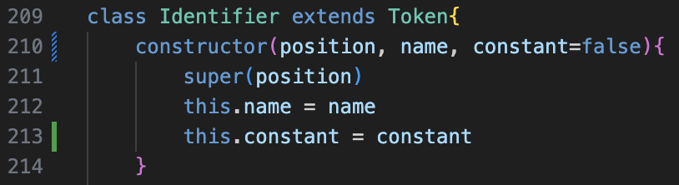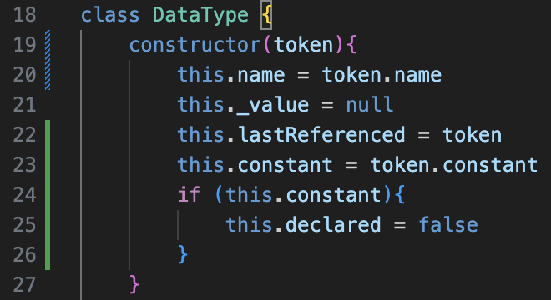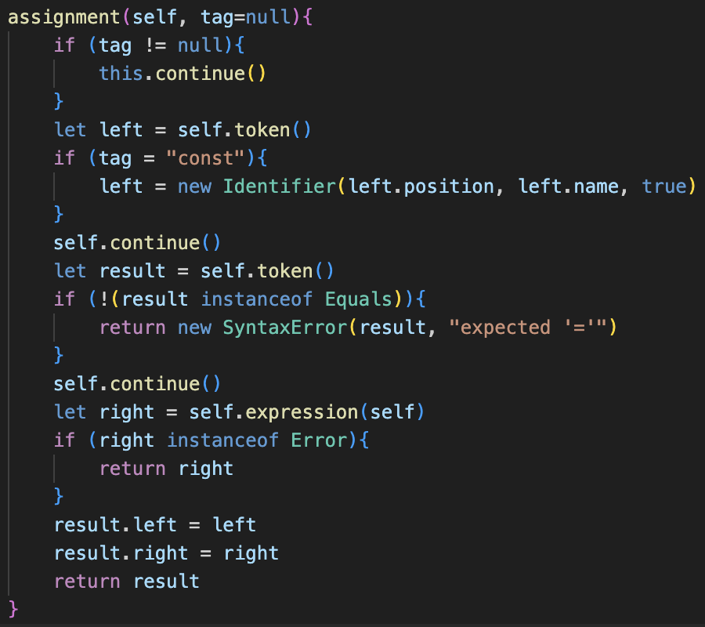then removed brackets from this.token()

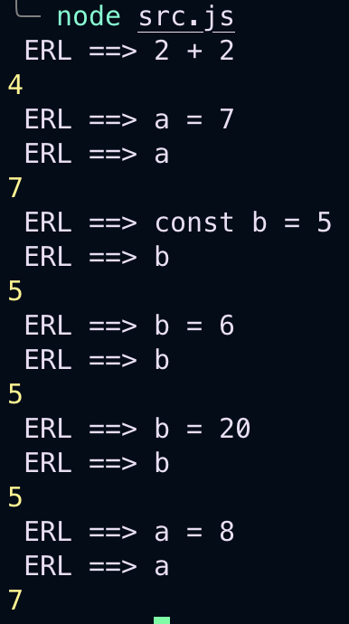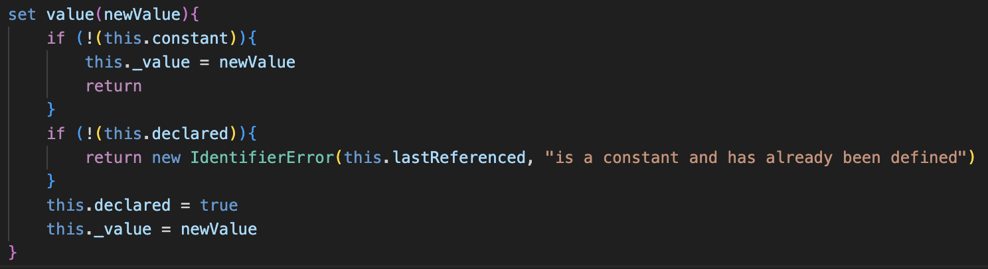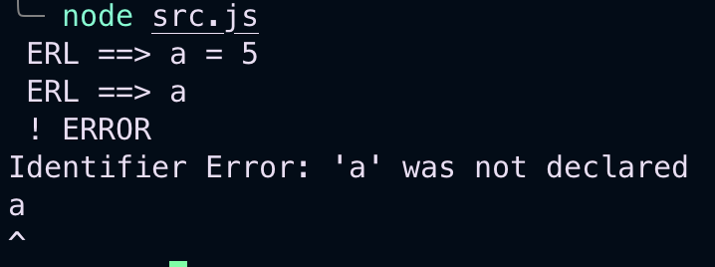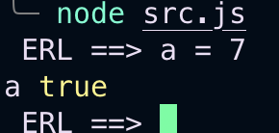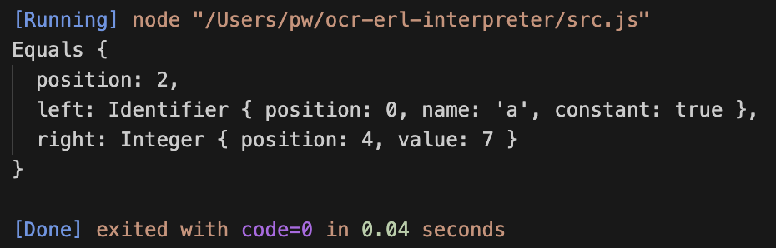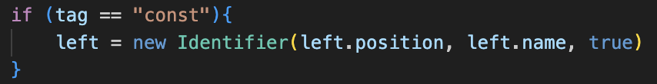instead of =

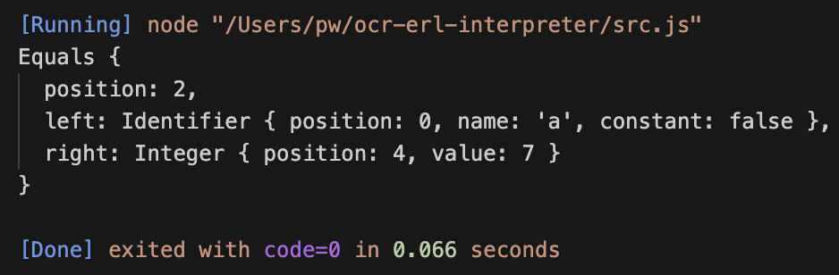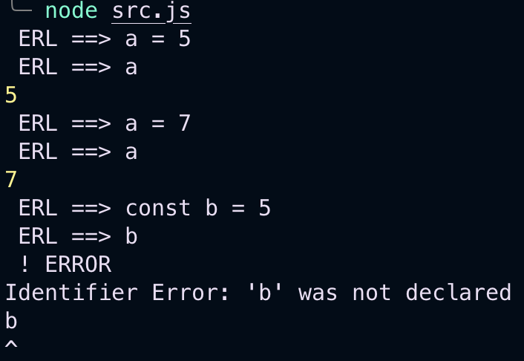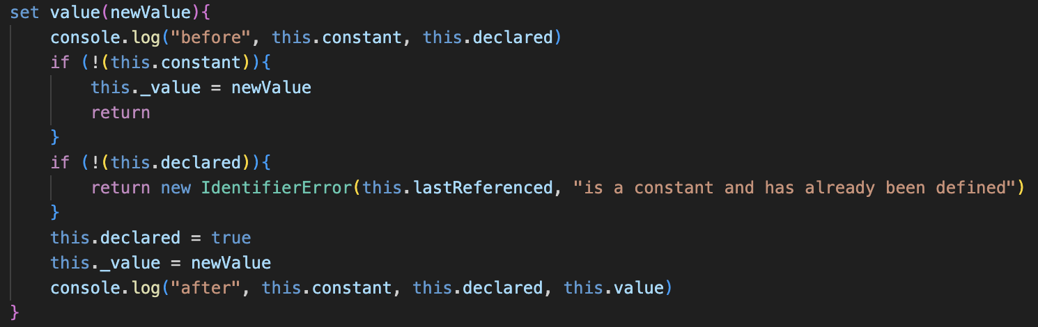

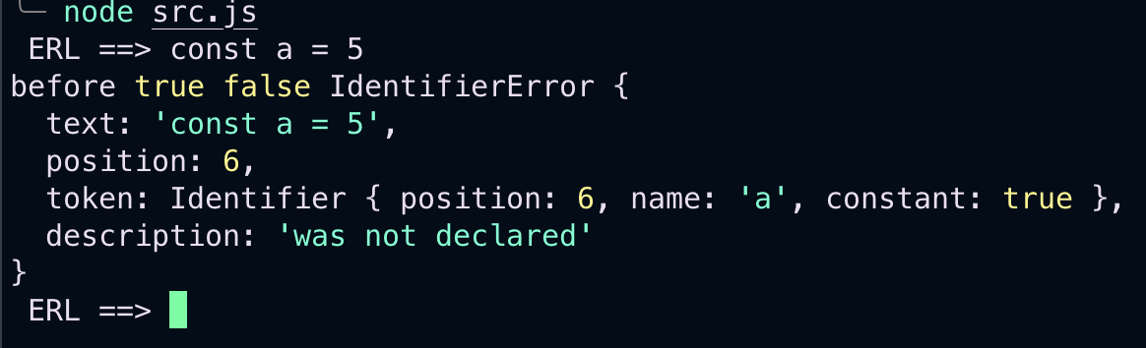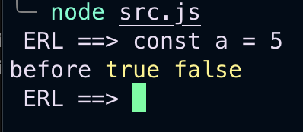

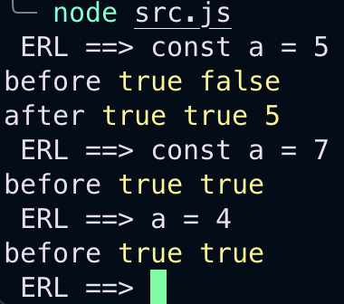error handling problem?

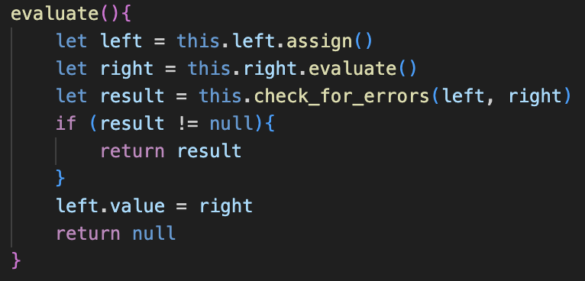cant use setters as no error detection

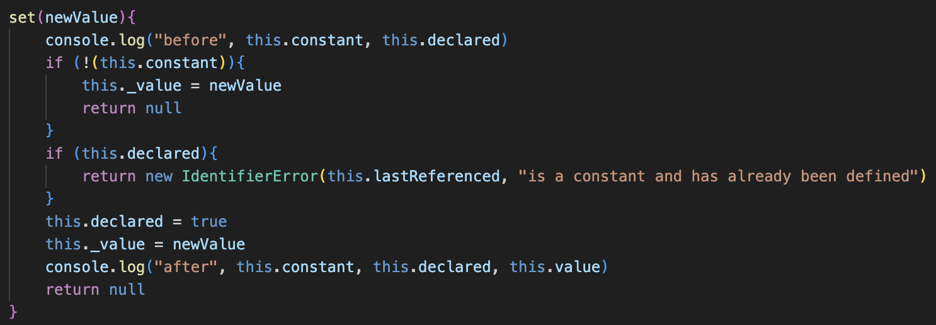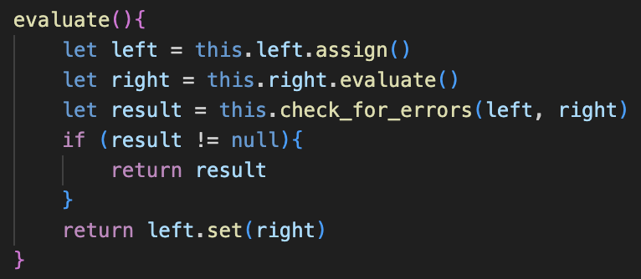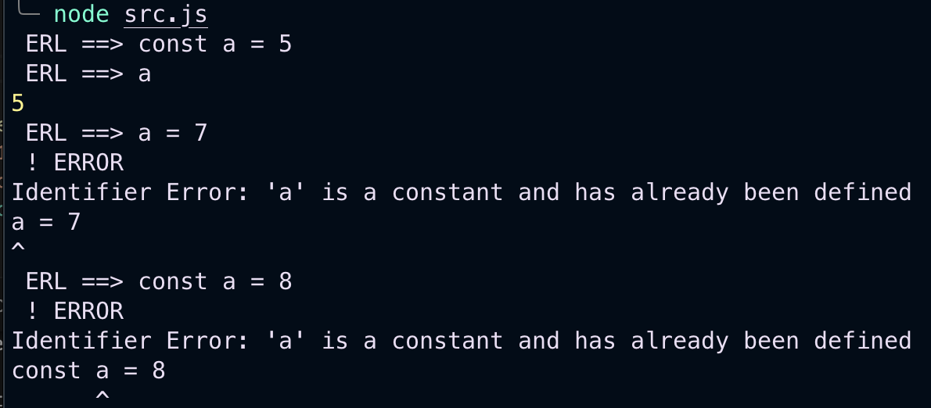

## Cleaning up

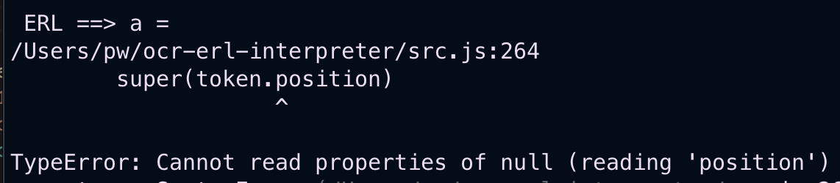

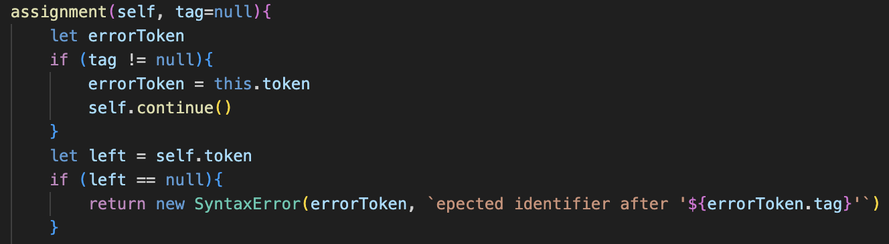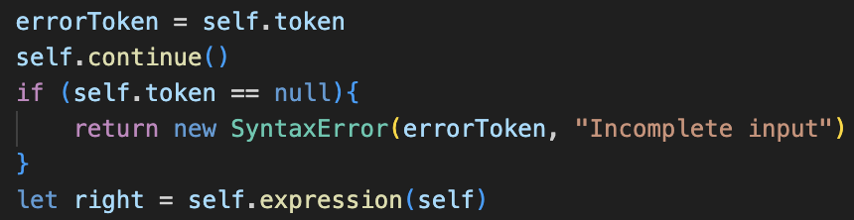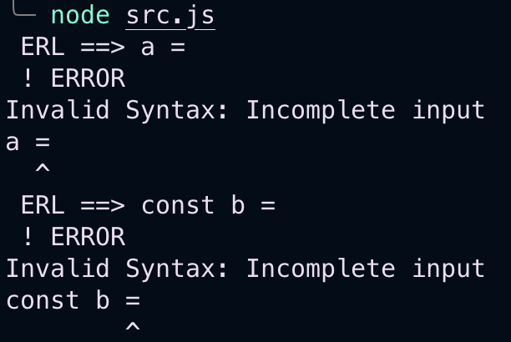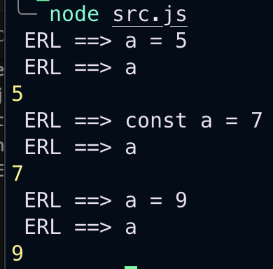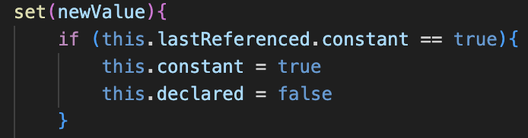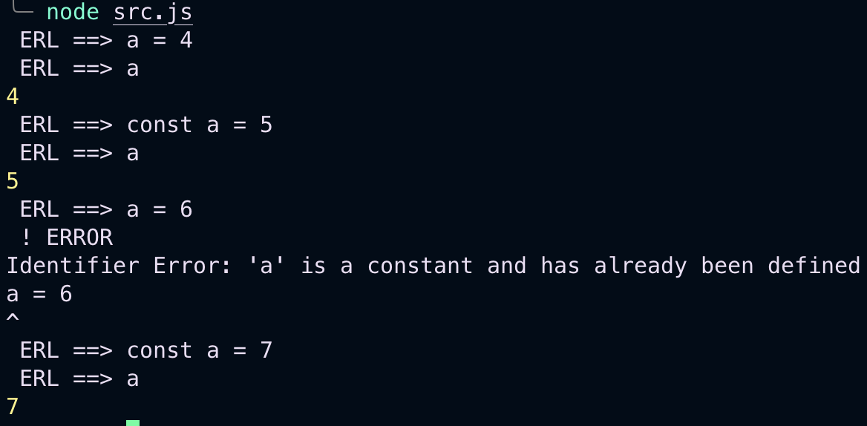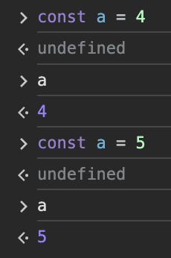

# Logic

## lexer

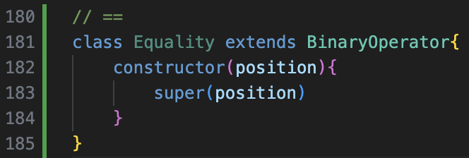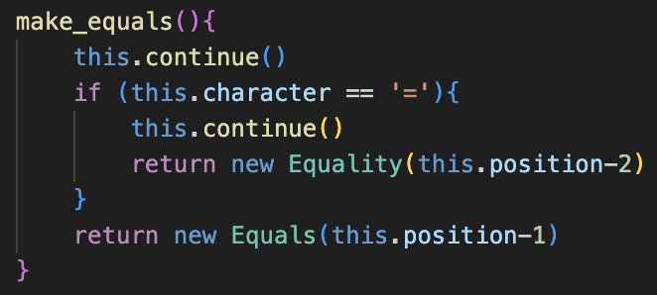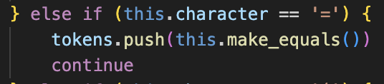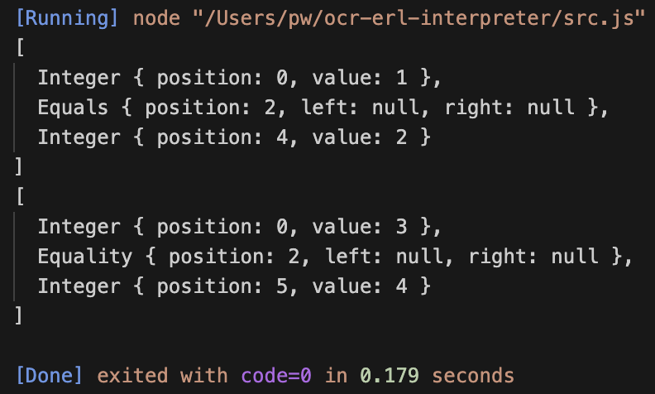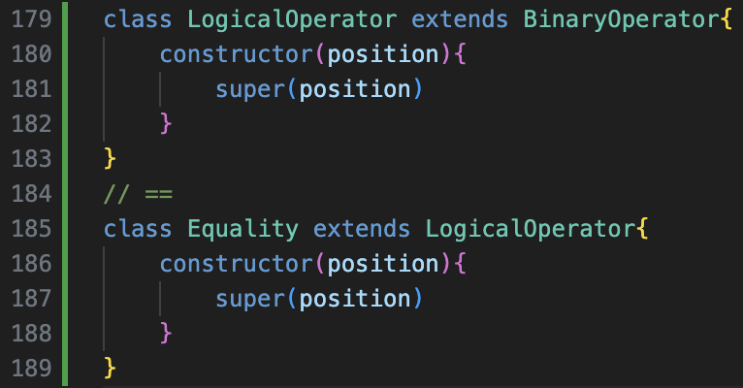

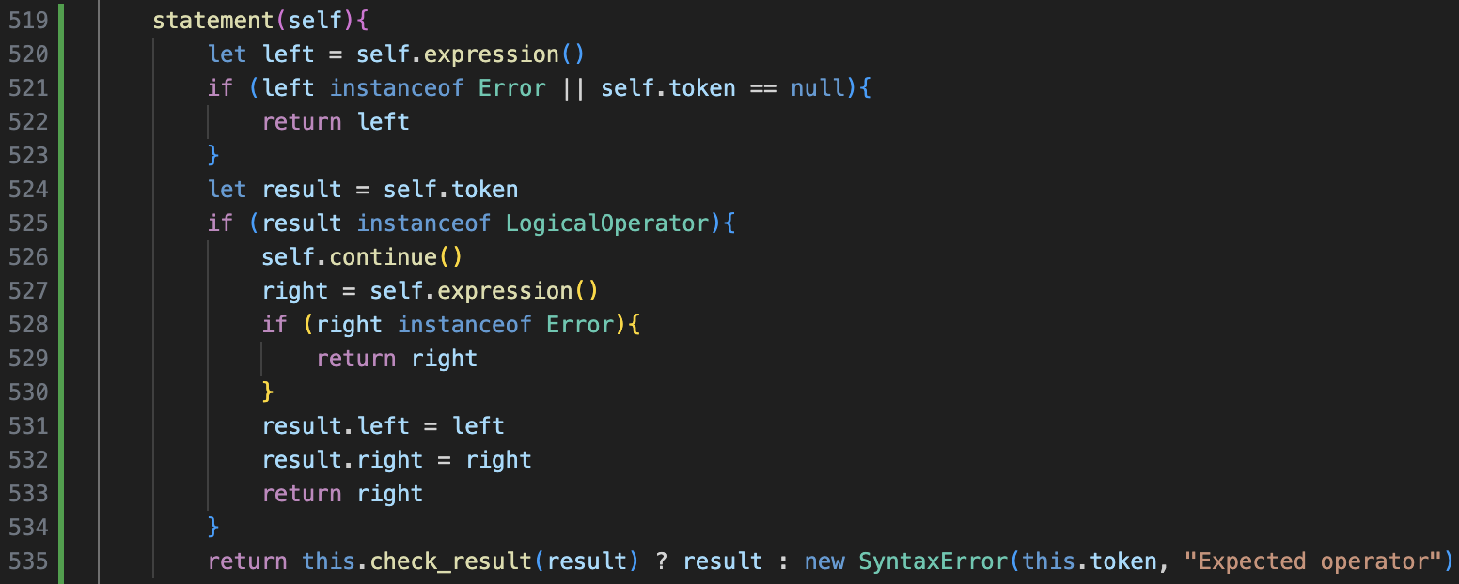

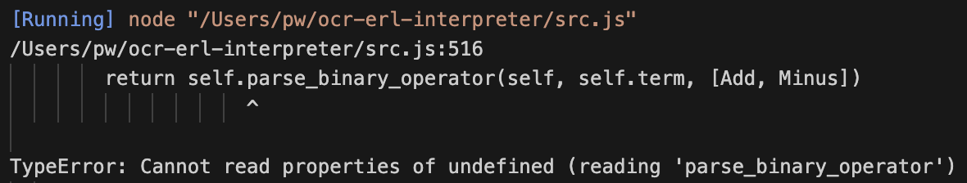 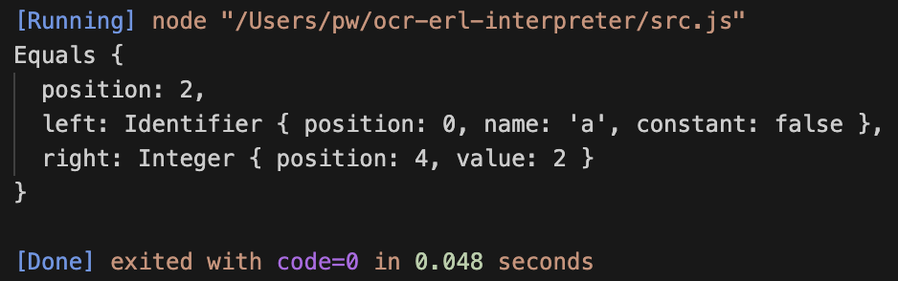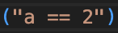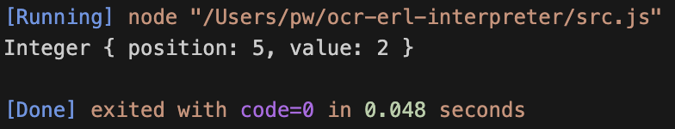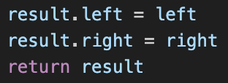

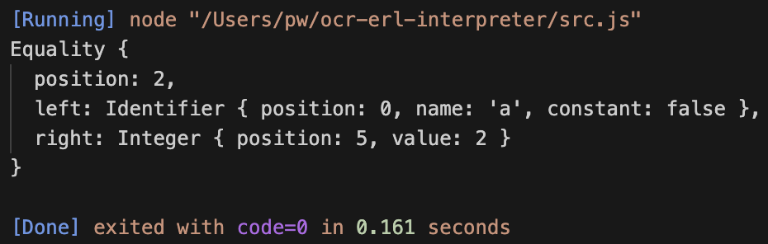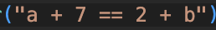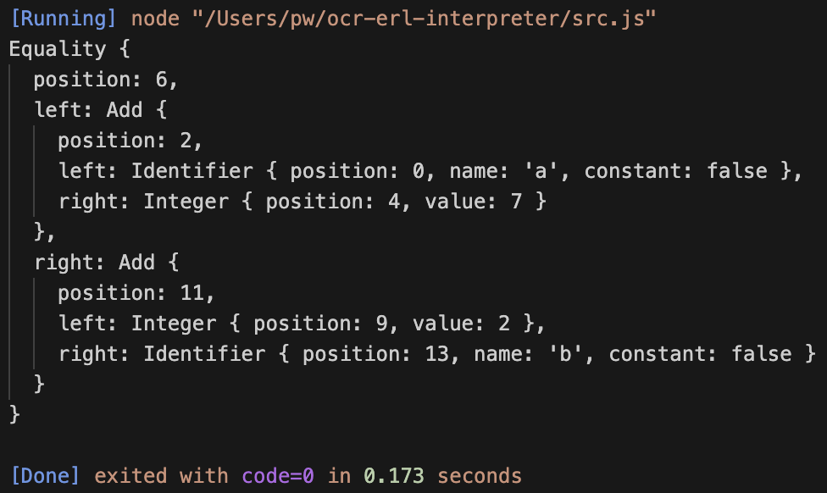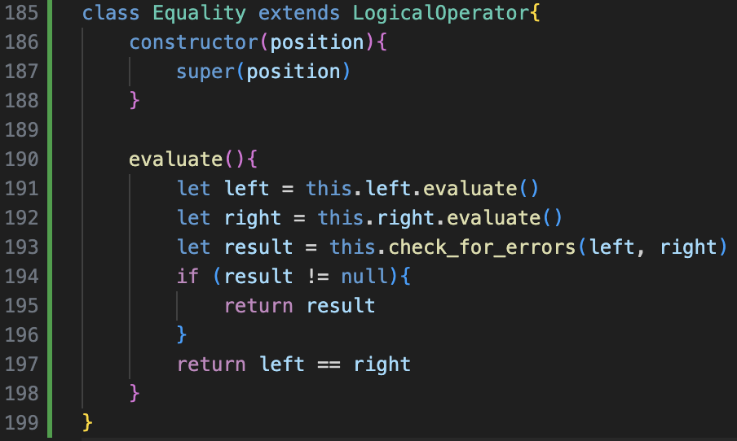

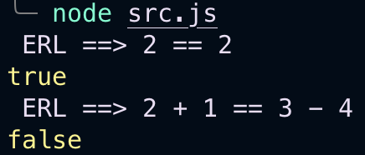

## fixing evaluation data types

Currently just returns normal JS data type rather than our custom ones  
This removes integers and floats and become same thing, and Booleans are lowercase  
Needed later so data types are more fixed

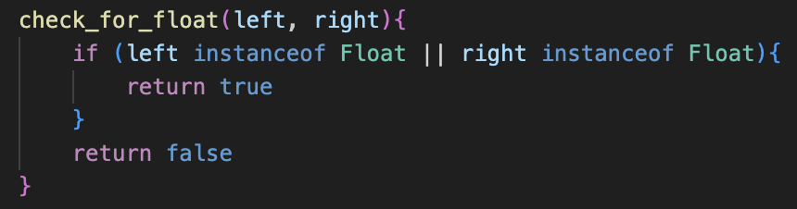

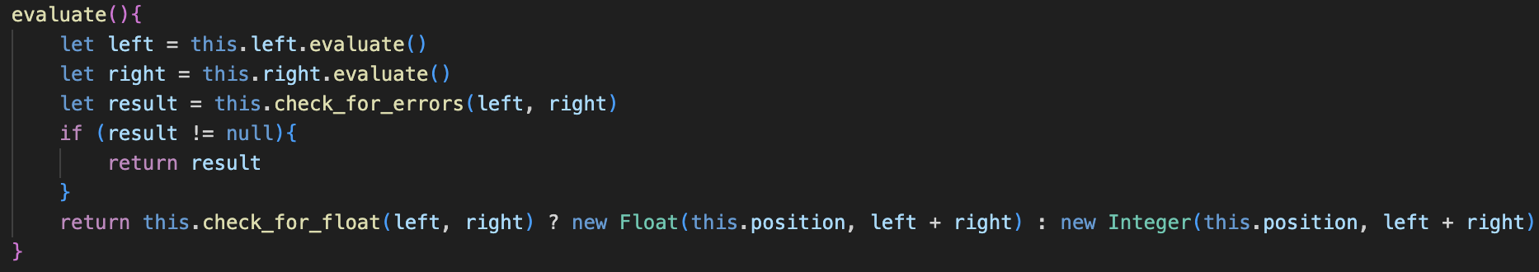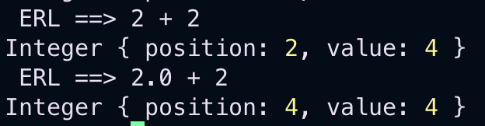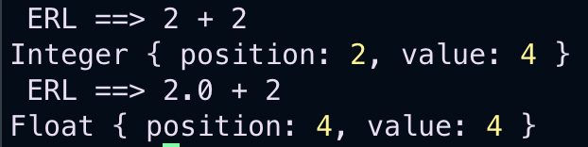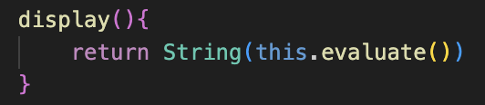integer

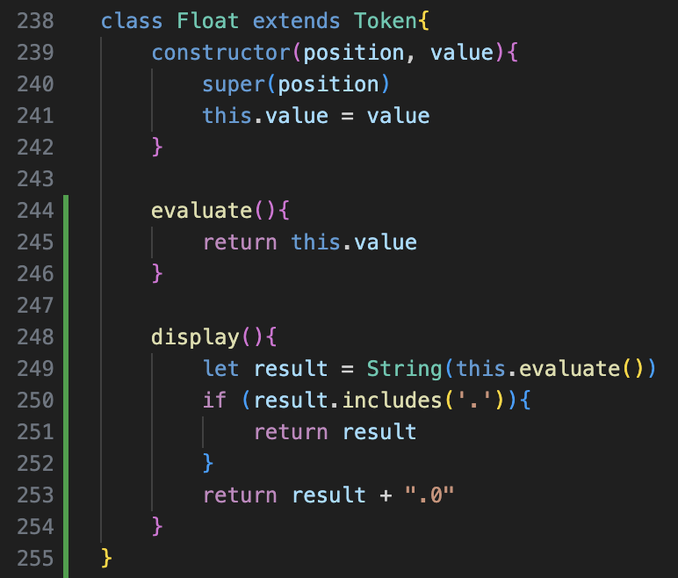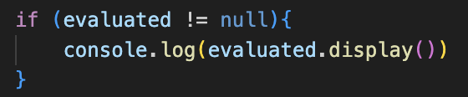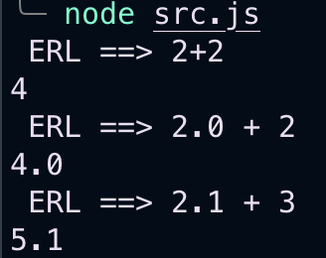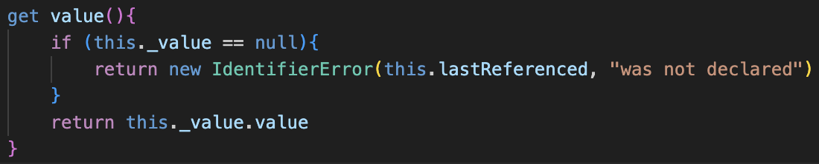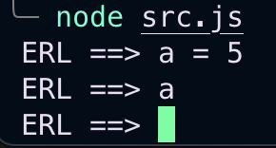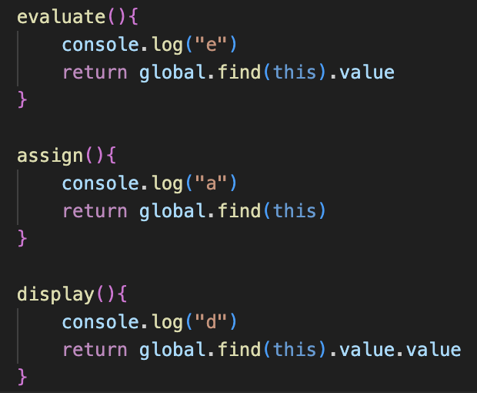

Very confused debugging

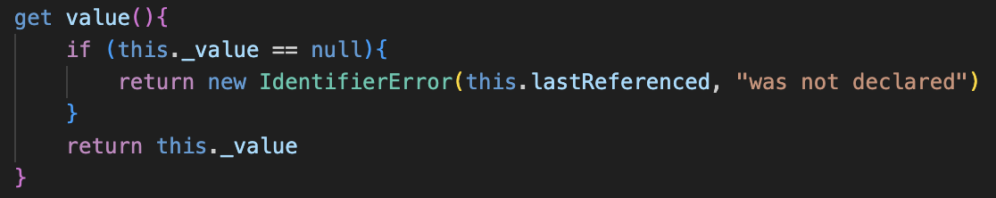

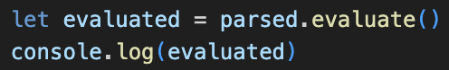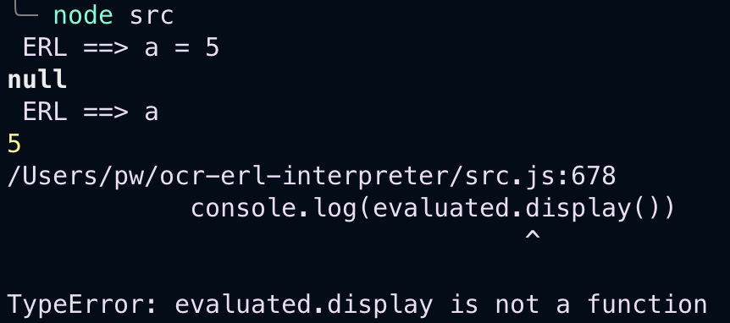

Returning normal number rather than datatype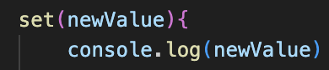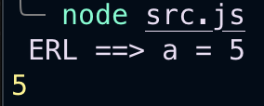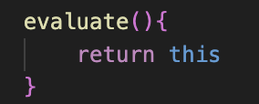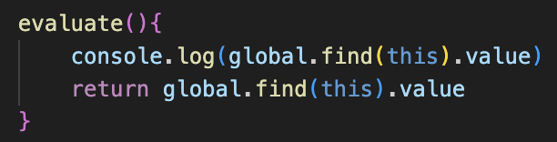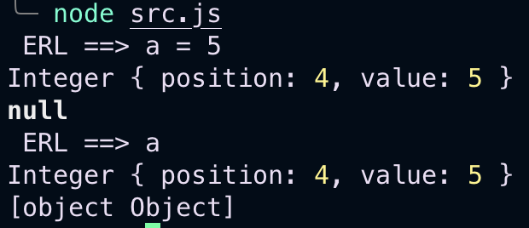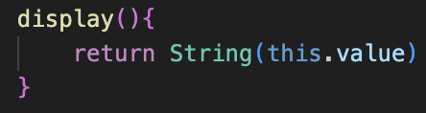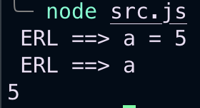

For consistency renaming error .message() to .display() and error.display() to error.location()

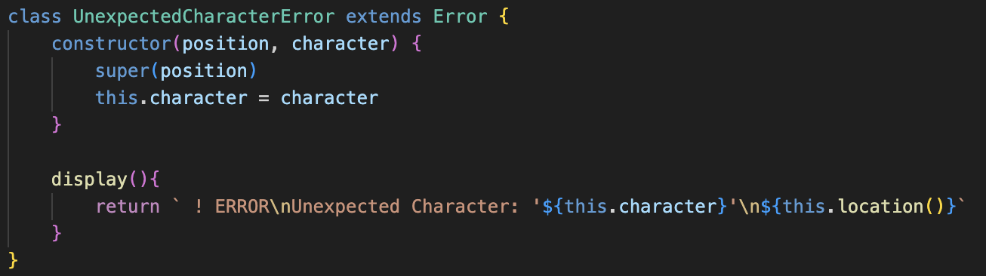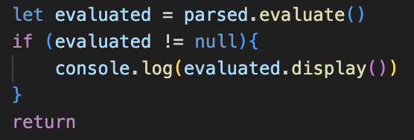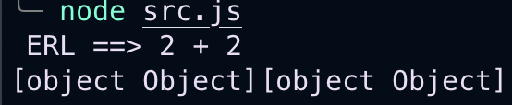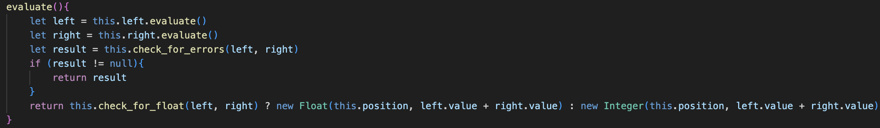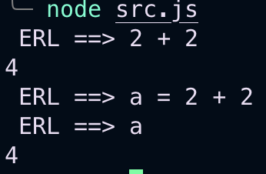

## Impliment for all operations

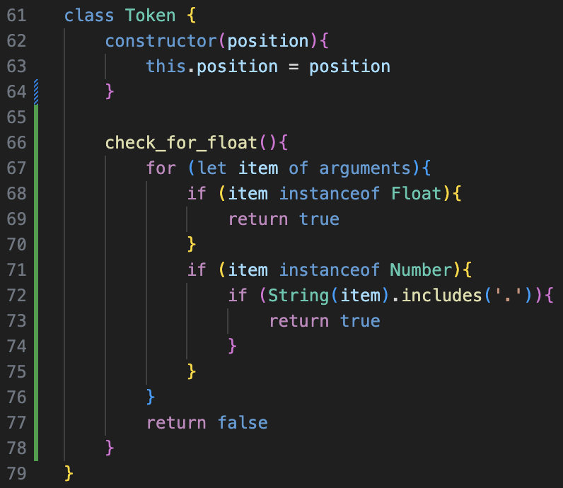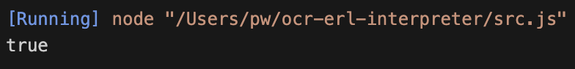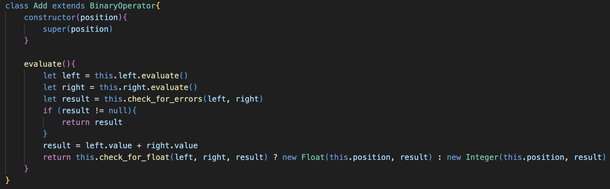

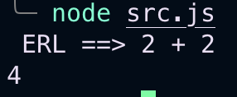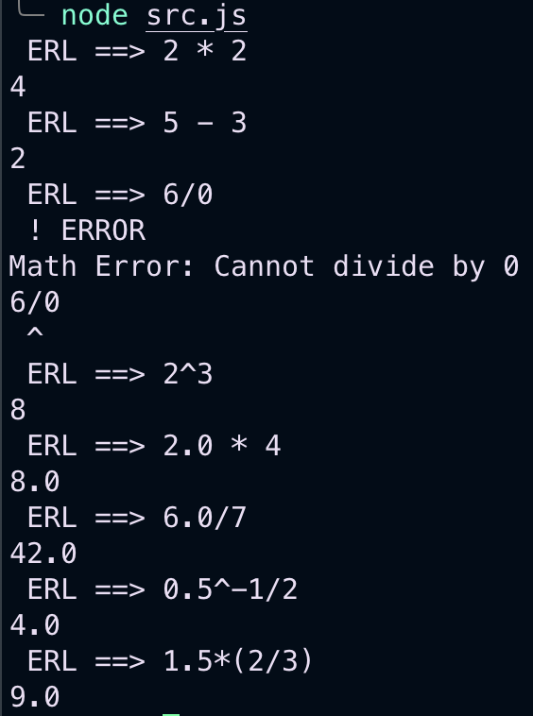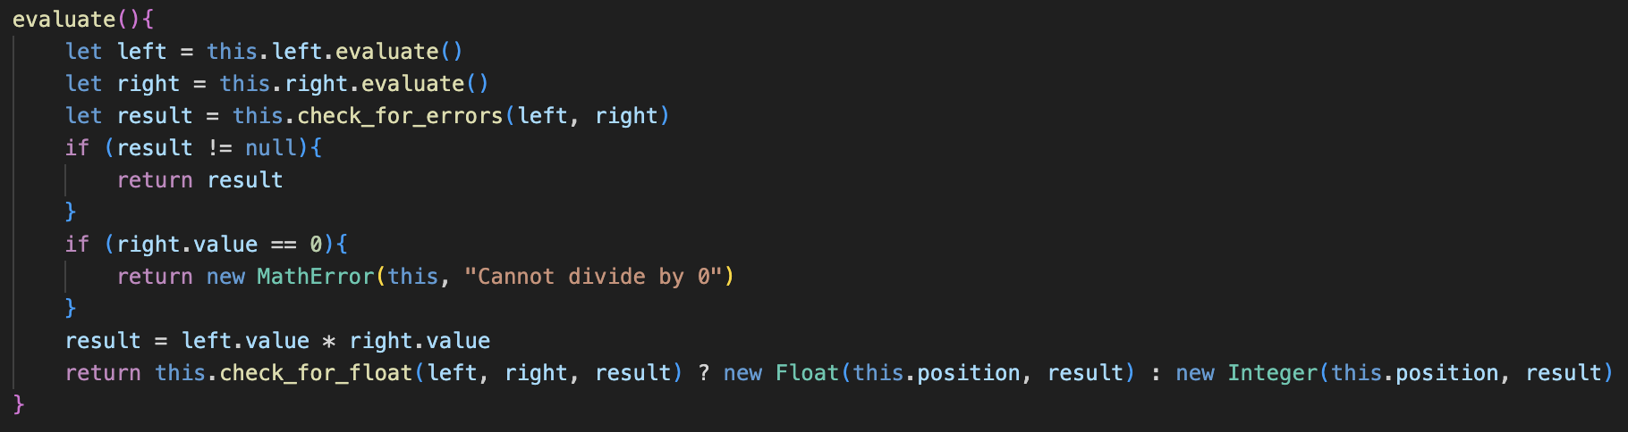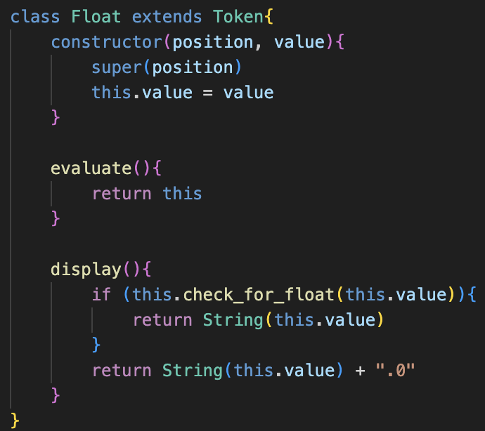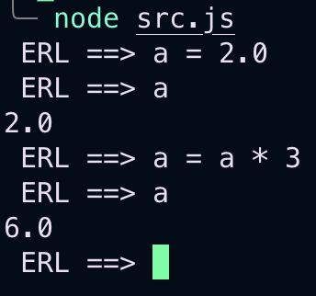

## General improvements with new arguments discovery

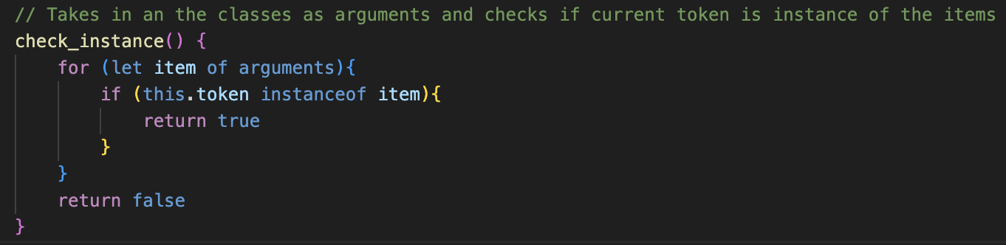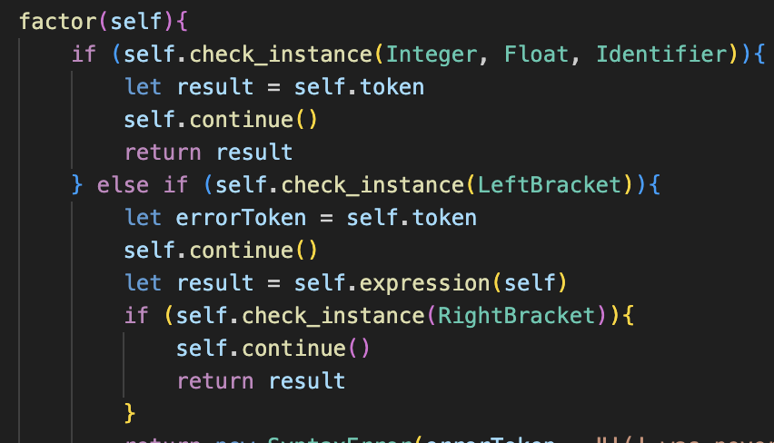

In parse bin op still taken in as an array

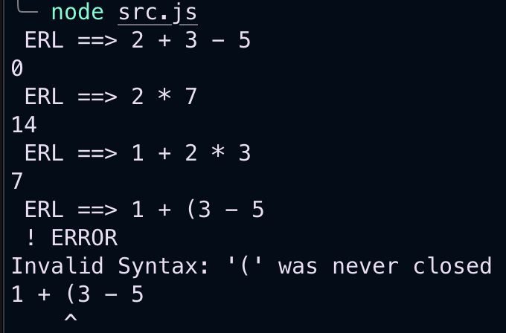still works

## boolean

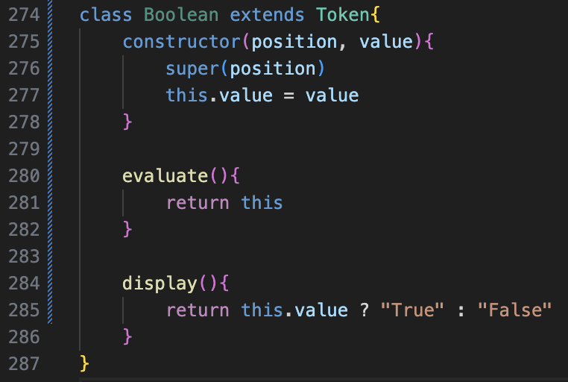yin equality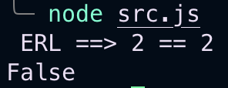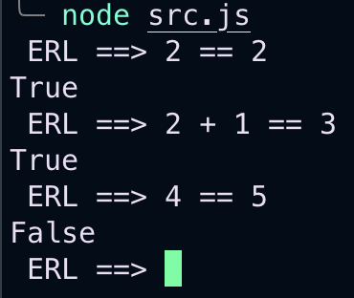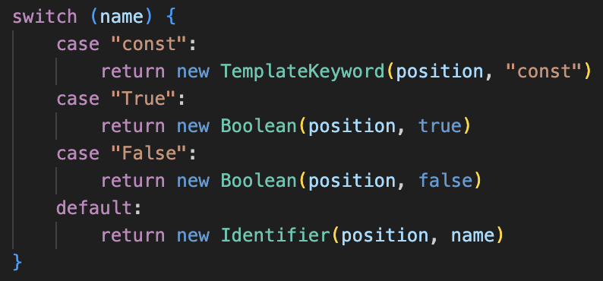

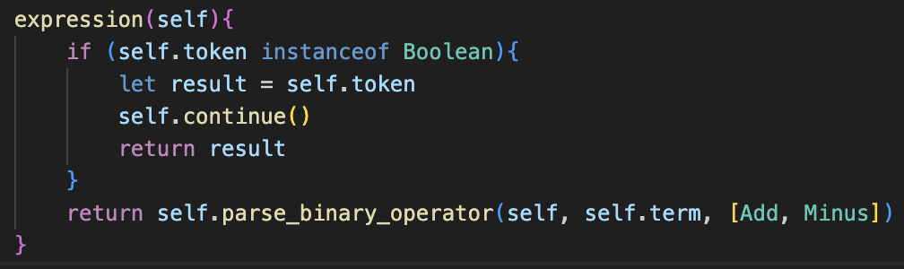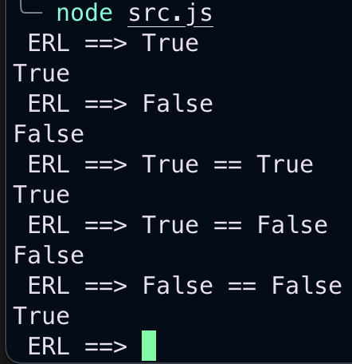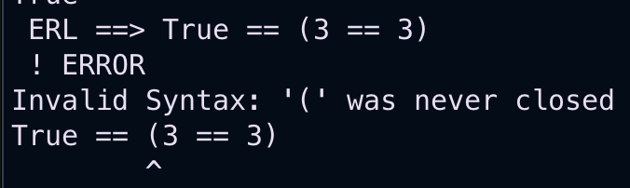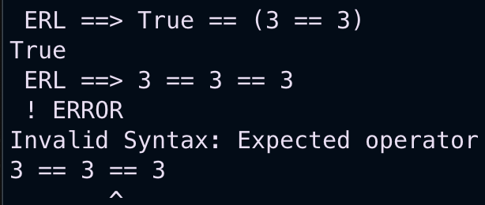perfect

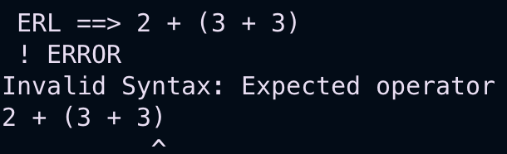need to separate mathematical and logical

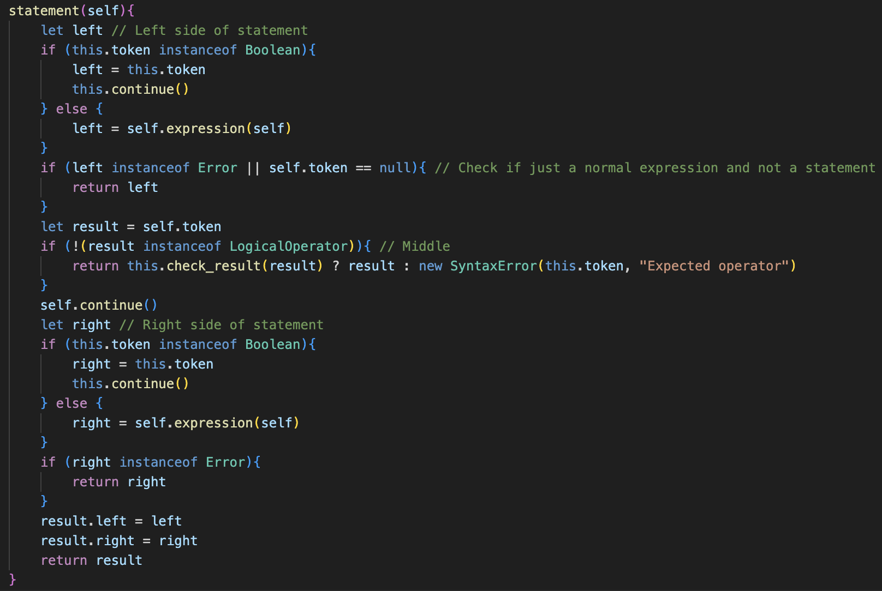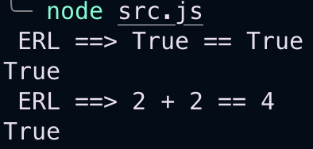 deal with brackets later

## And + OR

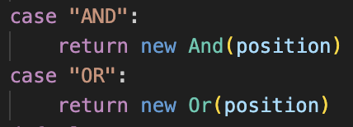

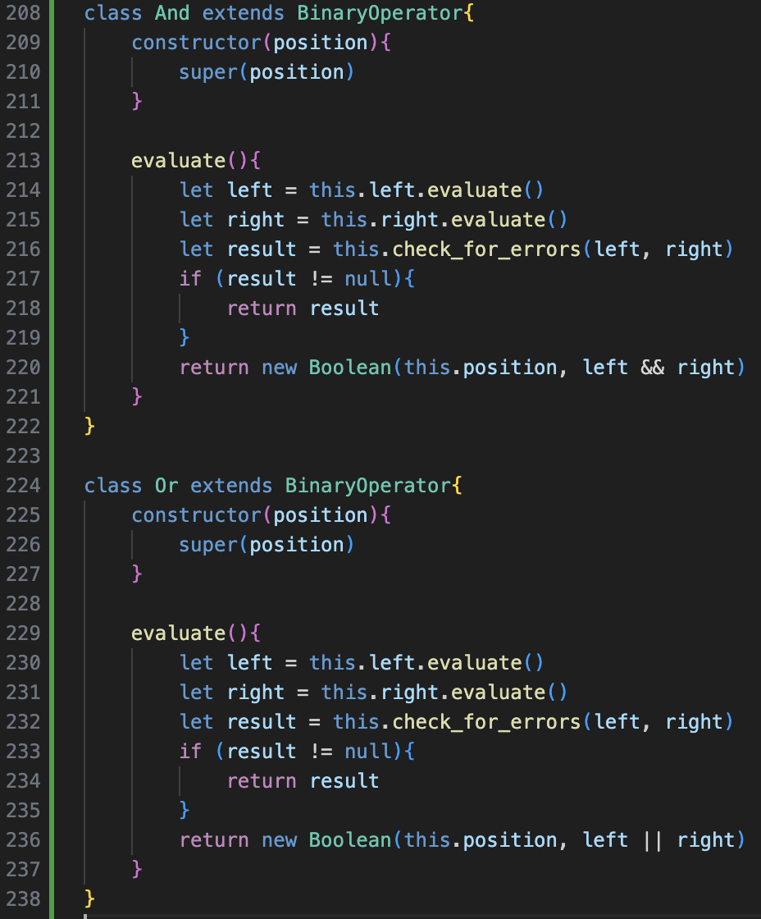

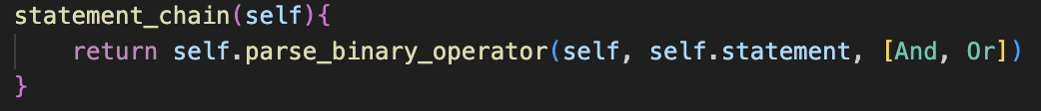 in parse()

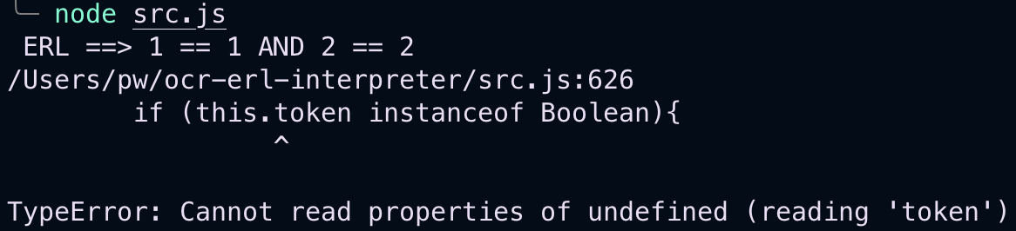

Replace this with self in statement()

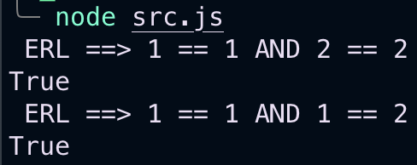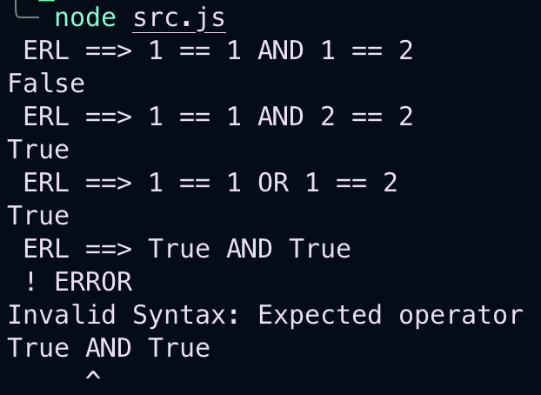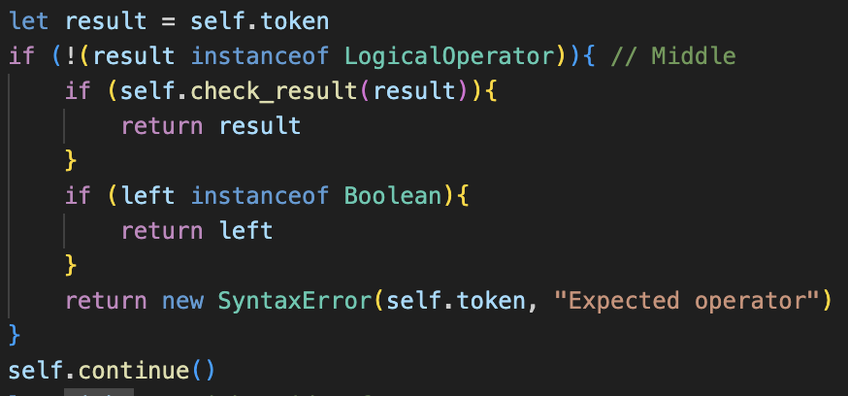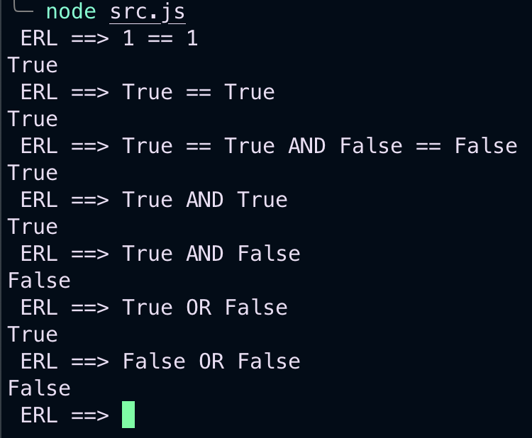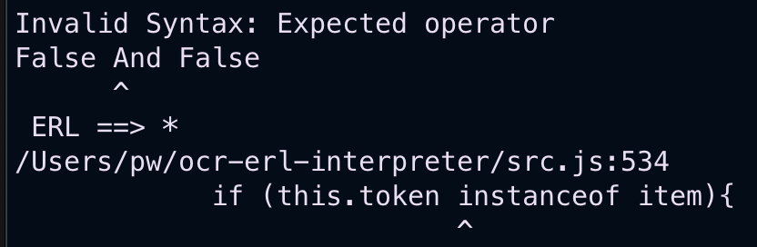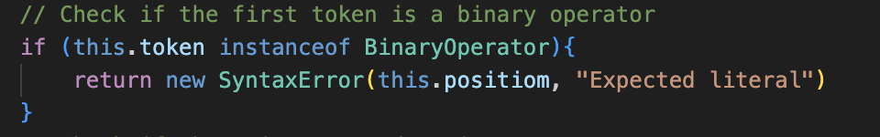in

parse()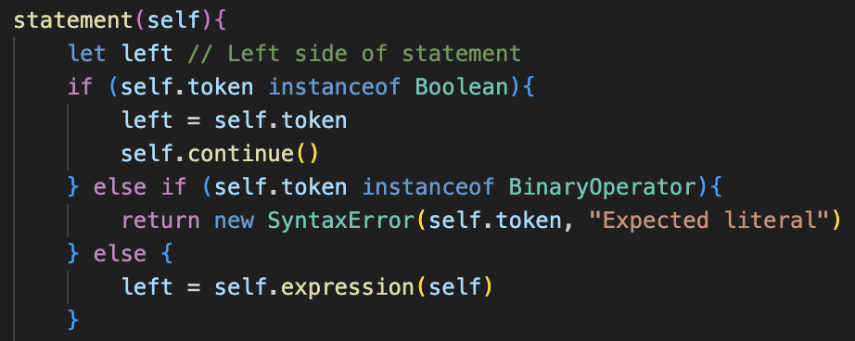

Also repeated afterwards

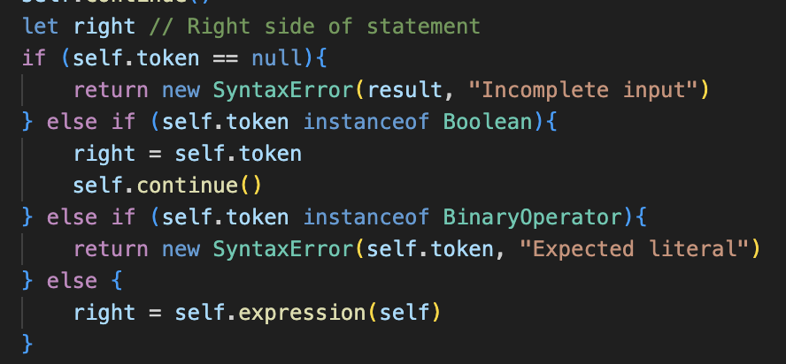 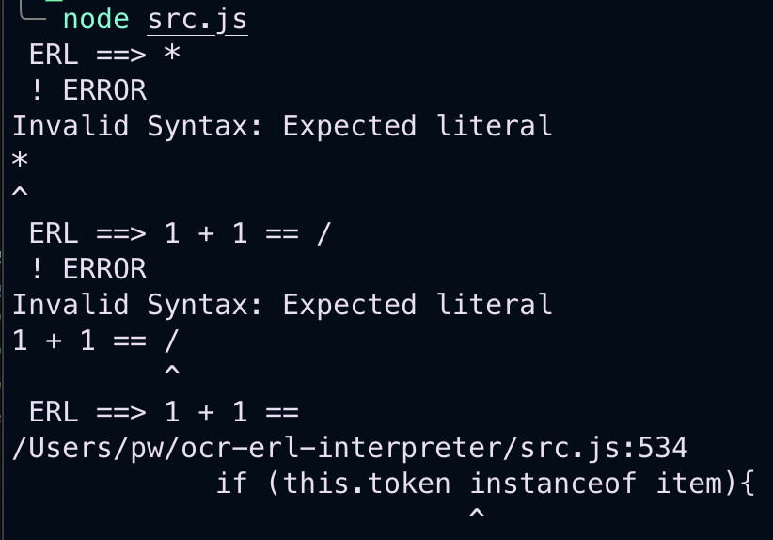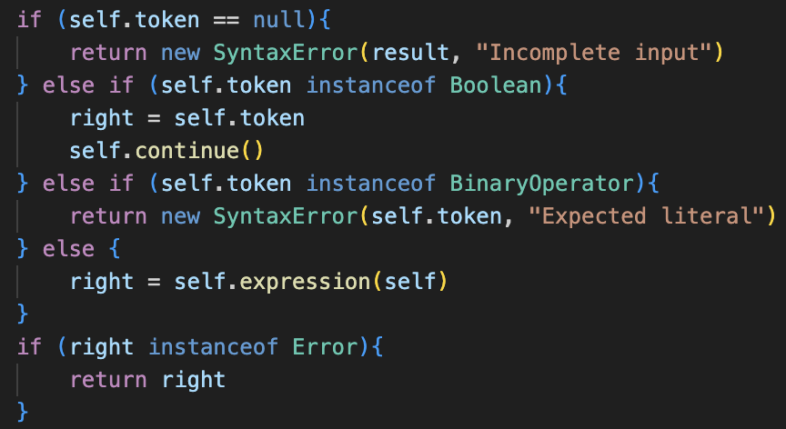

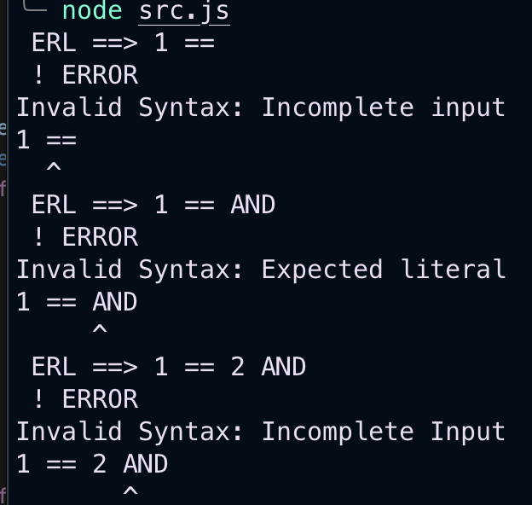

Now implementing brackets to work with old system with generic method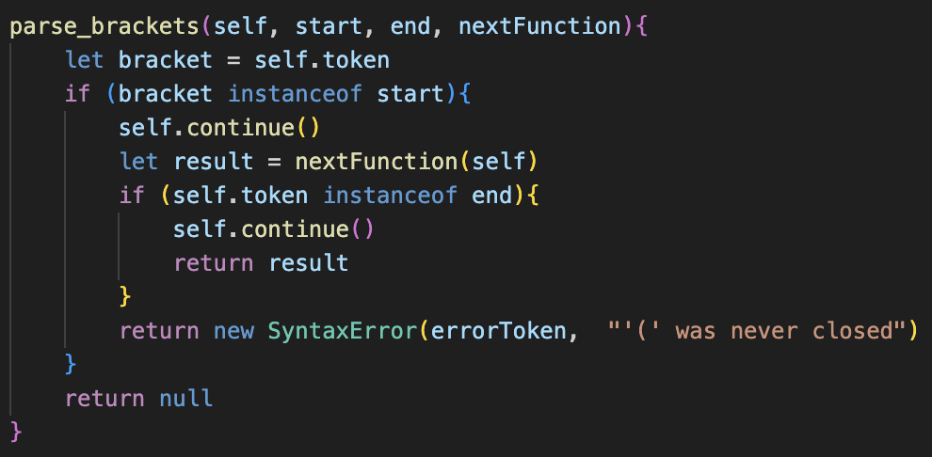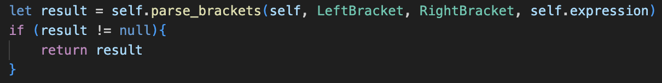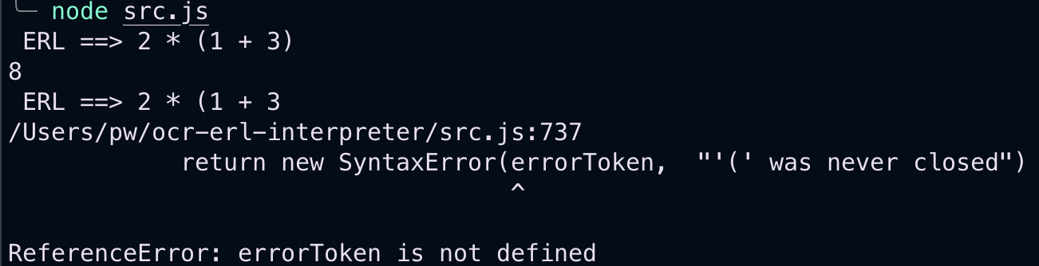s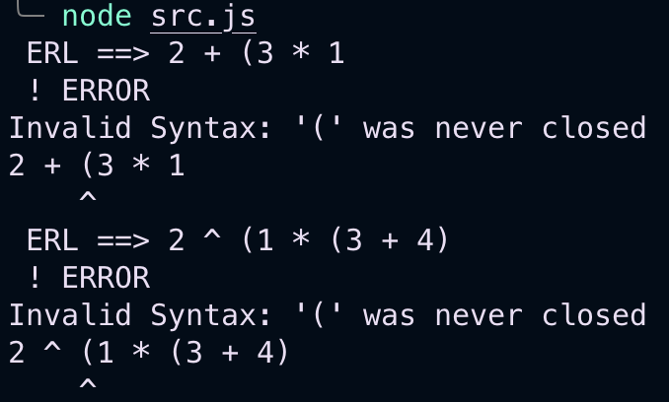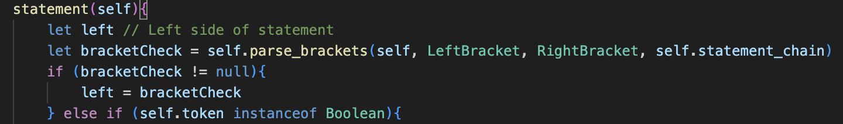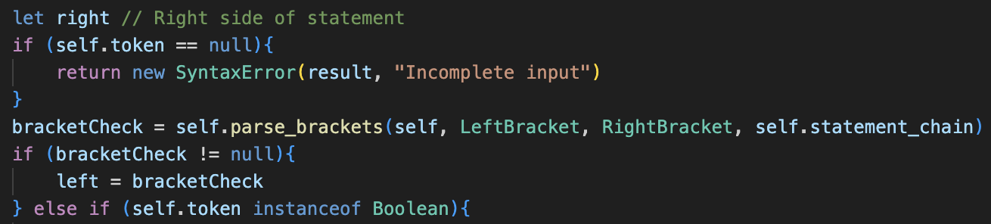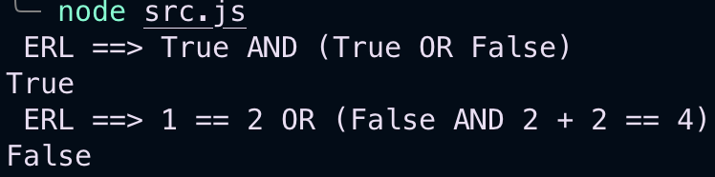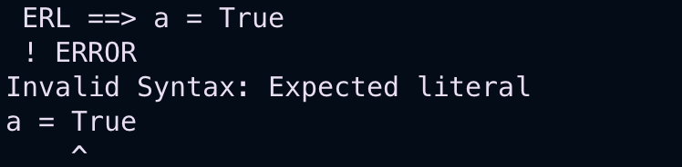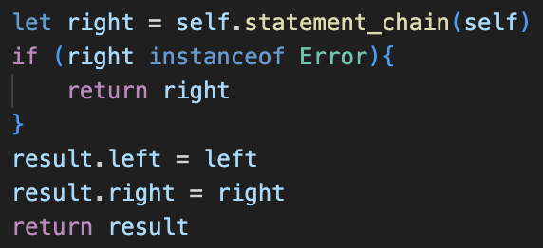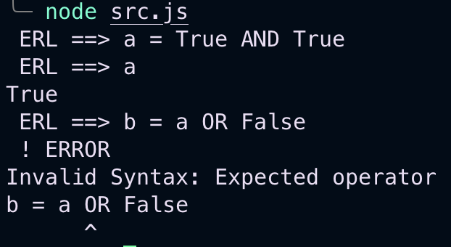

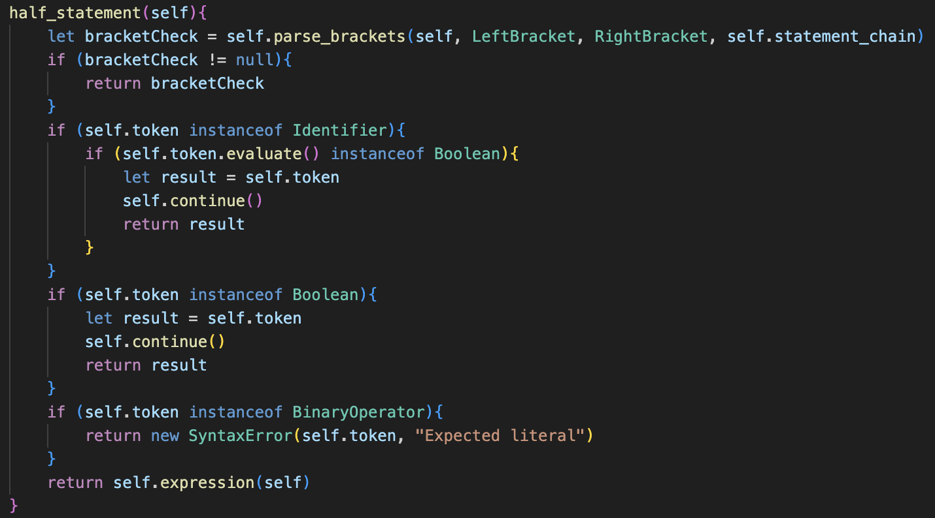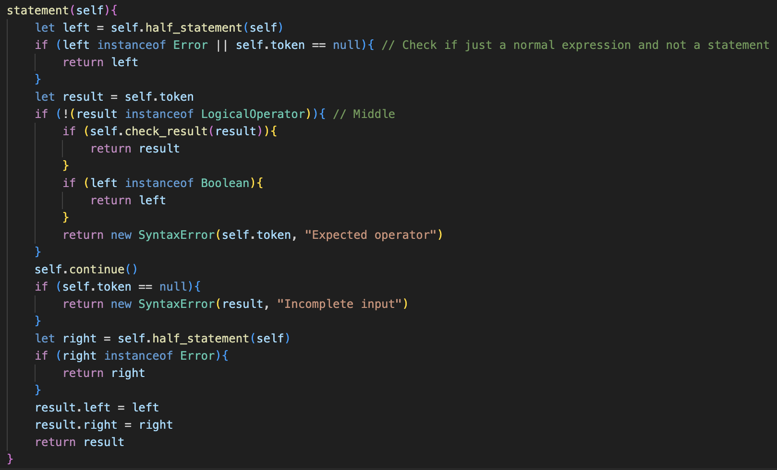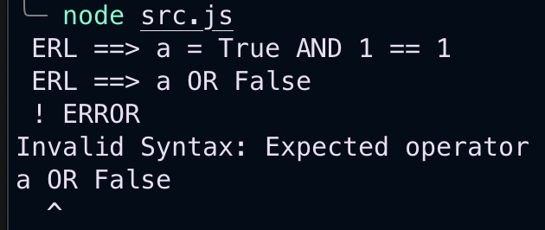

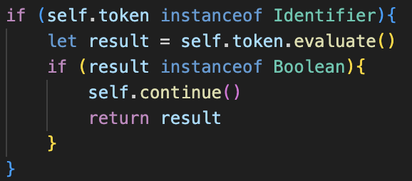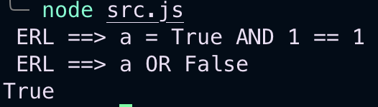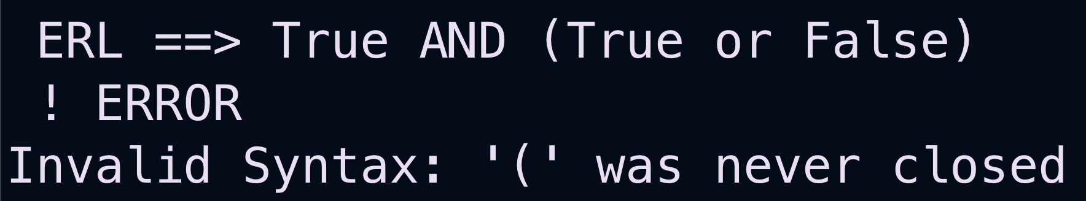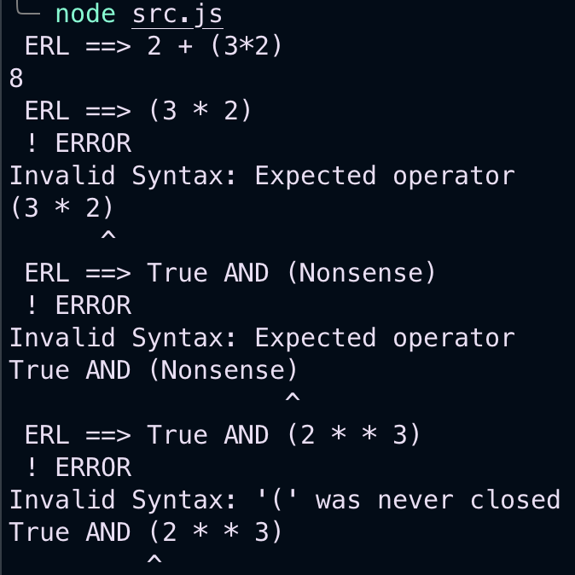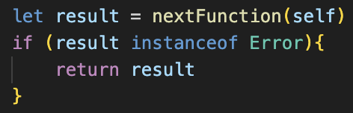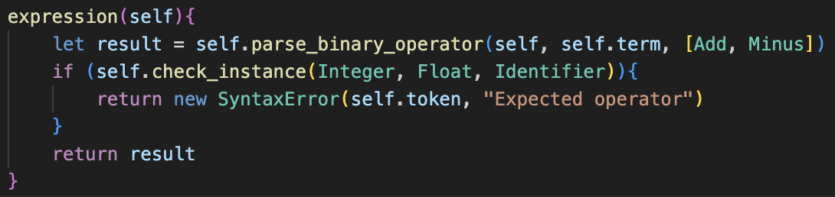

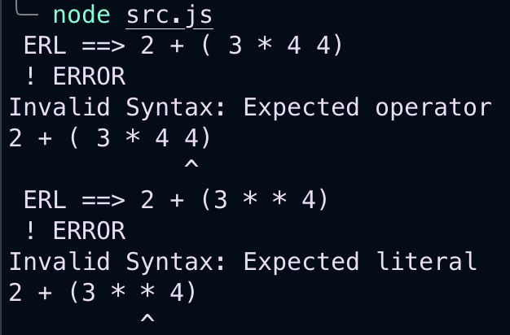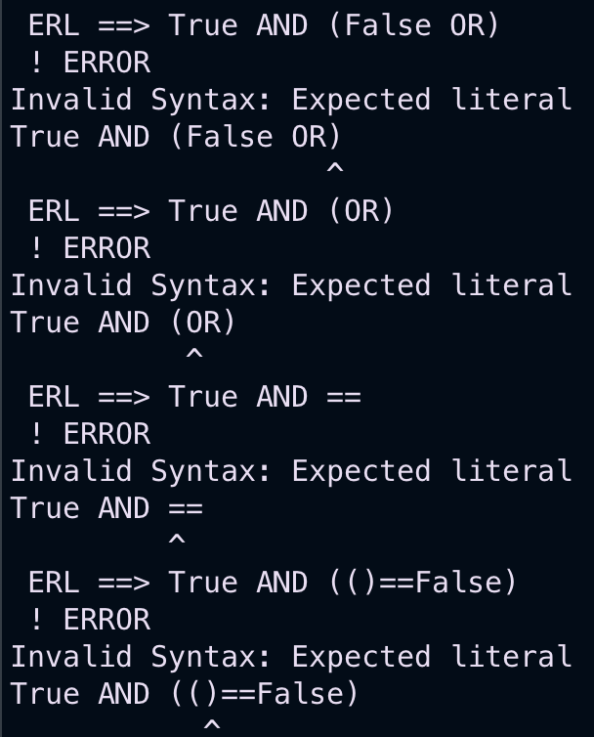

## Other comparisons

Could create a new class for every type but lots of repeated code

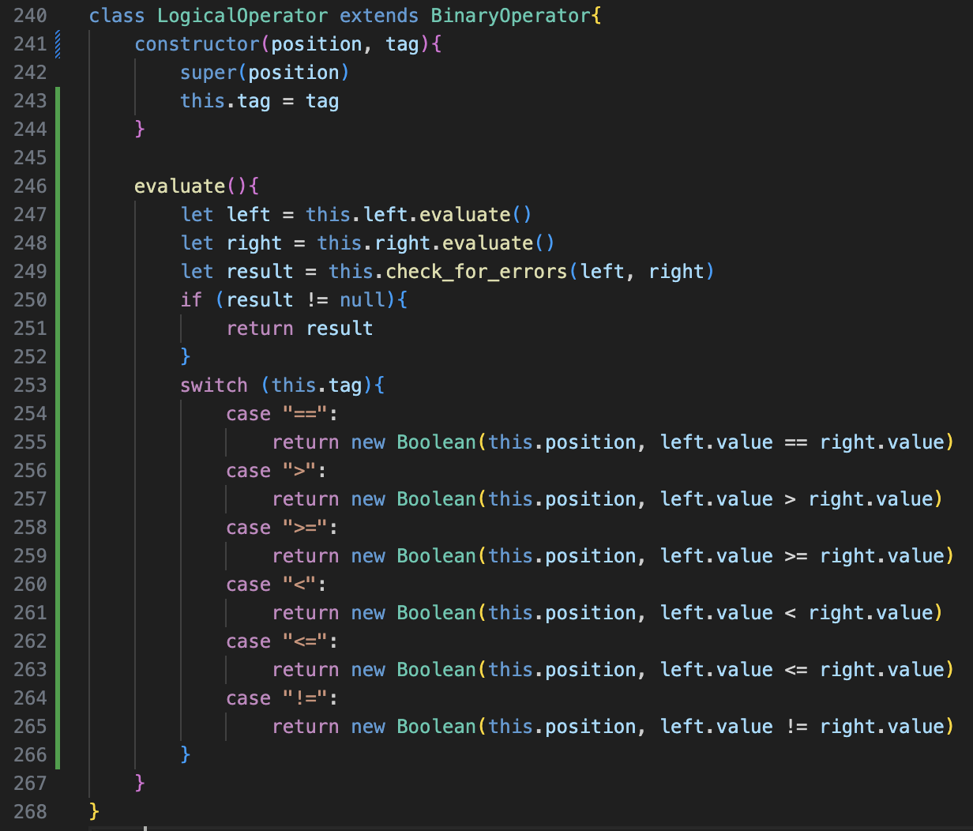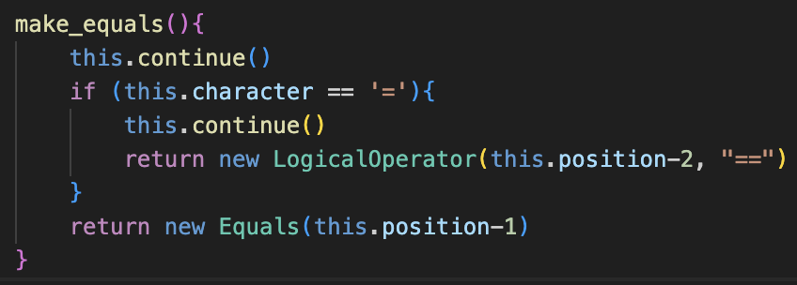removed old Equals class

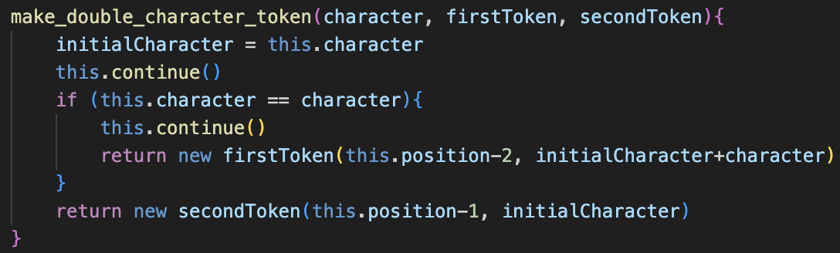

Realised can simplify even further

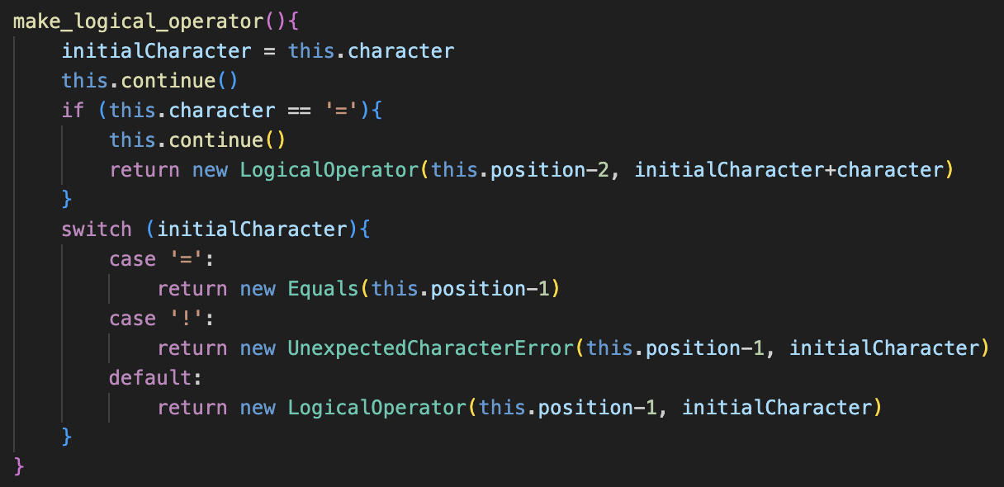

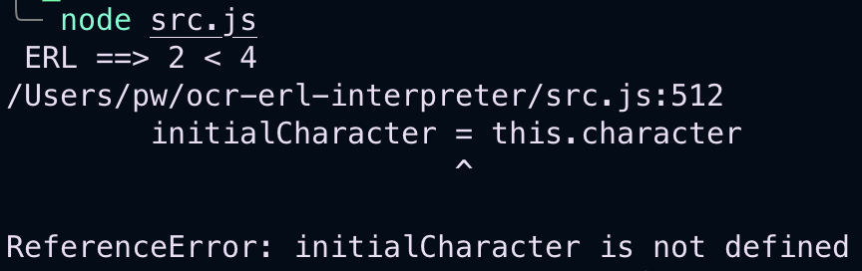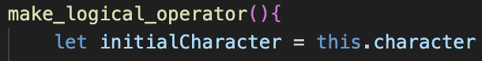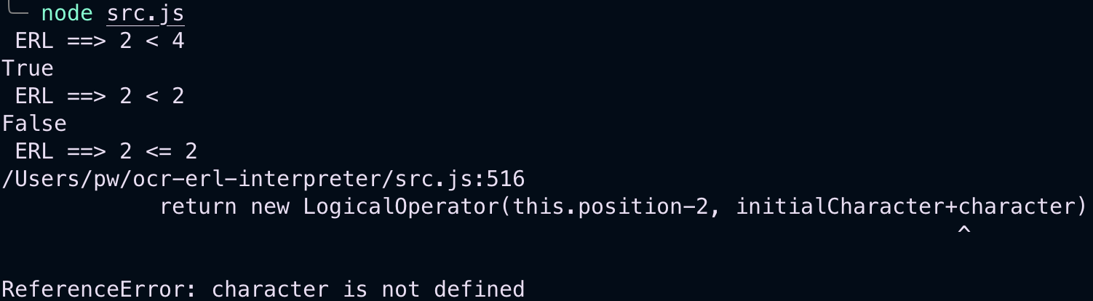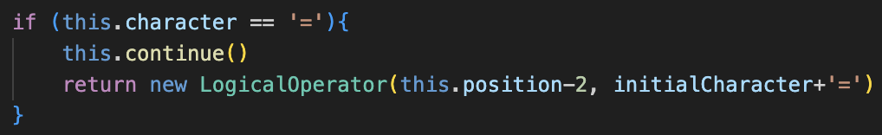

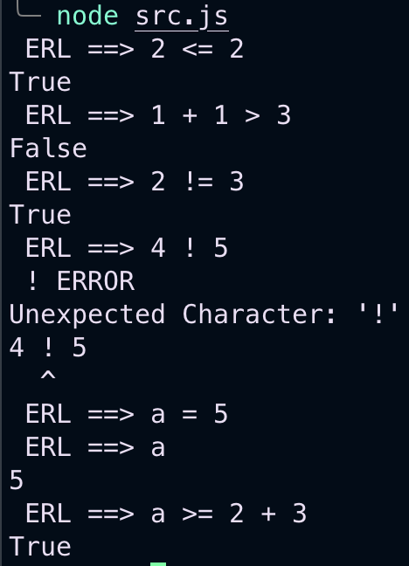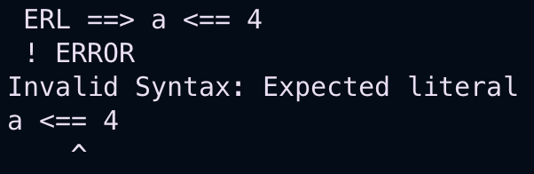

## Clean up

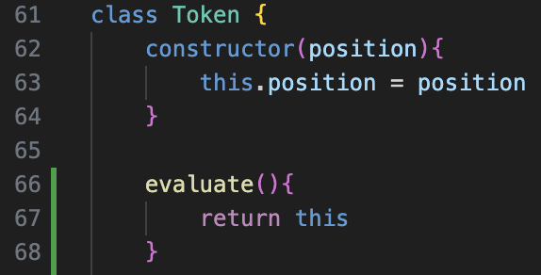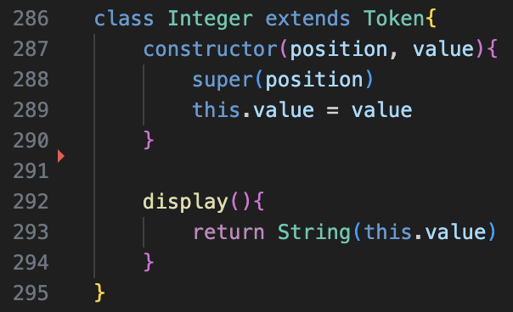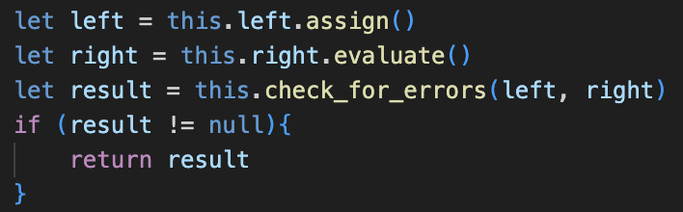 repeated in basically everthing

# if statements

## need multiple lines

<https://www.digitalocean.com/community/tutorials/how-to-work-with-files-using-the-fs-module-in-node-js>

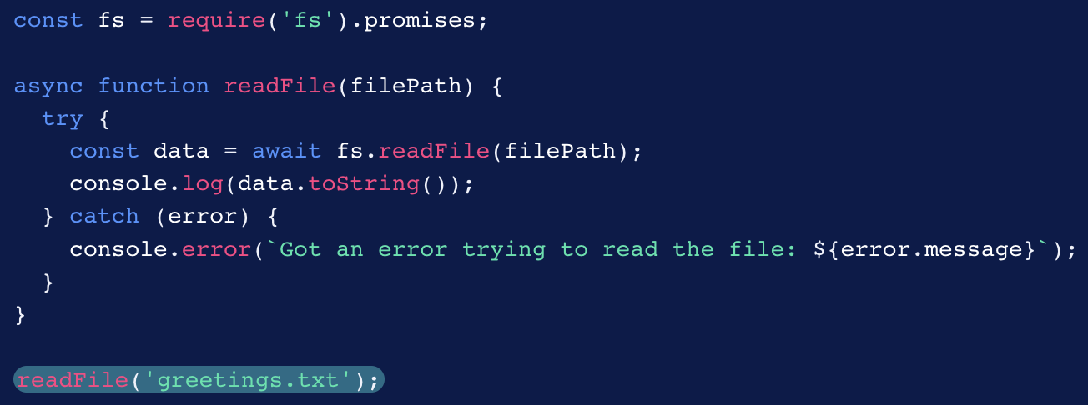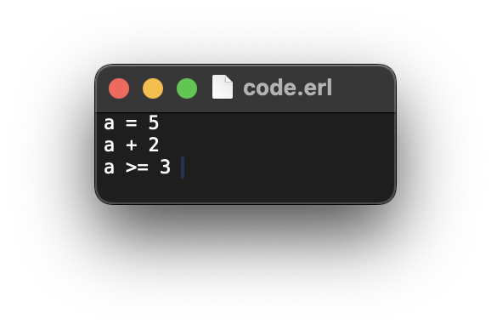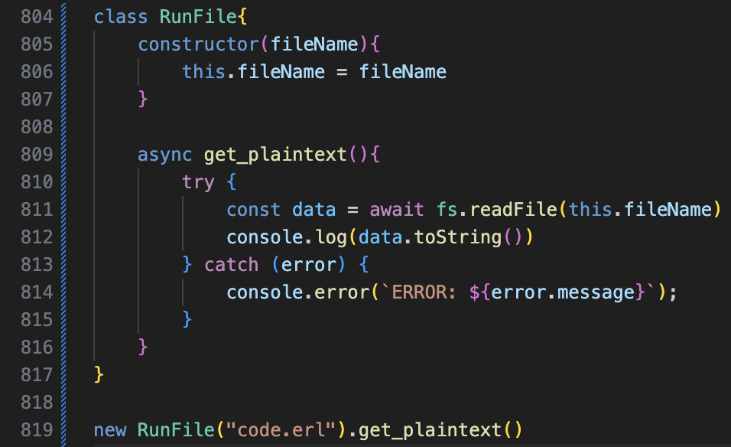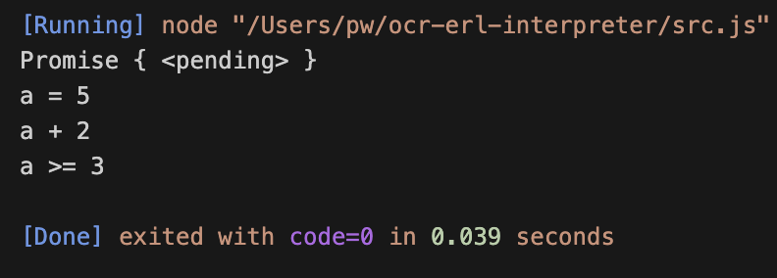

<https://nodejs.dev/en/learn/reading-files-with-nodejs/>

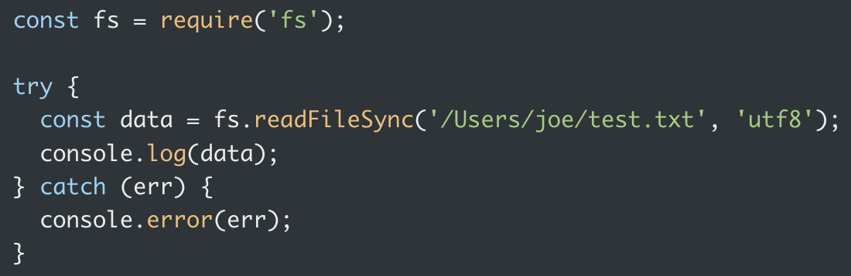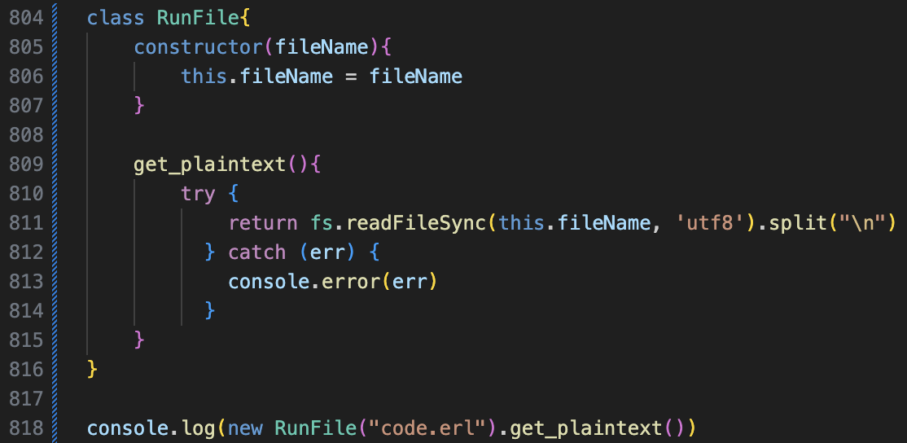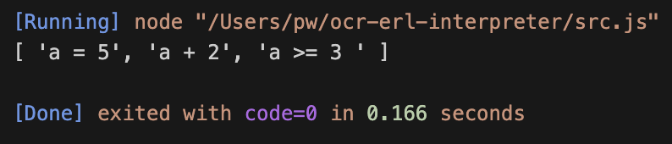

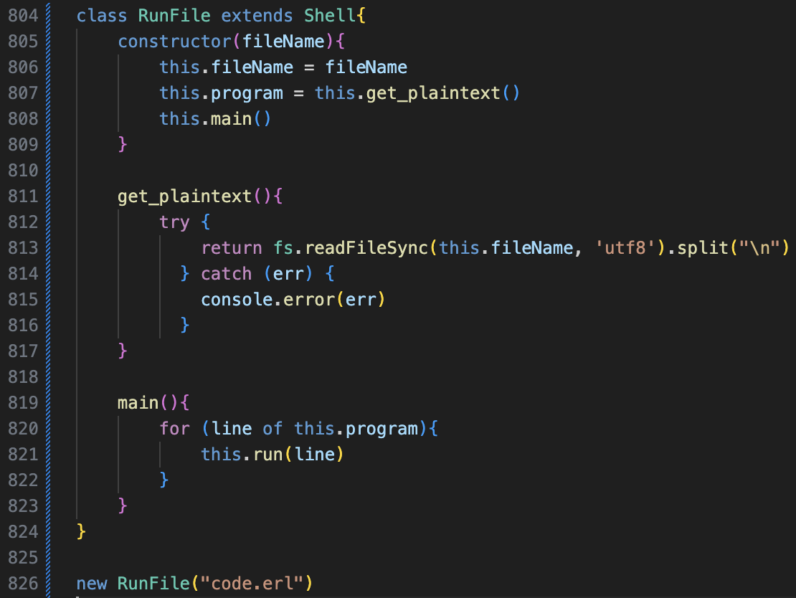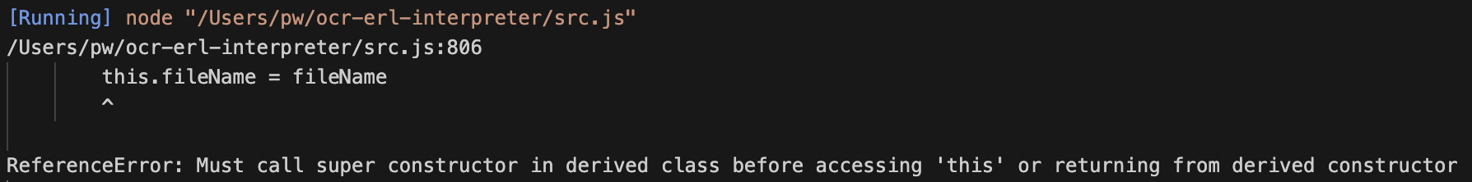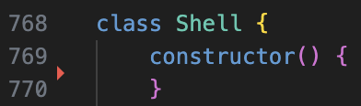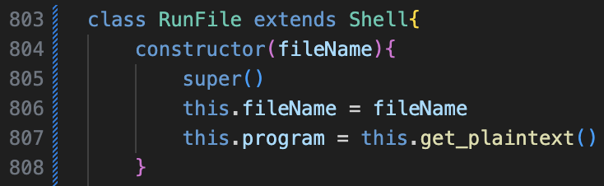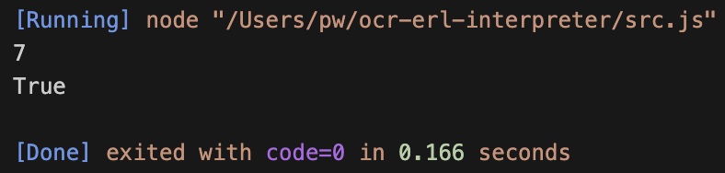

## Get multiple lines to work

Do we so far have an actual interpreter

